Spatial and temporal variation in natural organic matter quantity (as dissolved organic carbon) and quality (via UV-Vis spectroscopy) across a second growth forested drinking water supply area on Vancouver Island, BC

Hannah J. McSorley

2020

Table of Contents

# Abstract

*(max 350 words) - roman numeral TOC*

Most drinking water in Canada originates in forested headwaters, therefore forest management is intimately tied to the quality and quantity of water supply for many communities. However, without a baseline understanding of a watershed’s hydrochemical dynamics, it is difficult to determine if observations indicate a departure from natural variance due to forest treatments, or if observations fall within baseline variation. Monitoring source water quality and hydrologic dynamics is a crucial part of a multi-barrier approach to clean drinking water. This research established a stream water sampling program across a second-growth forested drinking water supply area (Greater Victoria, British Columbia, Canada) to evaluate spatial and temporal patterns and variance in natural organic matter (NOM), a master variable in aquatic systems. Over sixteen months (October 2018 to February 2020), 426 stream water samples were collected from twelve sites (ranging in size from 9.6 to 37 km2, elevation 215 to 870 m a.s.l) and were measured for NOM quality (via UV-Vis absorbance parameters) and quantity (as dissolved organic carbon, DOC). Mean sub-basin DOC concentrations ranged from 4.2 ± 1.8 mg L-1 to 9.9 ± 3.4 mg L-1 (DOC range spanned 1.64 - 19.1 mg L-1). From upstream to downstream NOM quantity and reactive character decreased. There was a seasonal shift in NOM character, from predominantly aliphatic in the dry season to predominantly aromatic in the wet season. Antecedent wetness was important for stream NOM molecular quality, and hydrologic connectivity to terrestrial source pools increased throughout the wet season. Approximately 80% of the time, DOC concentration peaked with stage. Early wet season NOM was not stable when held for 11 days (should be analyzed immediately), whereas the more aromatic, allochthonous NOM found in mid to late wet season samples was stable up to 20 days at temperatures between 0-7° C. DOC concentration was loosely correlated to air temperature, with higher concentrations occurring at warmer temperatures and lower concentrations occurring at lower temperatures; and freezing changed NOM molecular attributes in samples. Sub-sets of samples were evaluated for drinking water treatability parameters (n = 8) and total metals contents (n = 42). Dissolved organic carbon (DOC) concentration was well correlated with several metals (R2 values for Hg: 0.99; Al: 0.81; Fe: 0.72; Cu: 0.47; Ba: 0.25; Mn: 0.21), evidence that NOM is indeed a master variable important in contaminant transport. Evaluation of treatability data with UV-Vis spectroscopic results revealed the spectral absorbance coefficient at 254 nm (SAC254) was a better indicator of disinfection byproduct formation potential (DBP-FP) than was DOC concentration or specific UV absorbance at 254 nm (SUVA254). SAC254 was well correlated with total trihalomethanes (r = 0.9882) and total haloacetic acids (HAAs, r = 0.9927), but was only weakly correlated to bromodichloromethane (BDCM, r = 0.6539). Six sites in the Leech River watershed (~96 km2), future supplemental drinking water supply area, were studied with vertical passive sampling racks to evaluate aqueous NOM dynamics on the rising hydrograph limb. Random Forest variable importance measure (RF VIM) evaluation of monitoring site data identified warm and wet conditions as key drivers for NOM dynamics. RF VIM showed that forest age and harvest history were important predictor variables for NOM aromaticity and molecular size but determined that subsurface parent material was a more important driver for NOM quantity and quality. Results were framed in context of continued water quality monitoring and planning for drinking water supply and future inter-basin transfers.

# Lay Summary

*(max 150 words) - roman numeral TOC*

***to be updated following completion of abstract***

This research contributes to understanding the variability in DOM and DOC across a forested riverine watershed: the Leech River watershed on Vancouver Island, British Columbia, Canada. Land-use impacts are controlled in this research area as 96% of the watershed is protected as drinking water supply area (Leech Water Supply Area). Like most forested areas on Vancouver Island, the Leech watershed is second-growth softwood forest with a history of extensive harvest (nearly 96% cleared).

Sixteen months of bi-weekly field work was completed with the goals of contributing to the characterization of the Leech Water Supply Area (LWSA) while furthering our understanding of the variability of dissolved organic matter (DOM) dynamics in hydrologic response across a second growth forested watershed.

The purpose of this master’s research project was to establish a baseline understanding of hydrologic responses and water quality variability in rivers across the LWSA. The approach includes advanced passive sampling within stormflow, supplemented with synoptic grab sampling between storm events and during summer baseflow. Discrete samples of river water were collected passively during the rising limb of stormflow using low-powered, low-cost, custom-built vertical rack samplers including water level loggers (Odyssey) and observational reference staff gauges. By collecting samples during stormflow, a more robust understanding of water quality dynamics was achieved than basic grab sampling alone. Using low-powered passive sampling techniques allowed for multiple (six) sites to be equipped with monitoring/sampling racks, providing spatial resolution of hydrochemical variability across the watershed.

# Preface

*roman numeral TOC*

This dissertation is an original intellectual product of the author, Hannah J. McSorley.

Vertical sampling racks (Chapter 2) were based on principles employed by Maartje Korver (MSc Vrije Universiteit Amsterdam) at Hakai Institute, BC, Canada. Siphon sampling bottles were built by H.J. McSorley based on US Geological Survey’s single-stage siphon sampler for suspended sediment design (USGS U-59 Sampler) and a prototype provided by M. Korver.

Laboratory analyses conducted at the University of British Columbia (UBC), and all data analysis (using R (R 3.6.2) in RStudio (Version 1.3.820)) were completed solely by H.J. McSorley. Most geospatial data were collected from the Government of Canada Geospatial Data Extraction tool (geogratis.gc.ca) with supplemental data provided by the Capital Regional District (CRD). Weather station data and geospatial data (landcover and subsurface geological layers) for the Leech Watershed was supplied by the CRD and used with their permission. All maps included in this thesis were created by H.J. McSorley using QGIS (version 3.12.1, Bucuresti; www.qgis.org); catchment boundaries were delineated using the QGIS GRASS plugin (GRASS GIS 7, version 2). Geospatial data extractions (Table 2 & Table 13) were completed or confirmed (in the case of watershed boundary delineation) by Alison Bishop, BSc, ADGIS (Research Assistant, VIU Coastal Hydrology Research Lab).

see: <https://www.grad.ubc.ca/sites/default/files/doc/page/thesis_sample_prefaces.pdf>

* TOC
* LOT
* LOF

Table 1: List of Abbreviations

|  |  |
| --- | --- |
| Acronym | Term |
| CRD | Capital Regional District |
| DBP-FP | Disinfection By-Product Formation Potential |
| DBPs | Disinfection By-Products |
| DOC | Dissolved Organic Carbon |
| DOM | Dissolved Organic Matter |
| E2:E3 | Quotient of SAC250 divided by SAC365 |
| GVWSA | Greater Victoria Water Supply Area |
| HDPE | High density polyethylene (sample bottles) |
| NOM | Natural Organic Matter |
| NPOC | Non-Purgeable Organic Carbon |
| QA/QC | Quality Assurance & Quality Control |
| RF | Random Forest |
| RSD | Relative standard deviation (a.k.a coefficient of variance) |
| SAC254 | Spectral absorbance coefficient at 254 nm (absorbance at 254 nm divided by pathlength) |
| VIM | Variable Importance Measure (in randomForest, R) |
| WSA | Water Supply Area |

Table 2: Glossary of Terms

|  |  |
| --- | --- |
| Term | Definition |
| Absorbance | molecular interference with a beam of light in which a molecule absorbs a portion of irradiated light (UV-VIS spectroscopy employs this attribute to quantify compounds, as absorbance is proportional to molecular concentration via Beers Law) |
| Aliphatic | class of hydrocarbons characterized by lack of conjugated pi-bonds, which could be straight-chain, branched chain or saturated ring structures (e.g. squalene C30H50) |
| Allochthonous | natural organic matter (NOM) that is formed outside of a water body and then transported into the water body; composition depends on the plant-derived precursor compounds and natural diagenetic processes that alter its composition |
| Aromatic | class of hydrocarbons characterized by presence of conjugated pi-bonds with a ring structure (e.g. benzene C6H6) |
| Autochthonous | natural organic matter (NOM) that is formed in place (in stream) generally by micro-organisms |
| Capital Regional District | governing/municipal body for the Greater Victoria Area and the managing group for water supply and watershed management. Research partners in the forWater Network & hosts for this thesis research |
| Chromophore | part of a molecule (structure) that absorbs visible light and is responsible for molecular colour (function). Chromophores are generally conjugated pi-bond systems in the molecule, commonly aromatic structures. UV-Vis absorbance measurements can be a proxy for molecular aromaticity because of the relationship between aromaticity and chromophoric absorbance. |
| Discharge / Streamflow | the volume of water moving through a river channel over a defined period of time. In general, river discharge is computed by multiplying the area of water in a channel cross section by the average velocity of the water in that cross section, expressed in units of volume per time (e.g. cubic meters per second) |
| Disinfection By-Product Formation Potential | experimentally predicted amount of DBPs created through chlorination of source water |
| Disinfection By-Products | group of unintentional halogenated organic compounds resulting from chlorination of source drinking water (e.g. trihalomethanes, halogenic acetic acids, haloacetonitriles, haloketones) |
| Dissolved organic carbon (DOC) | organic carbon compounds that are operationally defined as being finer than 0.45 micron |
| Greater Victoria Water Supply Area | 20,549 hectares of protected drinking water catchment lands owned and operated by the CRD (including Sooke Lake reservoir (primary supply source), Goldstream watershed and reservoir system (secondary supply) and LWSA) |
| High density polyethylene (sample bottles) | plastic material that is impact resistant with good chemical compatibility. Suitable bottle material for water sample collection. |
| Leech Water Supply Area | future supplemental water supply area for the Greater Victoria Area & the main research site for this research project |
| Natural Organic Matter | diverse carbon-based compounds found in natural, engineered, terrestrial and aquatic environments |
| Non-Purgeable Organic Carbon | instrumentally measured parameter to quantify organic carbon (with Shimadzu TOC-V analyzer): aqueous sample is acidified (pH <2) to convert inorganic carbon (e.g. carbonates) to carbon dioxide and then sparged with hydrocarbon-free air to remove CO2, then the remaining organic carbon is combusted to CO2 which is detected with a non-dispersive infrared gas analyzer. |
| Pi Bond | a covalent bond formed by the side-to-side overlap of two atomic orbitals (versus a sigma bond is a covalent bond formed by head-on overlap of two atomic orbitals; note that every single bond (e.g. C-C) consists of one sigma bond, a double bond (e.g. C=C) is made of one sigma bond and one pi bond, and a triple bond consists of one sigma bond and two pi bonds). Adjacent pi binds can lead to increased molecular stability (through resonance structures), aromaticity, and chromophores. |
| Quality Assurance & Quality Control | methods of providing confidence in the quality of results, both are part of quality management (QA is more process oriented; QC is more product oriented) |
| Random Forest | Statistical machine learning algorithm (collection of classification and regression trees) |
| Relative standard deviation (a.k.a coefficient of variance) | An expression of standard deviation relative to the mean, expressed as a percentage (RSD = (sd/mean)*100) |
| Spectroscopy | quantitative and/or qualitative analytical techniques relying on the interaction of matter with electromagnetic radiation (e.g. light). Generally, preserves the measured sample (can be used in-line with other analyses) |
| Stream stage | water level above an arbitrary point (e.g. bottom of a stilling well, streambed, step) |
| Total suspended solids (TSS) | particles that are suspended in the water column (generally, fine sediments will transport further downstream than coarse sediments) |
| Turbidity | optical measurement of the “cloudiness” or clarity of water used as a proxy for total suspended solids. Measures the reduction in a beam of light based on particle-based light scattering to establish the amount of suspended material |

# Acknowledgments

This research work would not have been possible without the support and physical accommodations provided by the Capital Regional District (CRD) Watershed Protection and Management Division, Integrated Water Services (Victoria, BC). Thank you so much. I would like to acknowledge the help, support and assistance provided by the following CRD folks: Tobi Gardner, Kathy Haesevoats, Annette Constabel, Joel Ussery, Patrick McCoubrey, Ryan Biggs, Burn Hemus, Christoph Moch, Jessica Dupuis, Devon Barnes, and Athina Connor. I’m grateful to have been supported by the entire CRD Field Operations Staff; thank you all for making me feel welcome on site and including me in daily field operations and worker checks.

This research also would not have been possible without support and encouragement from my academic supervisors, Bill Floyd and Mark Johnson – thank you both for your patience, for supporting me, and for helping me grow as a researcher and writer; it’s been challenging and truly wonderful. Thank you also to academic partners in the NSERC forWater Network: Suzanne Tank, Mike Stone, Dana Harriman, Monica Emelko, Uldis Silins, and Axel Anderson. Thank you all for interesting discussions and your feedback. I’m grateful to the entire forWater Network for providing transdisciplinary training and workshops. Thank you to Emily Mistick for being my forWater travel buddy, for bouncing ideas and concepts around with me, and for checking my writing, each forWater trip was better with you there.

I would like to acknowledge Vancouver Island University, University of British Columbia, the NSERC Canadian Graduate Scholarship Masters Award, and the NSERC forWater Network for Source Water Protection Strategies – thank you for supporting me financial (and tangibly) as a master’s student.

For help with field installations, streamflow gauging and sampling, a big thanks to my friend and former field partner, Stewart Butler (formerly of VIU Coastal Hydrology Research Lab); thanks Stew for being the best field partner on the coldest, wettest, darkest field days. Thanks also to Alison Bishop for assistance on a field trip during the winter of 2019/2020 and for so much help with GIS. I owe you both some beers.

Big thanks to my incredibly wonderful friends and family for supporting me in my scientific and academic pursuits. I really appreciate all the love and support, dinners, coffees, bike rides, beers, proof-reading and encouragement. Thank you all for your patience also, this was a big project.

**Land Acknowledgment**

The author, Hannah J. McSorley, acknowledges and thanks the First Nations on whose traditional lands she traveled, learned, researched, lived and played on during this master’s thesis project, and on whose land she continues to live.

The research sites in Greater Victoria water supply areas are located on traditional territory of the T’sou-ke (Sooke) Nation, who have lived on these lands since time immemorial and who were the original watershed protectors. The Capital Regional District occupies land of the Scia’new (Beecher Bay), Songhees, T’Sou-ke First Nation and Malahat First Nation.

Research at the University of British Columbia in Vancouver BC was conducted on the traditional, unceded territories of xʷməθkʷəy̓əm (Musqueam) People. For the duration of this master’s research, Hannah gratefully lived and played in East Vancouver on traditional territory of the Musqueam, Sḵwx̱wú7mesh (Squamish), and Səlilwətaɬ (Tsleil-Waututh) Nations. Traveling between UBC and the water supply areas included passage across Tsawout and Tsawwassen First Nation territories.

Vancouver Island University (Nanaimo campus) is located on traditional lands of the Snuneymuxw First Nation, Quw’utsun and Tla’Amin Peoples. The land traveled between VIU and the research sites, along the south east coast of Vancouver Island, includes territories of the Stz’uminus First Nation (Chemainus), Halalt, Cowichan Tribes, Malahat First Nation, T’Sou-ke First Nation, and Songhees.

Thank you to the First Nations who are the original land protectors of the areas I call home; I tread lightly, and I am actively un-learning and re-learning our history.

# Dedication

First, I dedicate this thesis to each person who reads it in its entirety.

Second, I dedicate this thesis to the love of data science. I’m grateful for Jenny Bryan’s online resources, Stack Overflow (stackoverflow.com) for the solution to so many coding challenges, and to Dan Moore for teaching me R (UBC GEOB 503) and continuing to support my R development with additional resources. Thank you to RStudio for making a functional and friendly IDE for the R programming language and to GitHub for making version control streamlined and reproducible. Cheers to Hadley Wickham for the tidyverse and Yihui Xie for the bookdown package (in which I generated this thesis).

Third, I dedicate this to my undergraduate research supervisor and mentor, Dr. Erik Krogh (VIU Chemistry), for inspiring me to realize my potential as a scientific researcher.

Cheers!

## Introduction & background

### Forested source water and drinking water treatment

Over 85% of Canadians and approximately 80% of British Columbians depending on drinking water that originates from forested headwaters (Pike et al. 2010). Forests offer a variety of ecosystem services including slowing and filtering runoff, which can result in high quality source water supply (Dudley and Stolton 2003). Further, climate, weather, and physical characteristics of a watershed (e.g. topography, wetland cover, soils and geology) lead to spatial and temporal variations in surface water quality, and runoff links surface waters to the terrestrial landscape by introducing sediments, nutrients, and organic matter into solution (Pike et al. 2010; Johnson et al. 1997; Delpla and Rodriguez 2016; Health Canada 2019a; Yang et al. 2015; Matilainen, Vepsäläinen, and Sillanpää 2010).

In Canada, drinking water is deemed safe for human use and consumption if it meets Health Canada drinking water quality guidelines, which specify limits for biological, physical and chemical parameters (British Columbia Ministry of Environment 2017; HealthLinkBC 2018; Health Canada 2019b). To remove substances which may pose a health risk, source water is treated. Treatment technologies differ among communities by infrastructure design and operation, which may be guided by source water quality, infrastructure capabilities, budget, regional size and water quality regulations (Emelko et al. 2011). All drinking water treatment processes share the same goal: ensure public health by providing a continuous supply of safe water. There are guidelines for radiological, chemical and physical parameters (e.g. removal of metals), but the drinking water guidelines with highest priority are those that focus on inactivation of potentially harmful microorganisms; therefore, disinfection is the most important step in the treatment process (Critten et al. 2012; Health Canada 2019b). In British Columbia, chlorination remains the most widely used method of disinfection (HealthCanada 2006; HealthLinkBC 2018). Chlorination may be used alone or in combination with other treatment processes, such as combinations of physical filtration, chemically assisted filtration, reverse osmosis, and advanced oxidative processes (Levine, Yang, and Goodrich 2016; Critten et al. 2012; Emelko et al. 2011).

Drinking water treatment requirements vary with source water quality (Levine, Yang, and Goodrich 2016), thus guidelines are in place for source water as well as those for treated drinking water (HealthLinkBC 2018; British Columbia Ministry of Environment 2017). Source water quality affects treatment requirements, thus there are guidelines for parameters like turbidity, temperature, dissolved oxygen, pH and dissolved organic matter. Stable source water conditions lead to predictable treatment procedures, while fluctuating source water quality can create treatment challenges (Emelko et al. 2011). Treatment effectiveness is influenced, for example, by turbidity levels (i.e. suspended solids), varying temperature, dissolved oxygen, pH and dissolved natural organic matter. Because of this, having both an understanding of source water dynamics and impacts of land use/disturbance is critical to designing effective treatment.

#### Aqueous natural organic matter (NOM) in drinking source water supply

Aqueous natural organic matter (NOM) exists in complex and diverse combinations of particulate, colloidal and dissolved fractions that originate from a variety of sources (Peuravuori and Pihlaja 1997; Aiken, Hsu-Kim, and Ryan 2011; Matilainen et al. 2011; Ruhala and Zarnetske 2017). NOM can be introduced to a water body from terrestrial sources (i.e. allochthonous NOM) or generated through in-stream processes (i.e. autochthonous NOM) which are often associated with autotrophic organisms like algae and cyanobacteria (Kellerman et al. 2018; Health Canada 2019a; Epps 1994). Terrestrial organic matter (allochthonous NOM) includes humic and fluvic acids, tannins, and a wide variety of other compounds (e.g. phenols and lignin, hydrocarbons, proteins, carbohydrates, etc.), which enter fresh water through runoff (Zarnetske et al. 2018; Health Canada 2019a). Therefore, NOM concentration and character vary widely in source waters depending on source material, hydrology, and biogeochemical factors (Aiken, Hsu-Kim, and Ryan 2011; Abbott et al. 2018; Zarnetske et al. 2018; Matilainen, Vepsäläinen, and Sillanpää 2010).

For drinking water, NOM can lead to issues of objectionable taste, odour and colour (i.e. guideline aesthetic objectives) which may create unpalatable drinking water, but do not directly impact human health (Health Canada 2019a, 2019b). However, source water NOM can interfere with effective drinking water treatment. For treatement plants that perform chemically assisted filtration, elevated levels of NOM in source water can affect coagulation efficiency and increase coagulant demand and resulting production of sludge (to be disposed of). NOM in source water reduces treatment effectiveness by interfering with oxidative processes such as ultraviolet (UV) disinfection and/or increasing chlorination demand and promoting the formation of disinfection by-products (Matilainen, Vepsäläinen, and Sillanpää 2010; Health Canada 2019a). Furthermore, NOM promotes biological growth, which can lead to bio-fouling of treatment and distribution infrastructure (British Columbia Ministry of Environment 2017; Matilainen, Vepsäläinen, and Sillanpää 2010; Health Canada 2019a; Jacangelo et al. 1995).

Molecular structures of NOM can contain varying ratios of nitrogen, silica, oxygen and hydrogen and are composed primarily of carbon; thus, organic carbon is often quantified as a proxy for NOM concentration (Cory, Boyer, and McKnight 2011; Health Canada 2019a; Matilainen, Vepsäläinen, and Sillanpää 2010; Critten et al. 2012). Total organic carbon (TOC) is operationally divided into particulate and dissolved fractions (POC and DOC, respectively) which are typically distinguished based on separation by a 0.45-micron filter (Baird, Eaton, and Rice 2017a; Aiken, Hsu-Kim, and Ryan 2011). Generally, DOC is the predominant fraction of TOC in surface water, and the amount of DBPs in treated water can be proportional to raw water DOC concentration (Weishaar et al. 2003; Ruhala and Zarnetske 2017; Chow et al. 2008). Guidelines in BC specify that drinking source water TOC should remain below 4 mg/L, primarily to reduce the production of trihalomethanes (e.g. chloroform, a common DBP) in treated drinking water (British Columbia Ministry of Environment 2017).

In addition to acting as a precursor for DBPs, DOC (therefore NOM) has been called a master variable (or the “great modulator”) due to it’s terrestrial-aquatic linkages, influence on water chemistry and role in contaminant transport (Stanley et al. 2012; Zarnetske et al. 2018; Ruhala and Zarnetske 2017; Kellerman et al. 2018; LaZerte 1991). Indeed, NOM is an energy source for aquatic heterotrophs, it has the ability to bind and transport contaminants in solution (e.g. metals, hydrophobic organic pollutants, nutrients), can influence stream pH and aquatic light and temperature regimes which, in turn, effect aquatic microbial communities (Matilainen, Vepsäläinen, and Sillanpää 2010; Oni et al. 2013; Aiken, Hsu-Kim, and Ryan 2011; Weishaar et al. 2003; LaZerte 1991; Palleiro et al. 2013; Stanley et al. 2012; Cory, Boyer, and McKnight 2011).

Treatability concerns could result from natural fluctuations in NOM character and concentrations across a water supply area and over time (Levine, Yang, and Goodrich 2016; Li et al. 2014; Yang et al. 2015). The molecular composition and physical structure of NOM influence its functionality and reactivity, therefore different types of aqueous NOM have different disinfection by-product formation potentials (Delpla and Rodriguez 2016; Yang et al. 2015; Health Canada 2019a; Chow et al. 2008), and aquatic ecosystem roles (Cory, Boyer, and McKnight 2011). Different species of NOM vary in molecular size, structure and charge distribution, which determine requirements for effective treatment and removal (Jacangelo et al. 1995; Matilainen, Vepsäläinen, and Sillanpää 2010). Therefore, monitoring DOC (as a proxy for NOM) is important for addressing operational issues that could arise from NOM in source water. Furthermore, site-specific knowledge of relationships between DOC and other water quality parameters or contaminants (e.g. metals, nutrients, algae blooms) could allow for extrapolation, if indeed NOM is a master variable.

##### Spectroscopic assessment of NOM molecular quality

Given certain physiochemical properties, the molecular structure of NOM can be assessed through spectrophotometry.Ultraviolet and visible light (UV-Vis) absorption requires that a molecule contains a conjugated pi-bond system (i.e. a chromophore), an electronic structure that is common in aromatic molecules and often absent in aliphatic molecules. Therefore, UV-Vis absorption by NOM is inherently indicative of chromophoric composition and thus aromaticity. The wavelength of light absorption is proportional to the length of the molecule’s conjugated pi system – that is, a larger and/or more aromatic molecule will absorb UV-Vis light at longer wavelengths than a smaller, less aromatic molecule. So, higher molecular weight (chromophoric) NOM molecules will have stronger light absorption at longer wavelengths (Helms et al. 2008). The UV-Vis spectrum of a water sample can provide valuable information about relative weights, aromaticity and relative concentrations of aqueous NOM (Helms et al. 2008; Cory, Boyer, and McKnight 2011; Ågren et al. 2008; Karanfil, Schlautman, and Erdogan 2002; Karanfil, Erdogan, and Schlautman 2003).

Allochthonous NOM (i.e. humic substances) are more aromatic than aliphatic and the specific absorbance coefficient at 254 nm (SAC254, absorbance relative to pathlength) is a good indicator of terrestrial sources of NOM (Weishaar et al. 2003; Vidon, Wagner, and Soyeux 2008; Abbott et al. 2018). Specific ultraviolet absorbance at 254 nm (SUVA254) is a widely adopted indicator of NOM character that indicates the aromatic content of a sample per unit concentration of organic carbon (e.g. Weishaar et al. (2003); Chow et al. (2008)). SUVA254 is the ratio of SAC254 normalized to a samples’ DOC concentration (SUVA254 = SAC254/DOC) and has units of liter per milligram carbon per meter (Lmg-C-1m-1, i.e. L/mg-m) (Weishaar et al. 2003; Karanfil, Erdogan, and Schlautman 2003). SUVA254 has been shown to correlate strongly with aromaticity and also with chemical reactivity (Weishaar et al. 2003; Helms et al. 2008; Chow et al. 2008).

With respect to SUVA254 and drinking water treatability, it’s important to consider the diversity of NOM and DBP species and the heterogeneous character contained in a water sample. While SUVA254 may indicate reactivity, it is not necessarily a strong indicator of DBP formation potentials (Weishaar et al. 2003; Chow et al. 2008). This is because some DBP precursor NOM components, which have negligible absorptivity in the UV-Vis range (e.g. aliphatic components), may contribute to DBPs but not SAC254 or SUVA254 (Owen et al. 1995); additionally, not all NOM with measurable absorbance will create DBPs (Weishaar et al. 2003).

The slope of absorbances over certain wavelength ranges (e.g. 275-295 nm (S275-295) or 350-400 nm (S350-400)) is inversely proportional to (chromophoric) NOM molecular weight (Helms et al. 2008). A spectral quotient called E2:E3 is a similar parameter which is more straight-forward to calculate. E2:E3 is the ratio of absorbance at 250 nm to 365 nm and is inversely related to aromaticity and molecular size of aquatic humic solutes (Peuravuori and Pihlaja 1997; Helms et al. 2008). NOM aromaticity and size are important when considering treatability factors such as biofouling, filter clogging and interference with UV disinfection.

#### Watershed processes and water quality

NOM quality and quantity vary widely in source waters depending on source material, hydrology, and biogeochemical factors (Aiken, Hsu-Kim, and Ryan 2011; Abbott et al. 2018; Zarnetske et al. 2018; Matilainen, Vepsäläinen, and Sillanpää 2010). The quantity and quality of aqueous NOM fluctuate through space and time in dynamic equilibrium with physical parameters (such as stream morphology and runoff inputs), sediment loads and transport, and biological factors. The river continuum concept (RCC) predicts a temporal shift in NOM character, including seasonal shifts between autotrophic generation of NOM and heterotrophic processing of detritus; that is, a shift from autochthonous to allochthonous NOM (Vannote et al. 1980; Meyer and Tate 1983). The RCC also predicts a spatial reduction in NOM molecular diversity from lower-order headwater streams (the entry point for many solutes) to higher-order streams (Vannote et al. 1980; Mosher et al. 2015; Abbott et al. 2018; Creed et al. 2015). The longitudinal attenuation of NOM diversity can be explained by a combination of hydrological processes; geomorphic variables and physical impoundments; organic matter inputs and sources; sediment transport; solar inputs; and processing by aquatic invertebrates and microbes (Vannote et al. 1980; Stanley et al. 2012; Aiken, Hsu-Kim, and Ryan 2011; Zarnetske et al. 2018).

On a finer temporal scale, hydrologic pulses can cause temporal variability in NOM quantity and quality. For example, the molecular character of NOM has been shown to vary during hydrologic response to precipitation, which indicates a change in NOM source over the course of an event (Zarnetske et al. 2018; Vidon, Wagner, and Soyeux 2008; Abbott et al. 2018). The Pulse Shunt Concept (PSC) supplements the temporal aspects of RCC by considering how major hydrologic events drive regional NOM metabolism and the magnitude, timing and spatial extent of NOM flux (Raymond et al. 2016). While the link between mobilization of source material and biogeochemical processes govern the character of aqueous NOM, the PSC shows that it is hydrologic processes that govern NOM concentrations in streams (Abbott et al. 2018; Creed et al. 2015; Zarnetske et al. 2018).

Where the RCC relies on in-stream biogeochemical processing to explain longitudinal alteration of NOM character, intense hydrologic pulses (related to precipitation or melt events) override the rate of biogeochemical processing and force mass transport events. Discharge determines the magnitude of DOC flux (i.e. concentration transport) and under pluvial regimes, precipitation and discharge are the primary controls on stream DOC concentrations (Zarnetske et al. 2018; Vidon, Wagner, and Soyeux 2008). Indeed, brief flood events are often responsible for most (57%-86%) of the fluvial DOC transport in a watershed (Raymond et al. 2010). While treatment infrastructure can be designed and adjusted to handle a range of source water conditions, rapid changes and dramatic variations associated with hydrologic pulses could pose major challenges for drinking water treatment (Matilainen, Vepsäläinen, and Sillanpää 2010). Therefore, the timing and magnitude of DOC flux is important for drinking water treatment considerations.

Through a large and geographically diverse data study in the United States, Zarnetske et al. (2018) found that increasing flows systematically increased DOC fluxes in 80% of watersheds (*n*=1006) across ecoregions. Proportional increases in DOC flux and discharge indicates that the flux is not limited by organic matter supply, but rather by hydrologic connectivity and mobilization (Creed et al. 2015; Zarnetske et al. 2018). Watershed size and stream order were determined to be weak indicators of DOC flux-discharge relationship while watershed slope and mean precipitation were strong predictors of DOC flux (e.g. Zarnetske et al. 2018). Zarnetske et al. (2018) also found that wetland area exerted non-linear control over whether DOC flux was limited by supply or hydrologic transport.

Aspects of both the RCC and PSC were illustrated in a recent nested catchment study by Abbott et al. (2018) which found greater NOM chemical diversity in headwaters relative to downstream, but not greater temporal variance in headwaters biogeochemistry. Despite longitudinal differences in molecular character, solute concentrations varied synchronously among upstream and downstream sites, leading to stability in relative biogeochemical signatures over time (Abbott et al. 2018). The temporal extent to which water quality changes echo across nested sub-catchments depends on the synchrony (i.e. mean covariance) of the hydrologic pulse generation among sub-catchments (Abbott et al. 2018).

Forest management and landscape disturbances can also affect water quality by altering material inputs, biogeochemical processes and stream ecology, as well as changing preferential flow-paths and the mobilization, transport and dilution of biogeochemical components (Meyer and Tate 1983). For example, wildfire combined with post-fire salvage logging in the slopes of Alberta’s southern Rockies resulted in higher turbidity and DOC compared to basins that experienced fire without salvage logging, and both disturbed basins had elevated suspended solids and DOC compared to un-burned catchments (Emelko et al. 2011). In other studies, it was shown that two to three years post-harvest, baseflow DOC concentrations were higher in forested catchments than in clear-cut catchments; however, these studies also showed variable stormflow DOC responses in harvested and forested catchments (Meyer and Tate 1983; Mistick 2019). In the absence of long-term baseline data (i.e. pre- and post-disturbance data sets), the natural variability in fluvial processes complicates land-use studies and anthropogenic climate change can further confound our interpretations. Overall, NOM relationships to land-use are highly dependent on catchment attributes and hydrology. Understanding the hydrochemistry of a water supply area is key to conducting informed preventative forest management applications.

It’s possible that changing climatic conditions could lead to increases in hydrologic pulse generation through intensified precipitation, earlier or more intense freshet conditions, or changes in subsurface flow and connectivity (Jiménez Cisneros et al. 2014). Thus, drinking water treatment challenges could arise in response to more variable source water conditions (Emelko et al. 2011), and DOC flux is expected to increase with climate change (Rasilo et al. 2015). For forested source water supply areas, developing a better understanding of hydrochemical dynamics and response to landscape changes (e.g. wildfire, forest management, mass wasting events) could bolster drinking water security by developing source water protection plans to facilitate more predictable treatment requirements (Emelko et al. 2011). Understanding water supply area source water quality, variability and response patterns is an important part of the multi-barrier approach to safe drinking water (Canadian Council of Ministers of the Environment 2004).

### Surface water sampling strategies

A discrete water sample cannot tell a complete story of a hydrologic system’s water quality dynamics but it can provide information about specific attributes of the water in a given place at a certain time – so long as that sample accurately represent the body from which it was collected. Non-representative sampling techniques will lead to non-representative analytical results and ultimately to erroneous conclusions (CCME 2011). Collection of water samples must be done consistently and carefully to avoid sample contamination or sampling errors which would generate unreliable analytical results (CCME 2011). In a carbon-based world, sample contamination must be a crucial and constant consideration when sampling for NOM (CCME 2011; Cory, Boyer, and McKnight 2011).

The basis of a water quality monitoring network is the collection of representative quantitative data for physical, chemical or biological parameters that help to characterize a hydrologic system over time (R. O. Strobl and Robillard 2008). A monitoring network, therefore, will involve some form of a sampling program and it’s design should reflect research objectives and account for physical realities (e.g. spatiotemporal heterogeneity), while being cost-effective and practical (R. O. Strobl and Robillard 2008; Kirchner 2006). Grab-sampling is a standard method of collecting whole-water samples for laboratory or stream-side analysis (CCME 2011; Ruhala and Zarnetske 2017). Synoptic grab sampling can be completed at a number of sites over a relatively short period of time (e.g. hours to days) to assess spatial variations, however there is often a lack of temporal resolution due to scheduled, convenient or opportunistic sampling at relatively low frequencies (Ruhala and Zarnetske 2017).

Given that brief flood events are often responsible for most of the DOC transport in a river system (Raymond et al. 2016), event-based water sampling is an important part of a water quality monitoring program. The rising limb of the hydrograph has been shown to have higher DOC concentration than low flows between storm pulses (Yang et al. 2015; Raymond et al. 2016, 2010; Zarnetske et al. 2018). The change in DOC concentration across the rising limb is indicative of source pools of NOM, where increasing rising limb DOC indicates that source material is unlimited and flux is driven by hydrologic connectivity; whereas NOM is likely source-limited if DOC concentration decreases on the rising limb (Zarnetske et al. 2018). Therefore, the collection of event-based river samples is important for clarifying the magnitude and direction of water quality changes in response to precipitation, and providing information about solute supply and hydrologic connectivity to the landscape (Vidon, Wagner, and Soyeux 2008; Abbott et al. 2018; Creed et al. 2015; Zarnetske et al. 2018).

High flows present an opportunity to capture dynamic water quality changes that occur during events; however, it can be difficult to schedule a synoptic sampling campaign for specific weather and flow conditions, especially for short duration of rapid runoff (Harmel, King, and Slade (2003)). Furthermore, it is logistically challenging and potentially dangerous to manually collect grab samples during events across multiple sites (Graczyk et al. (2000); Mackay and Taylor (2012)). Rather than manual collection, pump samplers or passive siphon samplers can be used to collect water samples under difficult or unsafe conditions.

A pump sampler (e.g. ISCO samplers, Teledyne ISCO, Inc., Lincoln, NE, USA; or Global Water Instrumentation, Gold River, California) can be set up in the field and programmed to collect a set of water samples based on time intervals or changes in conditions (e.g. stage or turbidity thresholds). Pump samplers are effective for automatic event-based sampling (Harmel, King, and Slade (2003)) but can be prohibitively expensive (starting around $3K CAD), and require a reliable power source which can pose logistical challenges for setting up at multiple sites in remote or difficult to access locations (Mackay and Taylor (2012)). A passive siphon sampler is an alternative to a pump sampler that automatically and effectively collects discrete water samples on the rising limb of the hydrograph (e.g.: Mackay and Taylor (2012); Graczyk et al. (2000); Diehl (2007)). Siphon samplers are limited to sampling a single event and (so far) are not suitable for sampling the falling hydrograph limb; they are however very low cost, customizable and require no power (Newham, Croke, and Jakeman 2001).

### Source water considerations for Greater Victoria’s water supply areas

The Capital Regional District (CRD) encompasses the southern tip of Vancouver Island (British Columbia, Canada) including Victoria and the southern Gulf Islands. As drinking water providers, the CRD is committed to the multiple barrier approach to clean drinking water and has taken control of source water protection by purchasing and managing the water supply areas for Greater Victoria. Located on southeastern Vancouver Island, the Greater Victoria Water Supply Area (GVWSA) includes 205.49 km2 of protected drinking water catchment lands. Currently, Greater Victoria’s water supply is sourced from five surface water reservoirs in the Sooke and Goldstream watersheds; Sooke Reservoir is the primary drinking water supply. Treatment of source water from the GVWSA consists only of disinfection: raw water (unfiltered) is treated with ultraviolet light as primary disinfection, chlorination is secondary, and finally ammonia is added to produce chloramine (NH2Cl), a long-lasting disinfectant that persists throughout the distribution system (Capital Regional District 2015).

In anticipation of future water demands and uncertainty related to rainfall and climate change, the CRD purchased an additional 96.28 km2 of land in 2007 and 2010. This area includes about 92% of the Leech River watershed (~95 km2) which was designated as the Leech Water Supply Area (Leech WSA) for future supplemental source water. In the future, possibly by 2050, inter-basin transfer will move water from the Leech WSA through a diversion tunnel to supplement Sooke Reservoir (Figure 1).



Figure 1: Overview of the Leech and Sooke Water Supply Areas (Capital Regional District, Greater Victoria), located on southeastern Vancouver Island, British Columbia, Canada. Map at the bottom shows Vancouver Island’s position in Canada with precipitation including a common west coast atmospheric river event which recharges drinking source water supplies (image and inset of Vancouver Island are screenshots from the Windy app, Windy.com, captured 2020-02-04).

Prior to purchase by the CRD, the Leech WSA was privately managed forest land (commercial sustained harvest) which was extensively harvested (nearly 96% clearcut over the past 70 years); as a result, a large portion of the Leech WSA is densely forested with softwood stands around 50 years of age (as of 2020). The second growth forests of the Leech WSA are no longer managed for timber supply, but rather to improve and maintain drinking source water quality and to reduce the risk of landscape level wildfire. Due to prior harvest, reforestation and active fire suppression, forest fire fuels have accumulated in the Leech and pose a threat if a fire occurs. In the Sooke WSA, the CRD implements forest treatments designed to foster healthy forest stands capable of reducing fire intensity, such as reducing fuel hazards and creating conditions that are safe for crews to action a fire (e.g. closed-canopy fuel breaks). Similar preventative fire treatments may be applied in the LWSA prior to inter-basin transfers.

To gain baseline information in anticipation of Leech River water being used as supplemental drinking water supply, CRD hydrology and water quality monitoring programs for the Leech WSA began in 2017. Results from these programs in the Leech WSA will help to inform forest management strategies and allow for the effects of fire fuel management on water supply to be better evaluated. Furthermore, describing relationships of event-based water quality dynamics across the Leech WSA will help to anticipate possible treatment challenges that could occur with future inter-basin transfers and mixing between the Leech and Sooke WSAs. Understanding source water quality in relation to hydrology is an essential component to multiple barrier approach to ensuring clean drinking water.

### Research questions and objectives

This research was conducted in partnership with the CRD and forWater Network (Appendix A) to better understand variations in source water quality across second-growth forested watersheds, primarily with respect to the dynamics of NOM quantity and quality. This thesis tackled three research questions (RQ) and associated objectives.

**Research Question 1.** How does NOM quality and quantity vary through space and time among adjacent drainage basins and across nested sub-catchments in the Greater Victoria Water Supply Area, and what influence does seasonality have?

**Objective 1:** Design a sampling strategy to describe spatial and temporal patterns and variation of DOC concentrations and UV-Vis spectral properties of NOM characteristics.

**Research Question 2.** What are the primary drivers within watershed characteristics (e.g. slope or land-cover) and hydroclimatic conditions (e.g. antecedent rain) for changes in NOM quantity and quality in the Leech watershed?

**Objective 2:** Explore relationships between water sample results of NOM quantity and quality to watershed characteristics and sampling conditions to identify explanatory variables.

**Research Question 3.** What are the implications for watershed management and future drinking water supply?

**Objective 3:** Provide context of how results can be used to inform watershed management planning for wildfire reduction strategies and design of continued water quality monitoring for future inter-basin transfers.

Results of this research will contribute to baseline understanding and could be applied in further exploration of forest management strategies, such as fire fuel management, and their impacts on source water quality and supply.

#### Thesis structure outline

Chapter 2 outlines common methods that were used to generate results discussed in later chapters; it introduces details of the study site, and explains methods used for surface water sampling, laboratory analyses and data handling. Chapter 2 also includes foundational results and method refinement, upon which all subsequent data analysis relied. Chapters 3 and 4 present research findings from two different perspectives. Chapter 3 interprets synoptic sampling results to elucidate broad spatial and temporal patterns in NOM quantity and quality across twelve sites in the GVWSA. Chapter 4 focuses on six monitoring sites in the Leech WSA to evaluate research findings in context of watershed drivers for NOM dynamics. A comprehensive summary follows in Chapter 5.

## Common Methods

### Introduction

A combination of synoptic and event-based sampling was used to capture broad spatial and temporal dynamics of aqueous NOM across the GVWSA. The sampling design considered both limitations and resource constraints for manually collecting data through events and making continuous measurements. This chapter details methods and foundational results that are common to all subsequent chapters.

Surface water samples were collected between October 2018 and February 2020 to measure the quantity and quality of aqueous natural organic matter (NOM) through space and time in the Greater Victoria Water Supply Area (GVWSA). Samples were analyzed at UBC for dissolved organic carbon (DOC) concentration and NOM molecular character via high temperature combustion and UV-Vis spectroscopy, respectively (details follow in *‘Analytical Techniques’*). The sampling program designed for this project included synoptic sampling of twelve sites across the Sooke and Leech water supply areas (WSA), as well as installation of monitoring and sampling stations at six sites in the Leech WSA.

### Sampling sites

Twelve sites were selected across the GVWSA, most of which were in the Leech WSA. A few key streams in the Sooke WSA were included to facilitate preliminary comparison between the two WSAs for reference to future diversion scenarios. The three Sooke WSA sites were: Rithet, Judge, and Deception creeks. The nine Leech WSA sites were: Weeks, Chris, Jarvis, and Lazar creeks (headwaters), Leech River at the head (below of the confluence of headwaters), Cragg Creek, West Leech River, Leech River at the beach below confluence of West Leech, and the Leech River at the Tunnel (Figure 2).

Rithet Creek is the largest tributary (11.12 km2 basin) to Sooke Reservoir and Judge Creek is the second largest (8.33 km2 basin). The Leech River Tunnel (currently deactivated) terminates at Deception Gulch (‘Deception’), a small tributary (4.02 km2 basin) to Deception Reservoir; as such, Deception Reservoir could be used as a balancing reservoir for future inter-basin transfers, and it is separated entirely from the current water supply (Sooke Reservoir) by a dam. The Leech WSA includes two major tributary sub-basins: West Leech River (20.85 km2) and Cragg Creek (28.06 km2). The Cragg Creek sub-basin included two headwater sub-basins: Lazar (4.74 km2) and Jarvis (1.51 km2). The Leech-Beach site is located just downstream from the confluence of West Leech River with the Leech River mainstem (94.09 km2 sub-basin). And near the effective mouth of the Leech WSA, the Leech Tunnel basin included the entire Leech WSA (95.3 km2). Headwaters of the Leech River included Weeks Creek and Chris Creek sub-basins; Weeks sub-basin (11.52 km2) encompassed Weeks Lake and surrounding wetlands (Jordan Meadows fen), and Chris Creek sub-basin (5.8 km2) included smaller Worley Lake. Below the confluence of Weeks and Chris Creeks is the Leech-head site (20.59 km2 sub-basin).



Figure 2: Twelve synoptic sampling sites across the Leech and Sooke portions of the Greater Victoria Water Supply Area (BC, Canada). Sites with numbers were set up as monitoring sites and equipped with Vertical Rack samplers. Black lines delineate sub-basin boundaries (with the sampling point as the outlet).

Across the GVWSA, elevation ranges from approximately 200 m above sea level (asl) to 941 m asl at the top of Survey Mountain near the center of the Leech WSA (Table 3). The predominant geological formation across the GVWSA was metamorphic parent material (wark gneiss). The wark formation was common to all twelve sampling sub-basins except for West Leech sub-basin, which was underlain primarily by a meta-sedimentary mudstone (argillite-metagreywacke) and the Metchosin Volcanics group (igneous). Median sub-basin slopes ranged from 5 $​^{∘}$ to 13 $​^{∘}$ with maximum WSA slope of 61 $​^{∘}$.

Table 3: Watershed characteristics of synoptic sampling sites in the Leech and Sooke portions of Greater Victoria water supply areas

|  |  |  |  |  |  |  |  |  |  |  |
| --- | --- | --- | --- | --- | --- | --- | --- | --- | --- | --- |
| Site name | Latitude | Longitude | Strahler order | Drainage km2 | Elevation (m a.s.l.) | Slope median (degrees) | Wetland cover (%) | Open water (%) | Dominant parent material (%) | Secondary parent material (%) |
| Weeks crk | 48.57592 | -123.8440 | 3 | 11.52 | 521 | 8 | 4 | 2.90 | Argillite Metagreywacke (64.2%) | Chert Argillite Volcanic (22.2%) |
| Chris crk | 48.57691 | -123.8400 | 3 | 5.90 | 522 | 10 | 1 | 0.60 | Chert Argillite Volcanic (55.1%) | Wark Gneiss (44.9%) |
| Leech head | 48.56660 | -123.8257 | 4 | 20.59 | 476 | 9 | 3 | 1.80 | Argillite Metagreywacke (42.1) | Chert Argillite Volcanic (37.4%) |
| Cragg crk | 48.54856 | -123.7714 | 4 | 28.06 | 509 | 9 | 2 | 0.90 | Wark Gneiss (77.6%) | Chert Argillite Volcanic (22.4%) |
| West Leech | 48.50635 | -123.7862 | 4 | 20.85 | 248 | 9 | 0 | 0.30 | Argillite Metagreywacke (76.8%) | Metchosin Volcanics (16%) |
| Leech Tunnel | 48.50690 | -123.7680 | 5 | 95.30 | 207 | 10 | 1 | 0.70 | Argillite Metagreywacke (45.1%) | Wark Gneiss (30.6%) |
| Judge crk | 48.58569 | -123.6735 | 3 | 8.33 | 200 | 9 | 1 | 0.00 | Colquitz Gneiss (72.4) | Wark Gneiss (27%) |
| Rithet crk | 48.59123 | -123.7250 | 4 | 11.12 | 252 | 11 | 1 | 0.00 | Wark Gneiss (79.2%) | Colquitz Gneiss (20.3%) |
| Deception (gulch) | 48.51694 | -123.7204 | 3 | 4.02 | 195 | 13 | 9 | 0.00 | Wark Gneiss (61.2%) | Argillite Metagreywacke (38.8%) |
| Jarvis crk | 48.59677 | -123.7981 | 2 | 1.51 | 742 | 5 | 4 | 0.00 | Wark Gneiss (100%) | NA |
| Lazar crk | 48.59179 | -123.7700 | 3 | 4.74 | 651 | 6 | 12 | 0.07 | Wark Gneiss (100%) | NA |
| Leech beach | 48.50678 | -123.7818 | 5 | 94.09 | 237 | 10 | 1 | 0.02 | Argillite Metagreywacke (45.1%) | Wark Gneiss (31%) |

### Sampling methods

#### Synoptic sampling

Synoptic samples from the 12 sampling sites were generally collected every two to four weeks, over a one- to two-day period, from October 2018 to February 2020. Surface water was collected manually in triple-rinsed acid-washed 250 mL high-density polyethylene (HDPE) wide-mouth amber bottles. Samples were capped with minimal head-space and transported in coolers with ice to the lab for analysis of dissolved organic carbon (DOC) concentrations and spectroscopic absorbance.

Samples were manually collected (via wading) from within 2 meters of the same location at each sampling site, at the safest proximity to channel center, from approximately 5-10 cm below water surface. All samples were refrigerated between collection and analysis. Grab samples collected for DOC quantification were filtered and acidified within 48 hours of collection, except for a set of a dozen samples that were collected by CRD staff in January 2020 which were refrigerated for almost two weeks prior to filtration and acidification. Samples for NOM spectroscopy were not acidified, they were confirmed to have zero turbidity (measured as FTU with spectrophotometer) and measured unfiltered with a spectro::lyser spectrophotometer (details follow).

#### Monitoring & sampling stations

Six of the synoptic sampling sites in the Leech WSA were selected for more intensive monitoring (numbered sites in Figure 2). These sites represent the drainage area upstream of the Leech River Tunnel and five sub-basins nested within the Leech Tunnel catchment. Site 6 included the drainage area for the entire Leech WSA and was located at the Leech River Tunnel. The five sub-basin sites represented important portions of the Leech River system: two headwater streams, Weeks and Chris Creek (sites 1 & 2) and the head of Leech River below their confluence (site 3); and two major tributaries that feed the Leech River, Cragg Creek and West Leech (sites 4 & 5). Monitoring sites were selected based on year-round access, suitability for installation and safety considerations.

Monitoring included continuous river stage, air and water temperatures, and collection of whole surface water samples with passive siphon sampler bottles staggered vertically. Vertical Rack siphon sampling were a cost-effective, logistically practical, reliable and consistent method of passively sampling the rising limb of the hydrograph. In addition to passively collecting samples across the Leech watershed during increasing flow conditions, the vertical racks also recorded river stage at 10-minute intervals.

Each Vertical Rack included a central stilling well (3.81 cm (1.5 in) PCV pipe with 1.27 cm (0.5 in) holes along the length) with a measuring tape affixed to the front. Inside the stilling well was an Odyssey Capacitance Water Level Logger (Dataflow Systems Ltd., New Zealand) used to measure stage continuously and determine the date-time at which each siphon sample was collected. Slotted offset angle bars were installed on either side of the stilling well, which held siphon sampler bottles with hose clamps (Figure 3). Air and water temperatures were also measured at each site (30 minute intervals, using HOBO TidbiT V2 Temperature Data Loggers, Onset, USA). Reconyx trail cameras were also installed at monitoring site locations; images were taken every 15 minutes to confirm if streamflow was well mixed and to monitor installations.



Figure 3: Vertical sampling Rack and siphon sampler bottle, illustrative of installations at six sites across the LWSA (shown here is Chris Creek, site 2).

Siphon sample bottle design was based on a USGS single stage sediment sampler design (US U-59, 1961, (see Graczyk et al. 2000)). The siphon system was created by modifying lids of 250 mL HDPE wide-mouth bottles to include an inlet and exhaust tube. Two 1/4" (O.D.) stainless steel tubes (14 cm and 22 cm length), each with a 180° bend at the top end, were inserted into a pre-drilled cap. The taller tube formed the air vent, the shorter acted as the water inlet (Figure 3). The sample bottle filled when water reached the top of the inlet tube bend. When a siphon bottle was submerged below the filling height, a sample was collected in less than 60 seconds. To ensure a water-tight seal around the inlet and exhaust tubes, marine epoxy was applied to the outside of siphon caps and inert silicone sealant was added to the inside of lids. The siphon samplers collected stream water from approximately 5 cm below the surface (distance between the bend at top of intake tube to inlet orifice). A filled siphon bottle had approximately 1 cm of head space between the water level and sealed lid, such that a sample was not in direct contact with the siphon lid.

Each site was visited during synoptic sampling campaigns and acid-washed sample bottles with siphon lids were set out on vertical racks. Sampling bottles were generally staggered at 10-20 cm intervals; the Rack design allowed for bottles to be attached at any height so that the rising limb was well sampled. Bottle filling-stage was recorded from the stilling-well measuring tape at the height that corresponded to the top of each siphon intake tube bend; these positions were used to relate Rack sample collection to continuously recorded stage. Samples were retrieved on subsequent field trips, at which point the filling-stage was double checked. Each siphon bottle’s filling-stage was referenced to level-logger data to determine the date and time of collection for each rising-stage sample. The timestamps were used to assess temporal variability in DOC & NOM (later Chapters) and to inform quality management of samples.

The representativeness of Vertical Rack samples rely on two key assumptions: (1) well mixed water column (no stratification); and (2) each sample was discrete, such that there was no infiltration or mixing between surrounding water and the sample in the bottle once it was filled. Trail camera images and a circulating dye test were used to assess the assumptions of well-mixed water and discrete sample collection (respectively).

##### Vertical Rack sample hold-time experiments

Every effort was made to retrieve samples as quickly as possible from the Vertical Racks following hydrologic events. None the less, some Rack samples remained in the field from 3 to 40 days due to logistical, access and safety considerations (e.g. during the winter of 2018/2019, snow limited site access). Hold-time experiments were conducted at the Leech Tunnel site to assess the stability of surface water samples held in siphon bottles between Rack sample collection and retrieval. Air temperature data collected at each Vertical Rack were used as part of the hold-time assessment for sample stability.

The hold-time experiments included replicate surface water sample collection (*n* = 10) where half the samples were capped with siphon lids and placed out of water on the Vertical Rack (“held” samples), and the other half of samples were immediately returned to the lab for analysis (“fresh” samples). Three sets of hold-time experiments were completed such that the simulated-rack samples were left in the field for 11, 20 and 34 days before being retrieved for analysis and comparison to their counterpart replicates (details in *‘Foundation Results’*). The hold-time intervals were selected organically based on sampling campaign trips where the longest interval included a field visit without sample retrieval; these represented a common period between setting bottles on Racks and retrieving full samples (11 days), a longer period between setting and collecting (20 days) and an extended delay (34 days).

### Laboratory analyses of water samples

Surface water samples were transported from the field to the lab in a cooler with ice for quantification of dissolved organic carbon (DOC) and qualitative assessment of natural organic matter (NOM) molecular character.

#### Quantifying DOC (dissolved organic carbon)

Dissolved organic carbon (DOC), the major constituent of natural organic matter, was quantified as non-purgeable organic carbon (NPOC) via High-Temperature Combustion (Method 5310-B) on a Shimadzu TOC-V (Baird, Eaton, and Rice 2017a).

##### Sample preparation

Water samples were brought to room temperature, inverted to mix, then filtered and acidified by hand. A clean 60 mL luer-lock syringe was pre-rinsed with sample water three times, then used to triple-rinse a vial (acid-washed 40 mL borosilicate amber glass) with filtered sample water. Samples were filtered using pre-rinsed (filter to waste) 0.45 μm polyethersulfone syringe filters (Karanfil, Erdogan, and Schlautman 2003; Baird, Eaton, and Rice 2017a). Each sample was syringe-filtered into its pre-rinsed vial and acidified to bring pH below 2 (by adding 200 μL of 4 M hydrochloric acid, reagent grade, into 35 mL filtered sample). Filtered and acidified samples were sealed with Parafilm and place on the autosampler tray (Shimadzu ASI) for instrumental analysis. If samples were to be stored longer than 48 hours, they were filtered and acidified (as above) at end of the field day, capped with Teflon-lined caps and refrigerated until analysis.

##### Instrumental analysis methods

The first five vials of each analytic run contained only lab grade water; these blanks were analyzed to (1) flush the system and (2) assess instrumental stability (i.e. precision). In series, the Shimadzu autosampler sparged each sample vial with high purity hydrocarbon-free air (1 minute) to drive off dissolved inorganic carbon. Aliquots of sparged sample (80 μL) were drawn into the TOC-V and catalytically combusted (Shimadzu standard catalyst with quartz wool) to convert organic carbon to carbon dioxide which was measured by non-dispersive infrared gas detection to quantify sample NPOC (i.e. DOC). The instrument measured three to five aliquots from each vial to ensure the replicate measurements coefficient of variation (CV) was below 2% and standard deviation (SD) was below 0.1 mg/L. This method represents a direct quantitative measure of DOC; although small volatile organic compounds could be removed in the sparging process, most NOM compounds are of higher molecular weight (e.g. humic substances) and it is unlikely that DOC analytes would be lost (Baird, Eaton, and Rice 2017a; Matilainen et al. 2011; Aiken and Cotsaris 1995).

Calibration was completed each time the zero-air gas cylinder was replaced, and in one instance when the gas flow rate was adjusted. A five- or six-point calibration curve (0-30 mg/L organic carbon) was created with series made from stock solution of anhydrous primary-standard grade potassium hydrogen phthalate. Calibration was verified regularly by including a ‘cal-ver’ in most sample trays (standard organic carbon solution (catalog No.LC129107, labchem.com) gravimetrically diluted to approximately 3-8 mg/L).

#### Characterizing NOM (natural organic matter)

To assess the molecular character of NOM, samples were analyzed by UV-Vis spectroscopy (ultraviolet-visible light) using a spectro::lyser (s::can, Vienna, Austria) in a laboratory setting. The spectro::lyser is a self-contained spectrophotometer and data-logger (with external power source) that measures turbidity and UV-Vis absorbance (i.e. light attenuation) across the wavelength range of 200 nm to 750 nm (recorded at 2.5 nm intervals).

##### Sample analysis

Water samples were brought to room temperature, inverted to mix and used to triple-rinse the spectro::lyser sample space prior to analysis. Water samples were analyzed unfiltered and any sample with detectable turbidity (greater than 0.0000 FTU) was excluded from analysis because suspended matter can interfere with UV-Vis absorbance due to light scattering (Baird, Eaton, and Rice 2017b). The spectro::lyser used in these analyses had a fixed pathlength of 35.0 mm.

##### Instrument and data handling

The spectro::lyser is pre-calibrated with an internal Global calibration file (Global Calib.: “RIVER000V120”) to calculate estimates of total organic carbon (TOC), dissolved organic carbon (DOC), and nitrate-nitrogen (NO3--N) concentrations. The Global Calibration algorithm was reported as “multi-wavelength algorithms of a turbidity-compensated absorbance fingerprint” (Avagyan, Runkle, and Kutzbach 2014). Spectro::lyser specific absorbance coefficients (SAC, m-1) were used to assess NOM molecular character.

NOM molecular character was judged through a combination of specific UV-absorbance at 254 nm (SAC254, an indicator of chromophoric NOM), SUVA254 (L mg-1 m-1) which indicates aromaticity relative to DOC concentrations, and the quotient E2:E3 (unitless) which is inversely proportional to aromaticity and/or molecular weight of aqueous NOM.

###### Spectral indices of NOM character

More aromatic NOM molecules (i.e. humic substances) will absorb more energy at 254 nm wavelength than less-aromatic molecules, so the spectral absorbance coefficient (SAC254) is a common indicator of aromaticity. Specific ultraviolet absorbance at 254 nm (SUVA254) is an indicator of NOM aromaticity relative to concentration and is calculated by dividing SAC254 by DOC concentration (units of liter per milligram carbon per meter (Lmg-C-1m-1, i.e. L/mg-m)). Both SAC254 and SUVA254 are possible indicators of NOM reactivity and as such, each was calculated and evaluated with respect to disinfection by-product formation potential (DBP-FP, more details in Appendix C1) and the one most correlated to DBP-FP was selected for continued analysis.

The spectral quotient E2:E3 is inversely related to aromaticity and molecular size of aquatic humic solutes (Peuravuori and Pihlaja 1997; Helms et al. 2008). E2:E3 was calculated as the ratio of absorbance coefficients at wavelengths 250 nm and 365 nm (i.e. SAC250 / SAC365).

#### Collaborative analyses for treatability and metals

Synoptic grab samples were collected for treatability analyses with partners in the forWater Network and for metals analyses with the CRD (see Appendix C for details). To verify that DOC plays a role in metals transport, relationships between DOC and aqueous metals concentrations were assessed.

Aqueous NOM, particularly high molecular weight aromatic compounds, are precursors to chlorinated DBPs. Drinking water supply for the CRD is treated simply by chlorinating raw source water, and therefore NOM could have important implications for treatability. To assess sample reactivity with respect to forming potentially harmful DBPs, samples were collected from four locations and sent to partners at the University of Waterloo for analyses of DBP-FPs (Appendix C1). Results from forWater DBP-FP experiments were used to evaluate relationships between DOC, SAC254, SUVA254, E2:E3 with individual DBP-FPs.

### Defining seasons

Coastal BC climate is characterized by a predominantly wet and predominantly dry season, and the timing and length of seasons can vary year to year. Here, seasons were differentiated by sampling method restrictions. As Vertical Rack sampling was initiated by stream stage changes and ended when streamflow dropped, the “dry” season was characterized by baseflow conditions where stream response was not detected at the six Vertical Racks, and the onset of the “wet” season was signified by stream responses that triggered sample collection by Vertical Racks at all of the six monitoring sites across the Leech WSA..

Leech WSA rain data (average of Chris Creek and Martin’s Gulch FWx stations) were used to define events that corresponded to Rack sample collection. Rain events were defined using the ‘RMevents’ function in the R package *Rainmaker* (github.com/USGS-R/Rainmaker), in which threshold rain and inter-event period parameters were tuned to define events which aligned with stream response across the Leech WSA. Rain event data were used to put sampled events in context of one another.

### Foundational results

This section presents results used to inform all subsequent data analysis, interpretation and evaluations discussed in following chapters. Results presented here include weather data and its application in seasonal delineation and quality control for Vertical Rack sampling method development.

#### CRD weather data

The Capital Regional District (CRD) provided data from two fire-weather (“FWx”) stations located in the Leech WSA. Chris Creek weather station (560 m a.s.l) is near the headwaters of the Leech watershed and Martin’s Gulch (512 m a.s.l) is located on a ridge near the future point of diversion, the Leech River Tunnel (Table 4). Rain data were used in contextualizing Rack sampling events and seasons, while air temperature data were used in quality control assessments of Vertical Rack sample hold-times. Daily mean air temperatures at each monitoring site were measured and recorded with Hobo TidbiT loggers from 2019-08-24 to 2020-02-18 (field study end), and temperatures prior to TidbiT deployment were estimated by linear regression with CRD weather station data (Appendix B2).

Table 4: CRD fire-weather station (FWx) summary of features

|  |  |  |  |  |  |  |  |
| --- | --- | --- | --- | --- | --- | --- | --- |
| Station name (FWx) | Latitude | Longitude | Elevation (m a.s.l) | Installation | Rain gauge | Snow depth | Air temp |
| Chris Creek | 48.58028 | -123.8406 | 560 | Jan. 2015 | RG-T tipping bucket (FTS) | SR50A sensor (Campbell Sci) | THS-3-R (FTS) |
| Martin’s Gulch | 48.51611 | -123.7617 | 512 | Nov. 2009 | RG-T tipping bucket (FTS) | SR50A sensor (Campbell Sci) | THS-3-1 (FTS) |

Average LWSA weather data were calculated as arithmetic means from Chris Creek and Martin’s Gulch FWx stations data (Table 5, Figure 4; see Appendix B2 for summary of data from each FWx station). Although these data likely over-represented rain amounts that generated runoff in this forested catchment, it was assumed that the arithmetic means of rainfall from Chris Creek and Martin’s Gulch stations were representative of rain conditions across the Leech WSA and were used to define rain events that corresponded to Vertical Rack sample collection at the six monitoring sites.

Table 5: Average weather data from Chris Creek and Martin’s Gulch fire-weather stations in Leech Water Supply Area in 2018, 2019, and the period of 2020 included in this project

|  |  |  |  |  |  |  |  |
| --- | --- | --- | --- | --- | --- | --- | --- |
| Year | Rain (mm) | st.dev. (± mm) | Snow depth, max. (m) | Air temp., mean (°C) | st.dev. air temp. (± °C) | Min. air temp. (°C) | Max. air temp. (°C) |
| 2018 | 2005.1 | 52.7 | 0.53 | 8.5 | 0.6 | -10.7 | 33.8 |
| 2019 | 1457.5 | 41.2 | 0.48 | 7.9 | 0.6 | -13.2 | 31.2 |
| Jan-Feb 2018 | 573.6 | 4.5 | 0.24 | 1.9 | 0.5 | -10.7 | 12.3 |
| Jan-Feb 2019 | 468.8 | 28.7 | 0.41 | 0.8 | 0.7 | -13.2 | 12.9 |
| Jan-Feb 2020 | 883.6 | 65.8 | 0.56 | 1.9 | 0.4 | -9.4 | 10.8 |

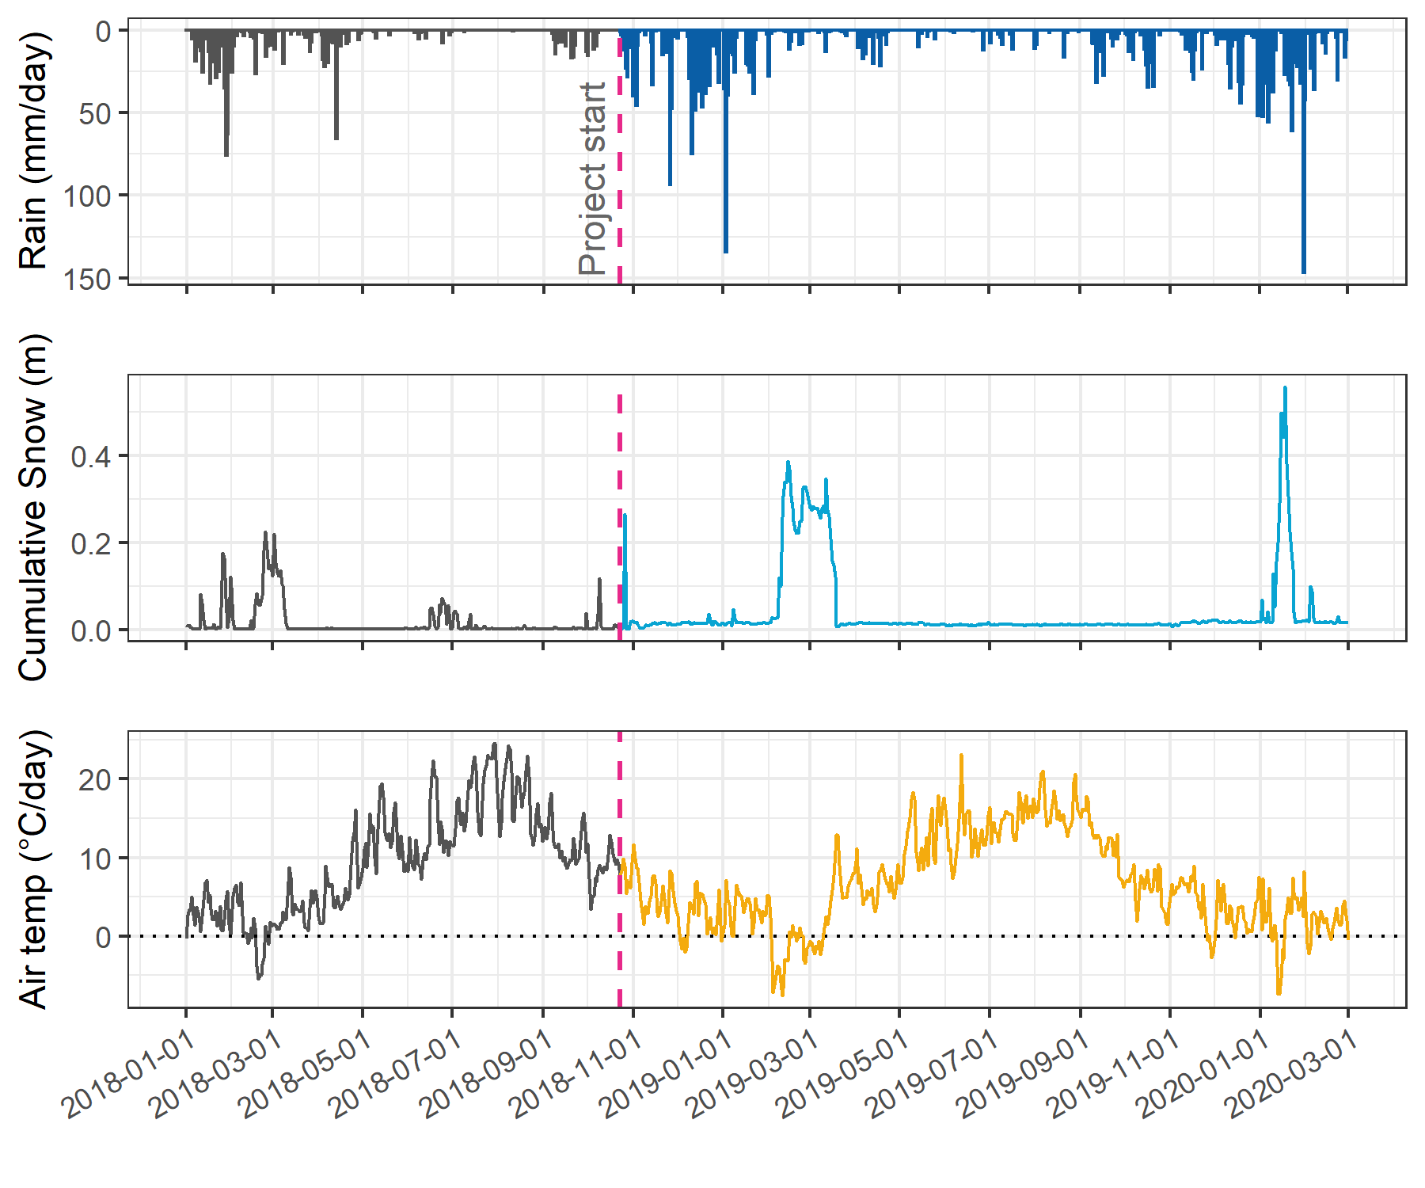

Figure 4: Mean daily air temperature, rain and accumulated snow from Chris Creek (560 m a.s.l) and Martin’s Gulch (512 m a.s.l) fire-weather stations in the Leech Water Supply Area, where the coloured sections following the dashed ‘Project Start’ line indicate data from the study period.

On average, October 2018 through to February 2020 (the study period) was warmer (0.56° C) and drier (7.5 mm/month or 13.4%) than historical (1971-2000) climate normals (PCIC (2020); see Appendix B1 for full details).

#### Seasonal delineation and Rack sample collection

A total of 18 rain events were captured using Rack samplers. Events were defined as 50 mm and larger, with a period of at least 14 hours between 50 mm rain accumulation (Table 6).

Table 6: Rain events where Vertical Rack samples were collected along the rising hydrograph limb of the event (corresponding to a threshold of 50 mm accumulation with 14-hour inter-event period)

|  |  |  |  |  |  |
| --- | --- | --- | --- | --- | --- |
| Major event no. | Start Date | Duration (days) | Intensity (mm/24-hr) | Rainfall (mm) | Percent of total rain for the study period |
| 1 | 2018-10-27 | 6.1 | 20.2 | 124 | 3.8 % |
| 2 | 2018-11-03 | 0.9 | 60.5 | 55 | 1.7 % |
| 3 | 2018-11-25 | 3.6 | 43.9 | 156 | 4.8 % |
| 4 | 2018-12-09 | 4.9 | 41.6 | 205 | 6.3 % |
| 5 | 2018-12-15 | 6.2 | 29.4 | 182 | 5.6 % |
| 6 | 2018-12-22 | 2.4 | 22.4 | 55 | 1.7 % |
| 7 | 2019-01-02 | 4.2 | 54.2 | 228 | 7 % |
| 8 | 2019-01-17 | 3.0 | 22.8 | 69 | 2.1 % |
| 9 | 2019-09-12 | 3.1 | 18.8 | 58 | 1.8 % |
| 10 | 2019-10-15 | 6.4 | 21.3 | 136 | 4.2 % |
| 11 | 2019-11-15 | 2.3 | 29.1 | 68 | 2.1 % |
| 12 | 2019-12-10 | 3.1 | 22.8 | 70 | 2.2 % |
| 13 | 2019-12-18 | 4.1 | 27.7 | 112 | 3.5 % |
| 14 | 2019-12-31 | 2.0 | 28.9 | 57 | 1.8 % |
| 15 | 2020-01-02 | 5.7 | 31.7 | 180 | 5.5 % |
| 16 | 2020-01-18 | 9.9 | 24.0 | 238 | 7.3 % |
| 17 | 2020-01-30 | 1.9 | 111.3 | 209 | 6.4 % |
| 18 | 2020-02-05 | 3.4 | 22.4 | 76 | 2.3 % |

Stream response was primarily driven by major rain events (Table 6); however, there was a period of snowfall (winter of 2018/2019) when rainfall runoff subsided and melt generated streamflow response across the monitoring sites. That period of snow accumulation and melt was included in the 2018/2019 wet season, despite the lack of major rain events (Figure 5). The 2018/2019 wet season, which was 26% drier (26 mm/mo) and 0.48° C warmer than normal on average, extended from the start of the project (October 2018) to mid-May 2019 with snowmelt primarily contributing to streamflow in the Leech WSA during the period from late January (event 8, Table 6) to mid-May 2019. The dry sampling season spanned from mid-May to late-September 2019 and was, on average, 1.4% wetter (6.4 mm/mo) and 0.94° C warmer than normal, though September 2019 was 132% wetter than normal (PCIC 2020). The 2019/2020 wet season began mid-September (event 9, Table 6) and extended to the end of the field study period (Feb 20, 2020). Overall, the 2019/2020 wet season was 5% drier than normal on average, but January 2020 was 136% wetter than normal [PCIC (2020); Appendix B1].

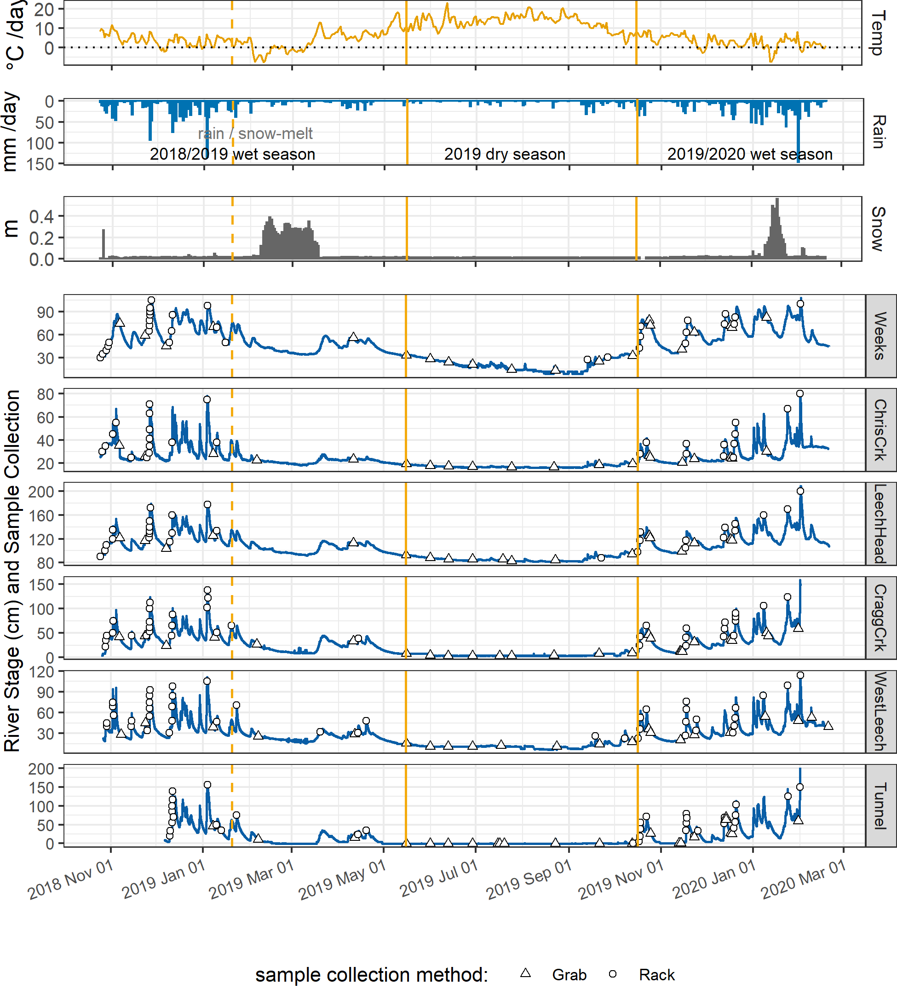

Figure 5: Leech Water Supply Area air temperature, rain and snow depth (CRD 2020) plotted with stream responses and sample collection at six monitoring sites. Vertical yellow lines indicate seasons, distinguished by rising limb Vertical Rack sampling (wet season). The dashed yellow line shows the 2018/2019 wet season separation of rain and rain/snowmelt dominated streamflow.

#### Collaborative analyses for treatability and metals

Relationships between DBP-FPs with DOC, SUVA254, E2:E3, and SAC254 (Figure 6, see Appendix C1 for full details) revealed that SAC254 was the best indicator of NOM reactivity with respect to DBP-FPs. Results from two sets of samples at four selected sites (n = 8) revealed that SAC254 was better correlated to most DBP-FPs (r = 0.68, overall) than was SUVA254 (r = 0.36) or DOC (r = 0.50). E2:E3 was not well correlated to DBP-FPs (not shown in Figure 6).

In particular, SAC254 was well correlated with total trihalomethanes (THM, r = 0.9882) including trichloromethane (TCM, r = 0.9869); total haloacetic acids (HAAs, r = 0.9927), including dichloroacetic acid (DCAA, r = 0.9945) and trichloroacetic acid (TCAA,r = 0.9900). SAC254 was only weakly correlated to bromodichloromethane (BDCM, r = 0.6539). Based on these results, SAC254 was included as an indicator of aromatic NOM reactivity, and SUVA254 was omitted from analyses. E2:E3 was used as an (inverse) indicator of aqueous NOM aromaticity and molecular size (Peuravuori and Pihlaja 1997; Helms et al. 2008).

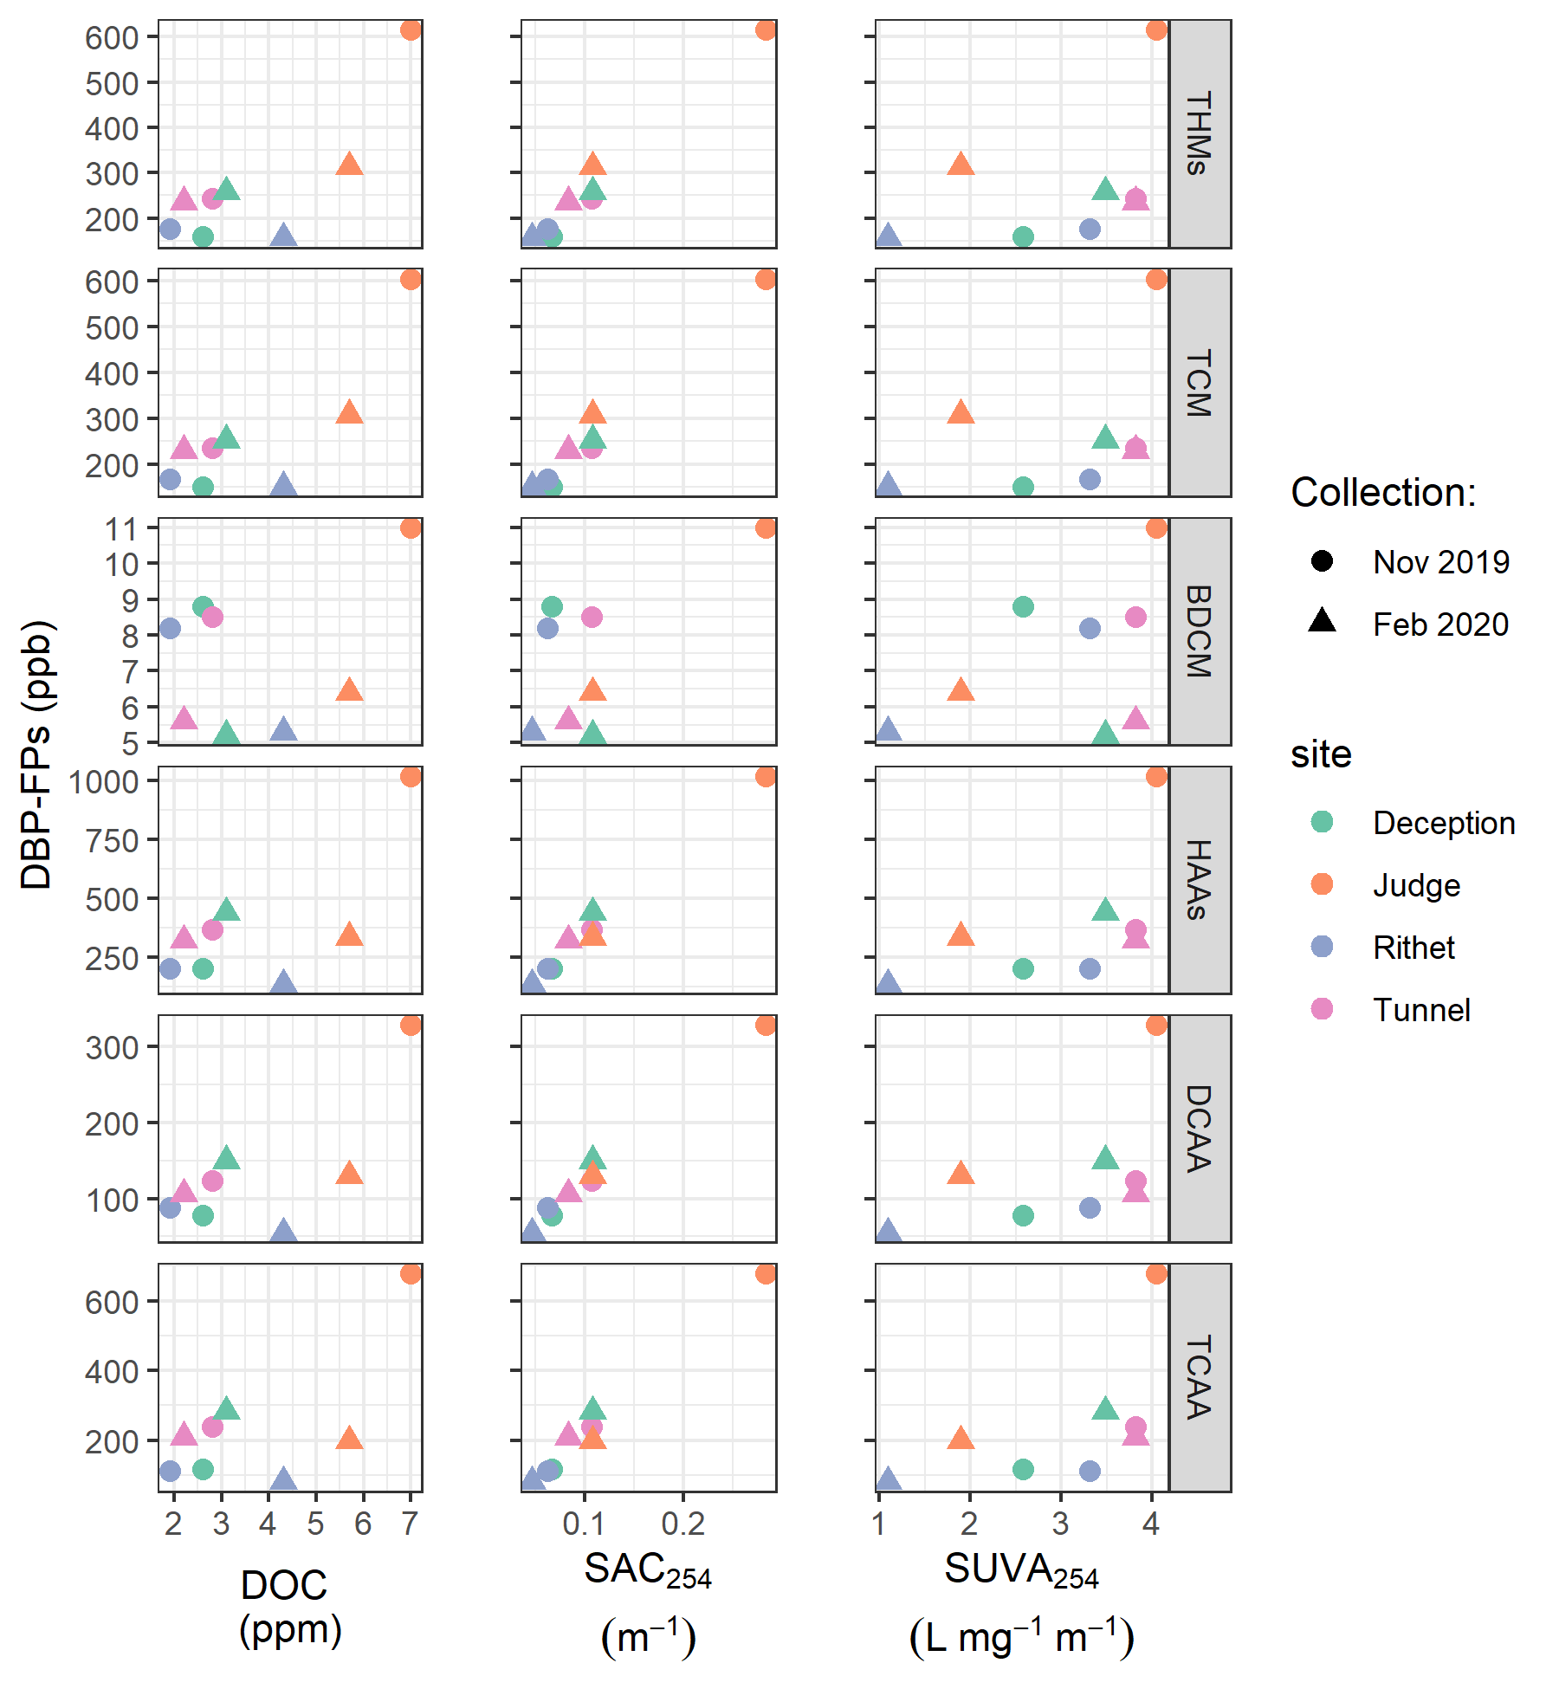

Figure 6: Disinfection by-product formation potentials (DBP-FPs) with dissolved organic carbon (DOC, left column), spectral absorbance coefficient at 254 nm (SAC254) and specific UV absorbance at 254nm (SUVA254). Duplicate samples collected at four sites in the Leech WSA on two occasions. DBPs include: total trihalomethanes (THM), trichloromethane (TCM), bromodichloromethane (BDCM), total haloacetic acids (HAAs), dichloroacetic acid (DCAA), trichloroacetic acid (TCAA). Below levels of detection (thus not shows here) were DBP-FP results for tribromomethane (TBM), dibromoacetic acid (DBAA), dibromochloromethane (DBCM), monochloroacetic acid (MCAA), monobromoacetic acid (MBAA).

Evaluation of DOC in relation to metals data provided by the CRD (see Appendix C2 for details and results plots) showed that DOC was positively correlated with aqueous total mercury (r = 0.9999), iron (r = 0.8326), manganese (r = 0.7706), and aluminum (r = 0.6297). While the relationships were not strong, DOC was also positively related to concentrations of barium (r = 0.4745), copper (r = 0.4198), and arsenic (r = 0.3335). Based on these results, it seems apt to consider DOC a master variable linked to metals transport (Appendix C2) and reinforces the importance of monitoring DOC concentration in source water supply.

#### Vertical Rack sampling quality assurance

##### Trail cameras and circulating dye-test

Trail cameras installed at four of the six monitoring sites provided observations of streamflow during Rack sample collection. Images (captured every 15 minutes) showed highly turbulent flows across rising limb stages (Figure 7). Therefore, the assumption that Vertical Rack samples were collected from well-mixed, un-stratified water was accepted.

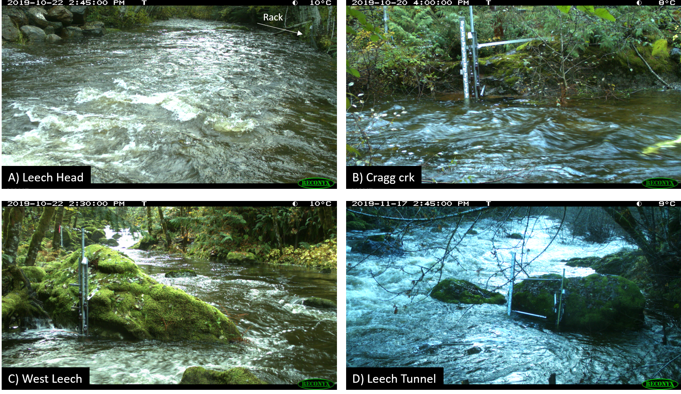

Figure 7: Trail camera images from four of the six Leech WSA monitoring sites showing turbulent flows upstream of and around Vertical Rack installations, satisfying the assumption of well-mixed water columns.

Discrete sample collection was validated in the lab using food colouring and a flow-through bucket system. A siphon sampler bottle was submerged in a container filled with circulating tap water; following siphon sample collection, food colouring was added to the system and circulated for 15 minutes, then the sample bottle was removed from this dye chamber and the colour of the sample inside the siphon bottle was visually compared to the dyed water that had circulated around it. This test was repeated five times with different siphon-lid bottles. There was no dye present in any of the siphon sample bottles following the tests. Thus, the assumption of discrete siphon sample collection was accepted.

##### Hold-time experiments

Hold-time experiments included three sets of ten samples, each set compared five samples held on the Vertical Rack (“held”) to five replicate samples analyzed immediately after collection (“fresh”). For each set (set ‘A’, ‘B’ and ‘C’), the number of days that samples remained held on the Rack were used with air temperatures during the hold-period to assess Rack sample stability (Figure 8). Results were used to flag data as suspect or acceptable for inclusion in further data analysis.



Figure 8: Air temperature and sample hold-times for three sets of stream water samples from Vertical Rack hold-time experiments. Red horizontal lines indicate the 0-7°C range of a typical laboratory refrigerator and dashed vertical lines separate the three sets (A, B, C) of hold-time experiment samples. The period of each set starts with the collection of five ‘fresh’ samples (analyzed after collection) and ends with the retrieval of five ‘held’ samples (kept in the field on a Vertical Rack). Held samples from Set A were on the Rack for 11 days; Set B, 20 days; and Set C, 34 days. These hold-time experiments were conducted at the Leech Tunnel monitoring site, Leech water supply area, Greater Victoria, BC.

All samples were analyzed to quantify DOC and characterized NOM properties and hold-time set results of fresh and held samples were compared using two-sided paired Wilcoxon signed rank tests (Table 7).

Table 7: Results comparing three Vertical Rack hold-time experiment sets for sample stability in the field

|  |  |  |  |  |  |  |  |  |
| --- | --- | --- | --- | --- | --- | --- | --- | --- |
| Set | Days held | Air temp. | DOC change (%) | p-value (DOC) | SAC254 change (%) | p-value (SAC254) | E2:E3 change (%) | p-value (E2:E3) |
| A | 11 | 7.1 ± 2.2 | -45* | 0.0625 | 0 | 0.1250 | -1 | 0.1250 |
| B | 20 | 6.0 ± 2.7 | 1 | 0.4375 | -8* | 0.0625 | 0 | 0.8125 |
| C | 34 | 4.3 ± 3.2 | -23 | 0.1875 | -34* | 0.0625 | -14* | 0.0625 |

*Note:* one star (*) indicates significant difference at 90% confidence (p < 0.1), two stars (**) indicates significant difference at 95% confidence (p < 0.05)

There was a significant change in DOC concentration (at 90% confidence, p-value = 0.063) for hold-time set A, where mean DOC concentration was 45% lower in the held samples (4.2 ± 0.1 mg/L) compared to the fresh samples (7.54 ± 0.04 mg/L). Despite a change in concentrations, there was no change in NOM character as measured by SAC254 or E2:E3. Samples collected for hold-time set A were DOC-rich “first flush” samples (i.e. the first sampling event of a wet season), and the held samples were on the Vertical Rack for 11 days at average temperature of 7° C (slightly above laboratory refrigerator temperatures).

Set B had a hold-time of 20 days with average air temperature of 6° C. There were no significant changes to DOC concentrations between fresh (5.4 ± 0.1 mg/L) and rack-held samples (5.5 ± 0.1 mg/L). Set B also showed no significant change in E2:E3 values (4.58 ± 0.06 compared to 4.6 ± 0.2). Wilcoxon tests for set B showed that the 8% change in SAC254 was statistically significant (at 90% confidence). However, the SAC254 difference in set B was determined to be caused by an outlier which could be rejected with 99% confidence by Dixon’s Q-test (Qexp = 0.941 > Qcrit = 0.821). Therefore, it was concluded that, despite the measured difference (Figure 9, Table 7) there was no meaningful change in SAC254 for hold-time set B.

Hold-time set C included samples held for 34 days at an average of 4.4° C, including a period of sub-zero temperatures. While set C did not yield statistically significant changes in DOC concentration from fresh (3.3 ± 0.2 mg/L) to held (3 ± 1 mg/L) samples, the relative standard deviation (RSD) for DOC increased from 5% in the fresh samples to 43% in the held samples. Although the 23% reduction in set C samples was not deemed to be statistically significant, the nearly nine-fold increase in RSD from fresh to held samples DOC indicates an important change in concentrations for set C (Figure 9). Additionally, there were significant changes to SAC254 (p = 0.0625; 34% decrease in absorbance, from 14 ± 2 m-1 to 9 ± 2 m-1), and E2:E3 (p = 0.0625; 14% decrease, from 4.5 ± 0.2 to 3.9 ± 0.2). In addition to the changes in spectral properties, set C held samples had greater variability compared to the fresh sample counterparts (Figure 9).



Figure 9: Comparison of three hold-time experiment sets, contrasting ‘fresh’ and ‘held’ sample results for DOC concentrations, spectral absorbance coefficient at 254 nm (SAC254) and the spectral quotient E2:E3 (SAC250/SAC365).

#### Foundational results summary

A challenge of Vertical Rack sampling is rapid retrieval of collected samples; delays may arise due to logistics of field access and high water can prohibit safe access to the Rack. Sample hold-times were determined and applied as quality assurance in data analysis. Continuously recorded stage data was coupled with manually recorded siphon-bottle heights to determine date-times of sample collection and to calculate Rack sample hold-times, which were used to flag and filter data.

Results of hold-time experiments showed that early-wet-season (“first flush”) samples contain more labile and aliphatic DOC which is unstable and should be analyzed immediately after collection. Later season samples contained DOC which was relatively more stable for up to and including 20 days when held at field temperatures that mimicked a refrigerator (0° C to 7° C). A hold-time of 34 days with periods of freezing resulted in significant changes to sample NOM molecular character (i.e. aromaticity, molecular size, reactivity) and greater variability in DOC concentrations among replicate samples. Additional tests would be required to determine if changes in NOM character were caused by the length of time the sample was held, or perhaps due only to freezing and thawing, or a combination of both time and temperature. Freezing has been shown to decrease sample DOC concentrations in laboratory experiments (Fellman, D’Amore, and Hood 2008). Based on these results, sample analyses data were updated to include quality-assurance/quality-control (QA/QC) flags which were used to filter sample data, reducing the effective number of samples included in results by less than 10%.

Hold-times were calculated for each sample as the time between sample collection and analysis. Any sample that remained held for fewer than 20 days at temperatures between 0-7° C were flagged as acceptable for further data analysis; Rack samples that were held for 20 days or longer were flagged for exceeding a reliable hold-time; and samples identified as early-wet-season (“first-flush”) that had a hold-time of 7 days or longer (based on logistics of field access) were flagged as unreliable and not included in further data analysis. Because of possible freeze-thaw changes to NOM, any sample that underwent suspected or confirmed freezing was also flagged for temperature effects. Hold-time test experiments indicate that extended time in the field on a Vertical Rack could result in a decrease in DOC but not an increase, therefore no positive bias in DOC result should be suspected from event-based samples.

In future studies, more in-depth ‘discrete sample collection’ validation tests could be performed with similar food colouring and flow-through bucket system. Possible avenues to explore could include pressure effects of mixing for siphon sample bottles submerged at increasing depths, and spectroscopic analysis of water for more precise verification of any sample mixing post-collection. Additional Hold-time tests could also be performed for more refined method development; the primary suggestion for this includes repeated trials with the same hold-time interval (e.g. 10 days) over different weather and stream conditions (e.g. replicate sets in early-, mid-, and late- wet-season).

DOC has been called a master variable for its influence on water chemistry and role in contaminant transport (Stanley et al. 2012; Zarnetske et al. 2018; Ruhala and Zarnetske 2017; Kellerman et al. 2018; LaZerte 1991). This statement was supported by correlations between DOC concentration and aqueous metals in the Leech WSA streams (particularly mercury, iron, manganese and aluminum). Additionally, NOM in drinking source water supply is partially responsible for the formation of disinfection by-products (DBPs) in treated drinking water (Yang et al. 2015; Chow et al. 2008; Beauchamp et al. 2018). As a predictor of DBP-FPs, SAC254 was better correlated than SUVA254 or DOC concentration. These results are in agreement with findings by Chow et al. (2008), and clarified that SAC254 should be used as an indicator of NOM reactivity with respect to DBP-FP, rather than SUVA254.

## Spatial and Temporal Patterns in NOM Quantity and Quality Across the Greater Victoria Water Supply Areas

### Synopsis

The methods defined in Chapter 2 were used to collect and analyze surface water samples across the twelve Greater Victoria water supply area sites (GVWSA, refer to Figure 2 for map). The objective was to describe spatial and temporal patterns (including the influence of seasonality) of natural organic matter (NOM) quantity and molecular quality.

### Methods

All samples were collected by methods described in Chapter 2, and all data were flagged and filtered based on quality assurance described therein. Here, NOM quantity was assessed based on concentrations of dissolved organic carbon (DOC) and NOM quality was indicated by SAC254 (reactivity) and E2:E3 (molecular size and aromaticity).

#### Spatial & temporal patterns

Synoptic sample results were evaluated for spatial patterns by comparing low- to high-order streams, between the Leech and Sooke portions of the GVWSA, and by sampling methods at upstream and downstream sites. To assess temporal patterns, synoptic sampling results were evaluated over the full study period (Oct 2018 to Feb 2020). To detect possible changes in NOM character, the relationship between DOC and SAC254 was explored in context of seasons.

Water quality monitoring is generally completed as synoptic sampling, but perhaps monitoring programs could be simplified by installing a Vertical Rack downstream of the confluence of nested catchments. A method evaluation was completed to assess whether the combination of Rack and Grab sampling below a confluence captured the same range in DOC as Grab sampling at multiple upstream sites. Headwater sub-basins of Leech River and Cragg Creek, and three nested catchments above the Leech River Tunnel were examined. The Leech Tunnel is the effective outlet of the Leech WSA, where runoff from each nested catchment is integrated. From a headwater’s perspective, runoff from the sub-basins of Weeks Creek and Chris Creek is integrated at the Leech-head site; and runoff from Jarvis and Lazar Creek sub-basins is integrated at the Cragg Creek site (Figure 2). At each of these three site groupings, results from upstream Grab samples were compared to downstream Rack and Grab sample results combined. Results were compared using Levene’s test for homoscedasticity (homogeneity of variance).

For shorter scale temporal pattern assessment, rising limb event-based Rack samples from the six monitoring sites in the Leech WSA were compared to non-rising limb sample results (i.e. standard Grab samples). As Vertical Racks only collected samples during the wet season, wet season sample results were isolated and evaluated.

### Results

From October 2018 to February 2020, across the GVWSA 426 river samples were collected and analyzed for DOC, and 318 of those samples were analyzed by UV-Vis for NOM character assessment (Table 8). Fewer samples were analyzed for UV-Vis properties than for DOC concentration due to method evolution at the start of the project and constraints in instrument availability. Of the samples collected and analyzed, DOC data were reduced by 9.2% (to 387 samples) during hold-time quality control checks (described in Chapter 2). UV-Vis data were reduced by 19.5% (to 256 samples) through hold-time quality control (9% reduction in UV-Vis data) and, unfortunately, an additional 10.5% was lost during instrument maintenance. Analysis of calibration verification standards resulted in an average analytical accuracy of 10% (*n* = 20).

Table 8: Summary of samples collected, and number included in data analysis following quality assurance filtering based on sample hold-times, turbidity and algae

|  |  |  |  |  |
| --- | --- | --- | --- | --- |
| type of sample collected | total collected & analyzed for DOC | data included in DOC results | total collected & analyzed for NOM | data included in NOM results |
| synoptic Grabs outside of monitoring sites | 48 | 48 | 42 | 42 |
| opportunistic Grabs | 22 | 21 | 12 | 11 |
| monitoring sites synoptic Grabs | 153 | 148 | 114 | 103 |
| monitoring sites vertical Rack | 203 | 170 | 150 | 100 |
| total | 426 | 387 | 318 | 256 |

Mean DOC across the GVWSA was 6.1 mg/L (± 43%), which included the rising limb samples collected in the Leech WSA. This average concentration was similar to Malcolm Knapp Research Forest, near Maple Ridge on the lower mainland (near Vancouver, BC), where a forested basin (0.97 km2) had a mean baseflow DOC concentration of approximately 4.5 mg/L with ~2 mg/L increase during events (Mistick 2019).

#### Spatial patterns in NOM quantity and quality

From 366 quality-controlled river water samples collected over 16 months, DOC ranged from 1.6 to 19.1 mg/L (5.7 mg/L median) with mean DOC of 6.1 ± 2.9 mg/L overall. The relative standard deviation (RSD = std.dev/mean) for DOC in each of the synoptically sampled sites was at least 24% and at most 71%.

The headwaters sites of Weeks creek (11.52 km2 sub-basin) and Jarvis creek (1.51 km2 sub-basin) had the highest DOC concentrations of the twelve sampling sites (means of 9.9 mg/L (*n* = 49) and 9.7 mg/L (*n* = 12), respectively). The lowest DOC concentrations were recorded at the sampling sites of the Rithet Creek sub-basin (11.12 km2) and the Leech Tunnel sub-basin (95.3 km2) and their means (5.4 mg/L (*n* = 13) and 4.8 mg/L (*n* = 64), respectively) were not unlike other streams of 3rd order or above (overall average 5.18 mg/L). The greatest range in DOC concentrations was measured at the Rithet Creek site which had a relative standard deviation (RSD) of 71%. The site with the second highest DOC range was the West Leech sub-basin (20.85 km2) with mean DOC of 5.8 ± 2.4 mg/L (41% RSD). Between these two sites with the highest DOC variance, the West Leech (a monitoring site) was more heavily sampled (*n* = 57) than Rithet (*n* = 13), which was a synoptic sampling site alone (Table 9).

Table 9: Dissolved organic carbon concentrations (DOC) across twelve synoptically sampled sites in the Greater Victoria Water Supply Area

|  |  |  |  |  |  |  |  |  |
| --- | --- | --- | --- | --- | --- | --- | --- | --- |
| Site | Description | n | Mean DOC (mg/L) | sd (±) | Relative sd (± %) | Min. DOC (mg/L) | Median DOC (mg/L) | Max. DOC (mg/L) |
| Weeks | headwater of Leech Rv., LWSA | 49 | 9.9 | 3.4 | 34 | 3.78 | 9.7 | 19.1 |
| ChrisCrk | headwater of Leech Rv., LWSA | 42 | 4.9 | 2.1 | 42 | 1.84 | 4.7 | 9.2 |
| LeechHead | mainstem river, LWSA | 44 | 7.2 | 1.7 | 24 | 3.95 | 6.9 | 11.6 |
| Jarvis-crk | headwater of Cragg Crk., LWSA | 12 | 9.7 | 2.9 | 30 | 5.92 | 9.7 | 16.7 |
| Lazar-crk | headwater of Cragg Crk., LWSA | 9 | 6.3 | 1.7 | 27 | 3.69 | 6.5 | 8.6 |
| CraggCrk | mainstem river, LWSA | 62 | 4.7 | 1.5 | 33 | 1.79 | 4.4 | 8.2 |
| WestLeech | mainstem river, LWSA | 57 | 5.8 | 2.4 | 41 | 2.00 | 5.5 | 10.9 |
| Leech-Beach | below confluence of WestLeech with Leech Rv. | 3 | 4.7 | 1.2 | 26 | 3.27 | 5.1 | 5.6 |
| Tunnel | inlet of Leech Tunnel, LWSA outlet | 64 | 4.8 | 1.8 | 39 | 1.65 | 5.0 | 9.0 |
| Rithet-crk | key tributary to Sooke Reservoir, SWSA | 13 | 5.4 | 3.9 | 71 | 1.64 | 3.5 | 12.7 |
| Judge-crk | key tributary to Sooke Reservoir, SWSA | 6 | 5.7 | 1.1 | 20 | 4.42 | 5.3 | 7.6 |
| Deception | outlet of Leech Tunnel, SWSA | 5 | 4.2 | 1.8 | 43 | 2.16 | 4.1 | 7.0 |
| all sites | summary | 366 | 6.1 | 2.9 | 48 | 1.64 | 5.7 | 19.1 |

Mean DOC concentrations were similar between the Sooke WSA main tributaries to Sooke Reservoir: Judge Creek (5.7 ± 1.1 mg/L, *n* = 6) and Rithet Creek (5.4 ± 3.9 mg/L, *n* = 13). Though these three sites were sampled over the same span of time, the number of samples collected at the Tunnel (*n* = 64) was much greater due to less intense focus on the Sooke WSA and Vertical Rack sampling at the Leech Tunnel. Therefore, only overlapping sample dates were evaluated between these three sites to facilitate a preliminary WSA comparison between Sooke WSA main tributaries and the future supplemental supply (Table 10). Mean DOC was similar between Rithet Creek (3.2 ± 1.4 mg/L, *n* = 8) and the Leech Tunnel (3.7 ± 1.1 mg/L, *n* = 9), but higher at Judge Creek (5.7 ± 1.1 mg/L, *n* = 6).

Table 10: Comparing dissolved organic carbon concentrations (DOC) among synoptic grab samples collected on the same day at three sites in the Greater Victoria Water Supply Area: two main tributarites to Sooke Reservoir and the Leech River at the Tunnel

|  |  |  |  |  |  |  |  |  |
| --- | --- | --- | --- | --- | --- | --- | --- | --- |
| Site | Description | n | Mean DOC (mg/L) | sd (±) | Relative sd (± %) | Min. DOC (mg/L) | Median DOC (mg/L) | Max. DOC (mg/L) |
| Tunnel | inlet of Leech Tunnel, LWSA outlet | 9 | 3.7 | 1.1 | 29 | 1.74 | 3.7 | 5.3 |
| Rithet-crk | key tributary to Sooke Reservoir, SWSA | 8 | 3.2 | 1.4 | 44 | 1.64 | 2.8 | 6.3 |
| Judge-crk | key tributary to Sooke Reservoir, SWSA | 6 | 5.7 | 1.1 | 20 | 4.42 | 5.3 | 7.6 |

Spatially, DOC generally decreased from low-order headwater streams to higher-order downstream sites (Figure 10). Like DOC concentration, there was an overall reduction in aromaticity, reactivity, and molecular size of NOM from upstream to downstream sites (Table 11, Figure 10). The greatest diversity in NOM reactivity, measured by SAC254, were recorded in headwater samples from Chris Creek (50% RSD), Jarvis Creek (47% RSD) and Lazar Creek (45% RSD). The site with the greatest average reactivity, aromaticity and molecular weight NOM was Weeks Creek (mean SAC254 30.3 m-1, mean E2:E3 4.3 ± 0.2).

The lowest absolute measurement for NOM aromaticity, molecular size and reactivity occurred at the Cragg Creek site (maximum E2:E3 of 5.03, minimum SAC254 4.69 m-1). Cragg Creek also had among the lowest mean aromaticity and molecular weight NOM (E2:E3 of 4.59 ± 0.22), though it was very similar to Judge Creek (E2:E3 of 4.59 ± 0.05). Unlike Cragg Creek’s low aromaticity and molecular weight NOM, it’s headwater sites (Jarvis and Lazar) had samples with highly aromatic and reactive NOM character. Jarvis Creek had the most reactive NOM sample (max SAC254 41.7 m-1) and the other headwater creek in Cragg basin, Lazar Creek, had one of the most aromatic samples of all (lowest recorded E2:E3, 3.77). Lazar Creek sub-basin had the greatest proportion of wetlands (12% by area), and had the greatest range in NOM aromaticity and molecular size (E2:E3 values with 9% RSD); despite having one of the most aromatic samples of all, Lazar Creek also had the lowest average aromatic NOM (Table 11, Figure 10). Algae blooms were observed in the dry-season and early wet season (Appendix A2) in Jarvis Creek, Lazar Creek and Cragg Creek, as well as other small streams draining the east side of Survey Mountain (the ridge separating Leech River headwater sub-basins from Cragg Creek headwater sub-basins).

Table 11: Spectral properties of natural organic matter (NOM) character across twelve synoptically sampled sites in the Greater Victoria Water Supply Area

|  |  |  |  |  |  |  |  |  |  |  |  |  |
| --- | --- | --- | --- | --- | --- | --- | --- | --- | --- | --- | --- | --- |
| Site | Description | Count | SAC254 Mean (m-1) | stdev (±) | RSD (± %) | SAC254 Min. (m-1) | SAC254 Max. (m-1) | E2E3 Mean (unitless) | stdev (±) | RSD (± %) | E2E3 Min. | E2E3 Max. |
| Weeks | headwater of Leech Rv., LWSA | 28 | 30.3 | 8.5 | 28 | 12.49 | 39.82 | 4.27 | 0.19 | 5 | 3.80 | 4.73 |
| ChrisCrk | headwater of Leech Rv., LWSA | 33 | 13.5 | 6.7 | 50 | 5.68 | 30.72 | 4.42 | 0.24 | 5 | 3.92 | 4.98 |
| LeechHead | mainstem river, LWSA | 31 | 21.3 | 7.9 | 37 | 7.04 | 29.03 | 4.38 | 0.13 | 3 | 4.15 | 4.72 |
| Jarvis-crk | headwater of Cragg Crk., LWSA | 10 | 26.1 | 11.7 | 45 | 13.26 | 41.66 | 4.45 | 0.24 | 5 | 3.94 | 4.86 |
| Lazar-crk | headwater of Cragg Crk., LWSA | 7 | 10.6 | 5.0 | 47 | 5.18 | 16.98 | 4.55 | 0.43 | 9 | 3.77 | 4.95 |
| CraggCrk | mainstem river, LWSA | 44 | 14.4 | 5.5 | 38 | 4.69 | 24.87 | 4.59 | 0.22 | 5 | 3.98 | 5.03 |
| WestLeech | mainstem river, LWSA | 29 | 15.7 | 6.4 | 41 | 5.20 | 31.18 | 4.31 | 0.24 | 5 | 3.99 | 4.94 |
| Leech-Beach | below confluence of WestLeech with Leech Rv. | 3 | 12.3 | 2.7 | 22 | 10.39 | 14.17 | 4.35 | 0.16 | 4 | 4.25 | 4.53 |
| Tunnel | inlet of Leech Tunnel, LWSA outlet | 34 | 16.9 | 5.6 | 33 | 5.18 | 27.49 | 4.41 | 0.21 | 5 | 3.92 | 4.91 |
| Rithet-crk | key tributary to Sooke Reservoir, SWSA | 11 | 9.4 | 2.4 | 26 | 6.85 | 14.62 | 4.39 | 0.33 | 7 | 3.95 | 4.85 |
| Judge-crk | key tributary to Sooke Reservoir, SWSA | 5 | 15.3 | 3.4 | 22 | 12.30 | 20.59 | 4.59 | 0.05 | 1 | 4.53 | 4.63 |
| Deception | outlet of Leech Tunnel, SWSA | 5 | 10.7 | 2.9 | 27 | 7.70 | 14.69 | 4.49 | 0.20 | 4 | 4.31 | 4.72 |
| all sites | summary | 240 | 16.9 | 8.4 | 50 | 4.69 | 41.66 | 4.42 | 0.24 | 5 | 3.77 | 5.03 |

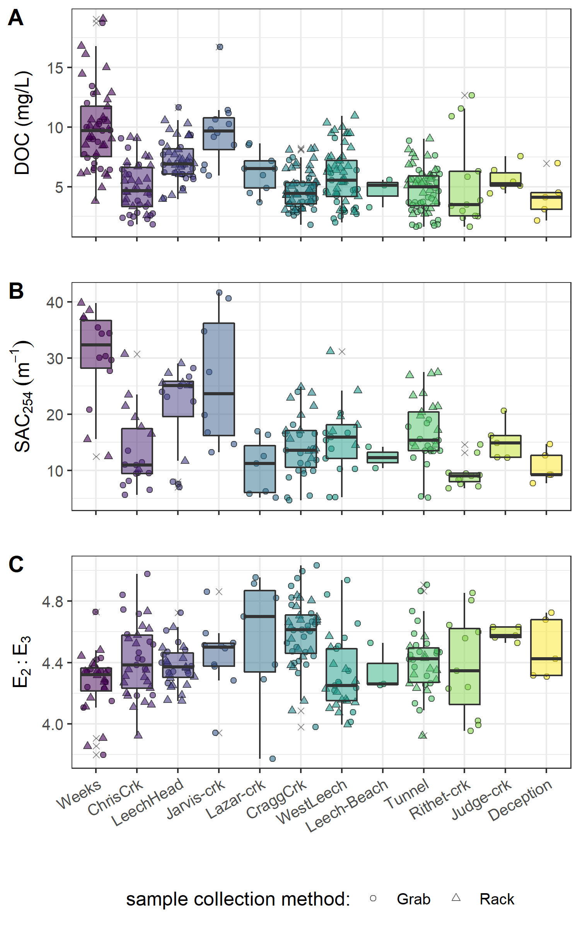

Figure 10: Synoptic sampling results of dissolved organic carbon (DOC) concentrations, SAC254 and E2:E3 from 12 sites (arranged left to right from upstream to downstream). Samples were collected from Oct 2018 to Feb 2020. Symbol type indicates samples were collected by siphon samplers on Vertical Racks (triangle) or synoptic Grab sample (circle), outliers are indicated with an ‘x’.

##### Sampling for variance: method evaluation

Below the confluence of headwaters sites, the combination of Rack and Grab sampling did not capture the ranges of DOC observed in upstream Grab samples alone. Leech-head, below the confluence of Weeks and Chris Creek, collected DOC concentrations that were close to the average of the two headwaters (Figure 11, plot A); the variance obtained by combining Rack and Grab samples downstream was not the same as upstream Grab sampling (Levene’s test for homoscedasticity p-value = 3.8 x 10-5). Similarly, Rack and Grab samples collected at Cragg Creek did not cover the same DOC variance as Grab sampling at the headwaters Jarvis and Lazar Creek (Levene’s p-value 0.0011). Unlike Leech-head, which had near-average DOC concentrations relative to its two headwaters, samples collected at Cragg Creek had lower DOC concentrations than either of its headwater sites (Figure 11, plot B). The differences between these two headwater sets can be attributed to different reach lengths between headwaters’ confluence and the downstream monitoring sites; where Leech-head was very close to the headwaters’ confluence and Cragg Creek was considerably further from its headwaters’ sampling locations.

The combination of Vertical Rack and Grab sampling at the Leech Tunnel captured the same variance in DOC that was observed in standard Grab samples at three upstream sites: Leech-head, Cragg Creek, West Leech (Figure 11, plot C). Levene’s test for homoscedasticity confirmed that there was no difference in DOC variance at the downstream Rack and Grab combination compared to Grab-sampling-only at upstream sub-basins (p-value 0.165). Similar patterns were seen for SAC254 but not E2:E3 (Appendix D).

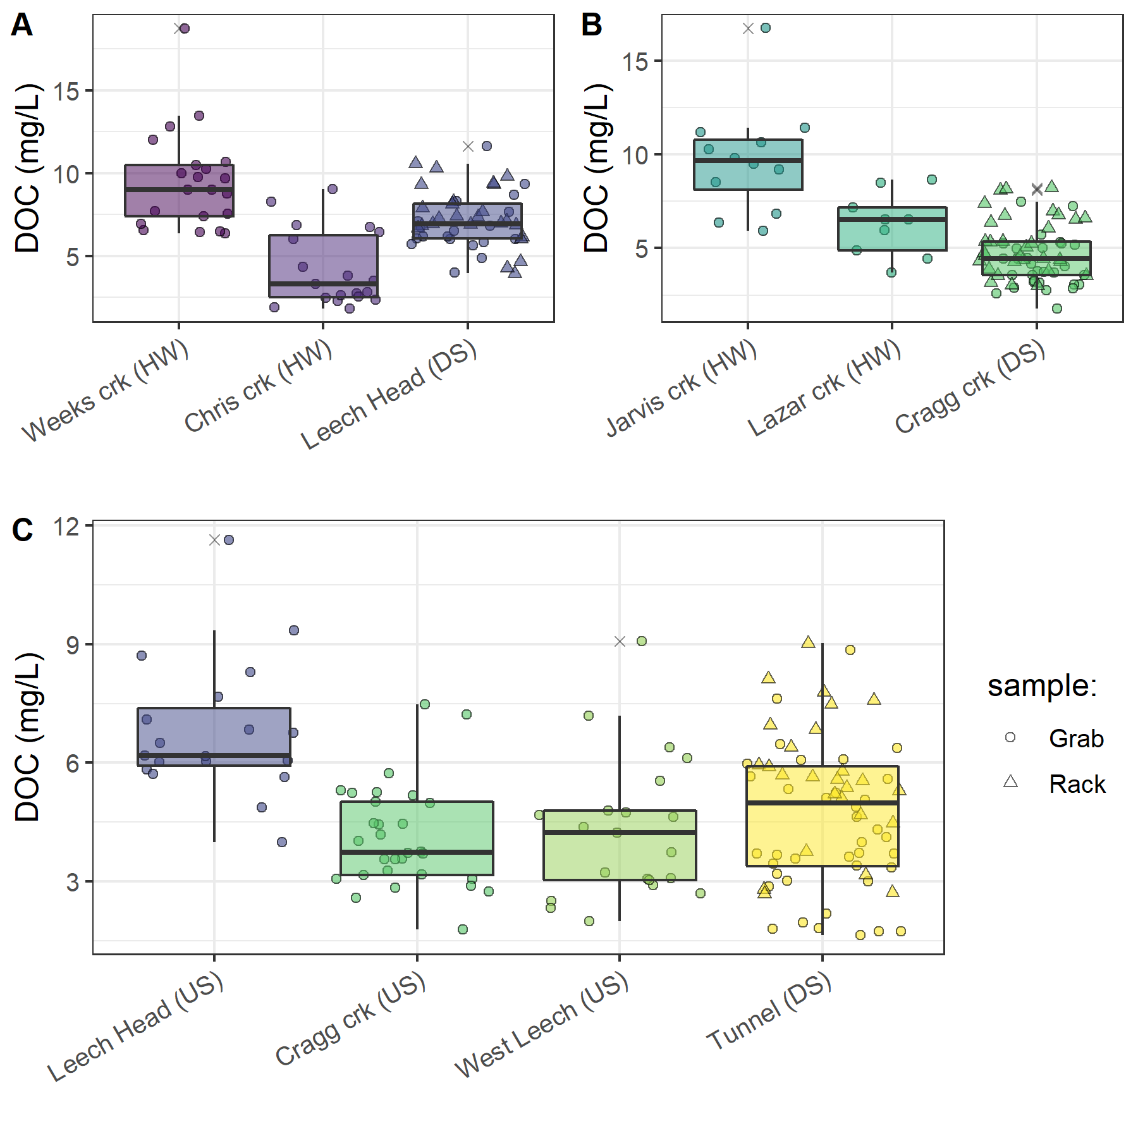

Figure 11: Comparison of dissolved organic carbon concentrations collected by Grab sampling at upstream sites compared to results obtained from both Vertical Rack and Grab sampling below their confluence(s). Plots A and B show Grab samples from headwater (HW) sites compared to Rack & Grab at downstream (DS) monitoring sites. Plot C shows DOC from Grab samples collected at upstream sites (US) compared to Rack & Grab at the mainstem monitoring site.

These results indicate that well-represented water quality monitoring for the Leech WSA could be achieved by implementing event-based Vertical Rack sampling combined with standard Grab sampling at the future point of diversion. In the headwaters, however, Rack sampling combined with Grab sampling at 4th order streams did not capture the DOC variance observed upstream in 3rd order headwater stream Grab samples; likely due to greater NOM variability at headwater streams.

#### Temporal patterns & seasonal changes

From Oct 2018 to Feb 2020, DOC concentrations followed similar patterns across the synoptic sampling sites (Figure 12). DOC was highest early in the wet season and progressively decreased through the fall and winter, reaching minimum concentrations at the end of the wet season (in the spring), and progressively increased over the dry season (summer). These patterns appear as a nearly sinusoidal trend in DOC over the sampling seasons (Figure 12).

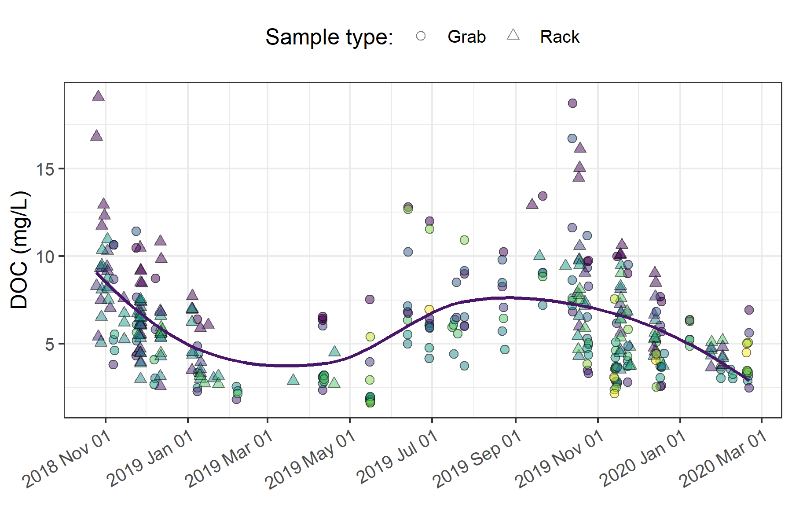

Figure 12: Dissolved organic carbon concentrations over sixteen months (Oct 2018 - Feb 2020) at twelve sites across the Greater Victoria Water Supply Area. Trend line shows locally weighted smoothing (loess method, local polynomial regression). Sampling methods are differentiation by point shape, and different colours indicate different sites.

There were few data points from mid-February through March 2019 (when snow limited field access); however, DOC concentrations were decreasing up to that gap, and were low following it. Thus, the loess trend line in Figure 12, though it includes this data-sparse period, appears to match with the overall pattern observed in available data. Indeed, in each sampling season, mean monthly DOC at each site was loosely correlated (r ≈ 0.52) to mean monthly air temperature (Figure 13), where low temperatures corresponded to low concentrations, and higher concentrations occurring at higher temperatures.

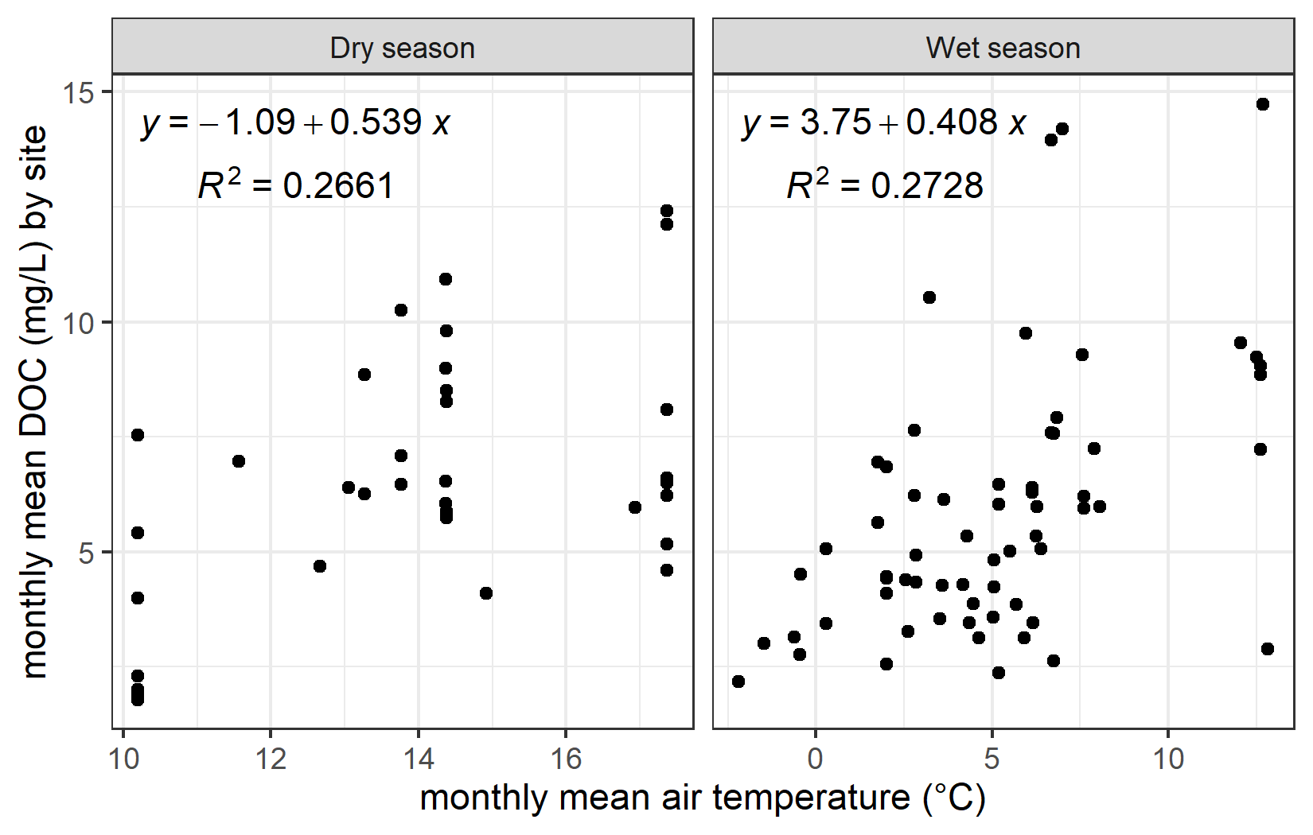

Figure 13: Mean monthly dissolved organic carbon (DOC) concentrations versus mean monthly air temperature at twelve sites across the Greater Victoria Water Supply Area, separated into dry and wet seasons.

Despite fluctuation in DOC concentrations over time, there was almost no difference between mean DOC concentrations during the wet and dry seasons (6.13 mg/L compared to 6.14 mg/L, Table 12). However, there were far fewer DOC samples collected in the dry season (*n* = 55) than during the wet season (*n* = 311). In a similar ratio, there were fewer spectral NOM characteristic samples collected in the dry season (*n* = 25) than wet (*n* = 139). While concentrations remained similar on average over seasons, NOM character was considerably more reactive in the wet season (SAC254 18.33 m-1 ± 44%) than in the dry season (8.99 m-1 ± 63%). With respect to extreme values, wet season samples contained higher minimum and maximum DOC concentrations and SAC254 values (Table 12).

Table 12: Sample Summary by Season for NOM Concentration (DOC) and Character (SAC254) from Twelve Synoptic Sampling Sites Across the Greater Victoria Water Supply Area

|  |  |  |  |  |  |  |  |  |  |  |
| --- | --- | --- | --- | --- | --- | --- | --- | --- | --- | --- |
| Season | DOC sample count | Mean DOC (mg/L) ± RSD (%) | Min. DOC (mg/L) | Median DOC (mg/L) | Max. DOC (mg/L) | SAC254 sample count | Mean SAC254 (m-1) ± RSD (%) | Min. SAC254 (m-1) | Median SAC254 (m-1) | Max. SAC254 (m-1) |
| dry | 55 | 6.13 ± 49% | 1.64 | 6.07 | 12.81 | 25 | 8.99 ± 63% | 4.69 | 7.04 | 27.73 |
| wet | 311 | 6.14 ± 47% | 1.84 | 5.60 | 19.07 | 139 | 18.33 ± 44% | 6.85 | 16.31 | 41.66 |
| overall | 366 | 6.14 ± 48% | 1.64 | 5.70 | 19.07 | 164 | 16.9 ± 50% | 4.69 | 14.87 | 41.66 |

DOC concentration (as NPOC) was well correlated with SAC254 during the wet season (R2 = 0.896, *n* = 149) and during the transition from dry to wet seasons (first-flush event, R2 = 0.916, *n* = 14), but the relationship between DOC concentration and SAC254 was weak during the dry season (R2 = 0.396, *n* = 25). The seasonal discrepancy between NOM concentration and spectral character is indicative of a shift in NOM source pools between seasons, with allochthonous (humic-like, aromatic) sources contributing in the wet season and autochthonous (biolabile algal-derived, aliphatic) sources dominating in the dry season (Figure 14).

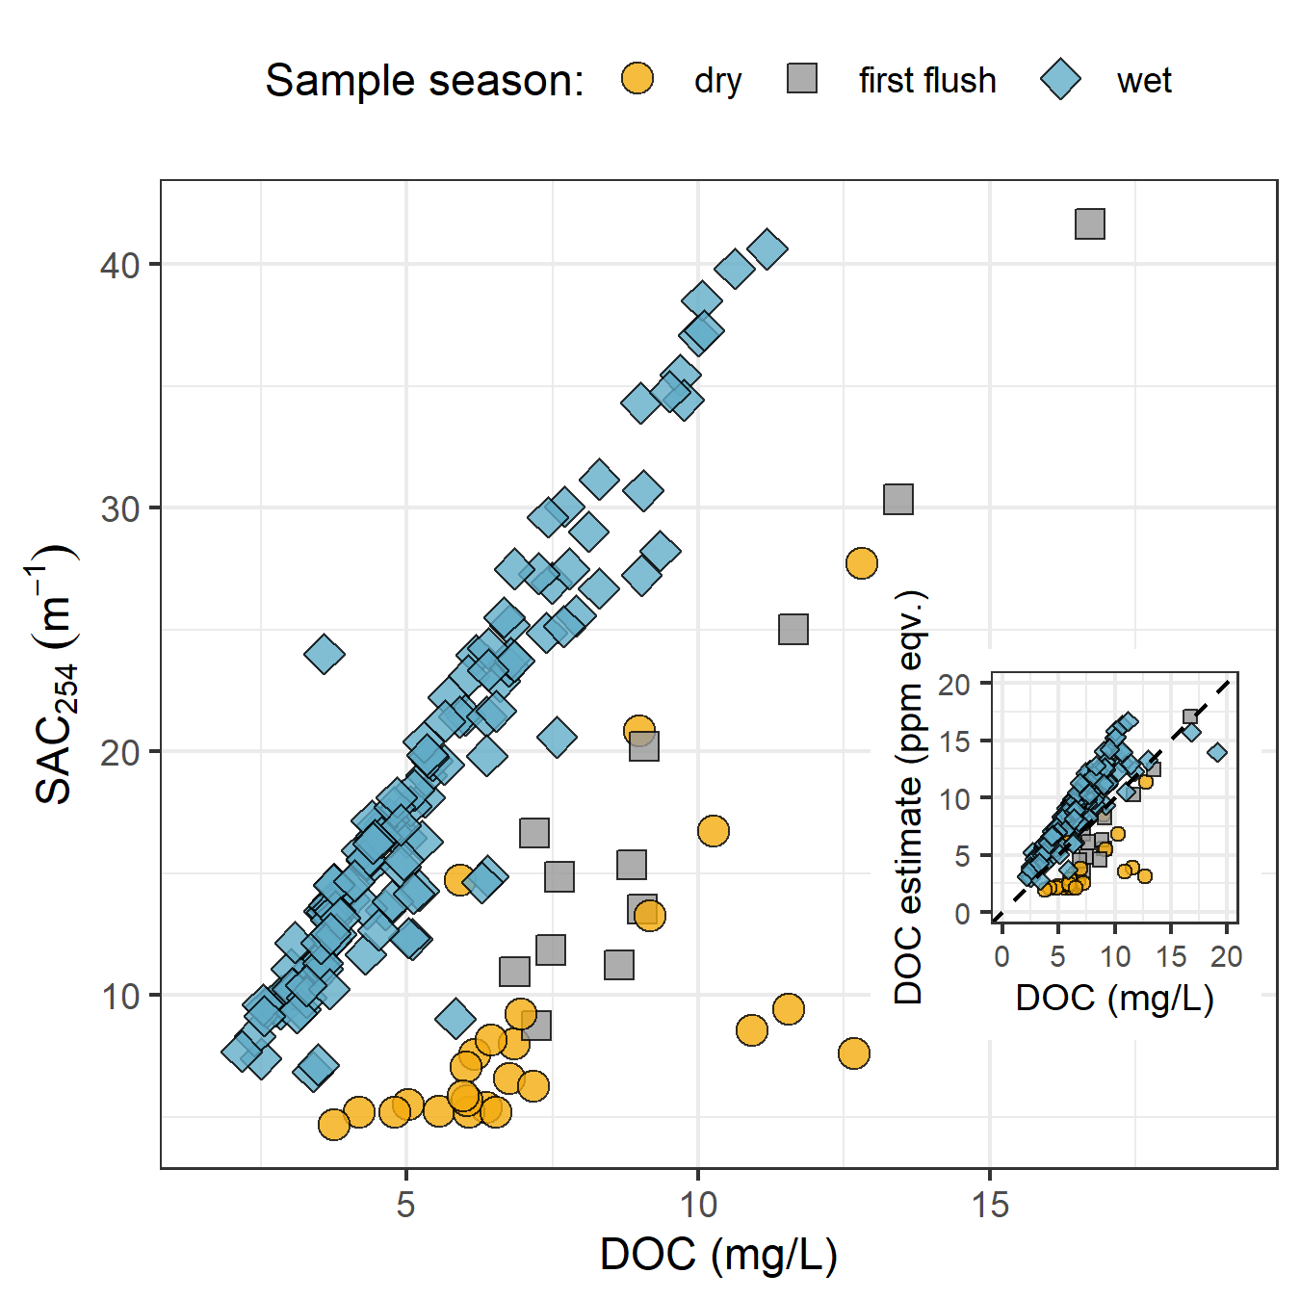

Figure 14: Stream samples collected Oct. 2018 to Feb. 2020 from twelve sites in the Greater Victoria Water Supply Area (B.C) showing seasonal relationships between dissolved organic carbon concentration (DOC) plotted against spectral absorbance coefficient at 254 nm (SAC254, m-1). The inset plot shows DOC (as NPOC) plotted against DOC estimated by the spectro::lyser spectrophotometer through an internal calibration file referenced to SAC254, where the dashed lined indicates best fit (1:1).

The seasonal shift in NOM source pools indicates that if spectral estimates of concentration are used in studies, season-specific and site-based calibrations should be conducted. Results show that wet-season NOM character causes positive bias in absorbance-based DOC estimates and dry-season sample characteristics lead to negative bias in UV-based DOC estimates (inset, Figure 14).

#### Leech WSA spatiotemporal patterns and event-based sampling

Across the six Leech WSA monitoring sites, rising-limb event-based Rack samples contained higher NOM quantities on average than non-rising limb Grab samples (6.8 mg/L compared to 5.2 mg/L DOC; Table 13). Rising limb samples also carried more reactive aromatic NOM (21.37 m-1) than non-rising limb samples (17.03 m-1). A slightly greater variance (relative standard deviation, RSD) in both concentration and character was captured through Grab sampling (±53% DOC and ±44% for SAC254) compared to Rack sampling (±41% DOC and ±32% for SAC254). This suggests that stormflow sustained greater concentrations of more reactive NOM compared to non-event flows which had lower concentrations of less reactive NOM. Overall, average wet season DOC was 6.17 mg/L and average SAC254 was 18.92 m-1 (Table 13). With respect to extremes, rising limb streamflow contained greater quantities of NOM with greater reactivity, captured by samples with higher minimum and maximum DOC concentrations and SAC254 values (Table 12).

Table 13: Wet season NOM quantity (DOC) and reactivity (SAC254) by sample collection method at six monitoring sites in the Leech water supply area

|  |  |  |  |  |  |  |  |  |  |  |
| --- | --- | --- | --- | --- | --- | --- | --- | --- | --- | --- |
| Sample type | DOC sample count | Mean DOC (mg/L) ± RSD (%) | Min. DOC (mg/L) | Median DOC (mg/L) | Max. DOC (mg/L) | SAC254 sample count | Mean SAC254 (m-1) ± RSD (%) | Min. SAC254 (m-1) | Median SAC254 (m-1) | Max. SAC254 (m-1) |
| Grab | 109 | 5.22 ± 53% | 1.84 | 4.37 | 18.74 | 62 | 17.03 ± 44% | 7.39 | 14.64 | 37.07 |
| Rack | 170 | 6.79 ± 41% | 2.59 | 6.39 | 19.07 | 48 | 21.37 ± 32% | 10.25 | 20.82 | 39.82 |
| all | 279 | 6.17 ± 47% | 1.84 | 5.64 | 19.07 | 110 | 18.92 ± 40% | 7.39 | 16.84 | 39.82 |

At all monitoring sites rising-limb Rack samples had higher mean DOC compared to non-rising limb Grab samples (Table 14). Leech-head was the only site where maximum NOM quantity was found in a non-rising-limb sample; at all other sites, peak DOC was obtained on the rising limb of event flows by Rack samplers. Interestingly, rising limb Rack sampling at Weeks Creek captured both the highest and lowest DOC concentrations (minimum of 3.8 mg/L, maximum of 19.1 mg/L).

Four of the six monitoring sites had more reactive NOM in on the rising limb than at other sampled flows. Leech-head and Weeks Creek both had slightly less reactivity NOM in rising-limb samples. These two sites also had higher minimum concentration of DOC collected outside of the hydrograph rising limb, by Grab sample (Table 14). Weeks Creek had the greatest quantity of NOM with the most reactive character of all monitoring sites. Weeks had more variable but less reactive NOM moving through the rising limb of event flows (SAC254 28.7 m-1 ± 47%) compared to other flow conditions (33.0 m-1 ± 9%). A similar pattern was seen downstream at Leech-head, where slightly more variable and less reactive NOM (SAC254 24.04 m-1 ± 26%) occurred in rising limb samples than not (24.92 m-1 ± 8%). The other monitoring sites showed consistently more reactive NOM with greater variance in rising limb event flows (Table 14).

The difference observed at the Weeks Creek and Leech-head sites indicate their event hydrograph rising limbs were more dilute in character due to precipitation inputs while inter-event and lowers flows were sustained by water from the Weeks sub-basin wetlands and lake; water that had more aromatic NOM content.

West Leech showed the greatest difference in DOC collected as Grab samples (4.2 ± 1.9) versus event-based Rack samples (6.7 ± 2.2 mg/L). This suggests that hydrologic pulses in the West Leech sub-basin created considerably different DOC transport than non-stormflow in that sub-basin (Table 14, Figure 15).

Table 14: Wet season stream NOM quantity and quality (as DOC & SAC254, respectively) by sample collection method at each of six monitoring sites in the Leech watershed

|  |  |  |  |  |  |  |  |  |  |  |  |
| --- | --- | --- | --- | --- | --- | --- | --- | --- | --- | --- | --- |
| Site | Sample type | DOC sample count | Mean DOC (mg/L) ± RSD (%) | Min. DOC (mg/L) | Median DOC (mg/L) | Max. DOC (mg/L) | SAC254 sample count | Mean SAC254 (m-1) ± RSD (%) | Min. SAC254 (m-1) | Median SAC254 (m-1) | Max. SAC254 (m-1) |
| Weeks | Grab | 16 | 9.28 ± 35% | 6.38 | 8.88 | 18.74 | 7 | 33.04 ± 9% | 29.62 | 34.31 | 37.07 |
| Weeks | Rack | 28 | 10.25 ± 36% | 3.78 | 9.94 | 19.07 | 5 | 28.73 ± 47% | 12.49 | 37.28 | 39.82 |
| Weeks | overall | 44 | 9.89 ± 36% | 3.78 | 9.44 | 19.07 | 44 | 31.25 ± 28% | 12.49 | 34.37 | 39.82 |
| ChrisCrk | Grab | 14 | 3.62 ± 55% | 1.84 | 2.78 | 9.04 | 8 | 10.34 ± 17% | 7.39 | 10.26 | 13.52 |
| ChrisCrk | Rack | 23 | 5.52 ± 32% | 2.59 | 5.41 | 9.16 | 7 | 19.95 ± 32% | 10.25 | 19.47 | 30.72 |
| ChrisCrk | overall | 37 | 4.8 ± 43% | 1.84 | 4.54 | 9.16 | 37 | 14.83 ± 44% | 7.39 | 11.41 | 30.72 |
| LeechHead | Grab | 13 | 7.13 ± 27% | 4.87 | 6.19 | 11.64 | 7 | 24.92 ± 8% | 22.24 | 25.02 | 28.23 |
| LeechHead | Rack | 25 | 7.45 ± 23% | 3.95 | 7.26 | 10.57 | 6 | 24.04 ± 26% | 11.69 | 25.54 | 29.03 |
| LeechHead | overall | 38 | 7.34 ± 24% | 3.95 | 7.05 | 11.64 | 38 | 24.52 ± 18% | 11.69 | 25.20 | 29.03 |
| CraggCrk | Grab | 24 | 4.1 ± 32% | 2.58 | 3.64 | 7.47 | 16 | 13.39 ± 30% | 8.73 | 12.47 | 24.00 |
| CraggCrk | Rack | 32 | 5.26 ± 29% | 3.00 | 4.91 | 8.22 | 12 | 17.98 ± 25% | 12.13 | 17.10 | 24.87 |
| CraggCrk | overall | 56 | 4.76 ± 32% | 2.58 | 4.45 | 8.22 | 56 | 15.36 ± 31% | 8.73 | 13.89 | 24.87 |
| WestLeech | Grab | 16 | 4.18 ± 45% | 2.33 | 3.47 | 9.08 | 9 | 14.6 ± 23% | 10.24 | 15.35 | 20.22 |
| WestLeech | Rack | 36 | 6.67 ± 33% | 2.89 | 6.49 | 10.95 | 6 | 20.78 ± 29% | 14.53 | 18.87 | 31.18 |
| WestLeech | overall | 52 | 5.91 ± 41% | 2.33 | 5.62 | 10.95 | 52 | 17.07 ± 32% | 10.24 | 16.65 | 31.18 |
| Tunnel | Grab | 26 | 4.28 ± 34% | 2.19 | 3.71 | 8.85 | 15 | 14.77 ± 15% | 11.08 | 14.42 | 19.02 |
| Tunnel | Rack | 26 | 5.6 ± 30% | 2.69 | 5.61 | 9.02 | 12 | 21.47 ± 21% | 14.29 | 21.34 | 27.49 |
| Tunnel | overall | 52 | 4.94 ± 34% | 2.19 | 4.98 | 9.02 | 52 | 17.74 ± 27% | 11.08 | 15.56 | 27.49 |

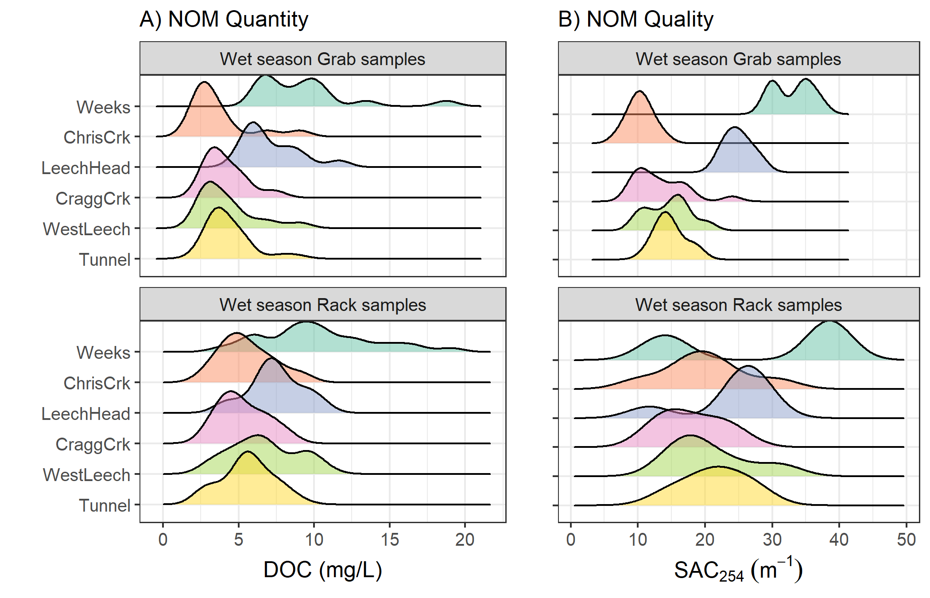

Figure 15: NOM quantity and reactive quality during the wet season at six monitoring sites, comparing samples collected by Vertical Racks (rising-stage event-based samples) and standard synoptic Grab sampling (non-rising limb). Plot A shows dissolved organic carbon (DOC) concentration and plot B shows spectral absorbance coefficient values at 254 nm (SAC254), which indicates aromatic NOM reactivity.

### Discussion

Vertical Racks proved important for measuring event-based rising-limb NOM quantity and quality. Rising limb samples had 26% more DOC, on average, than non-rising limb Grab samples. These results are in agreement with other studies that found higher DOC concentration on the rising limb of the hydrograph compared to non-event samples (e.g. Yang et al. (2015), Raymond et al. (2016), Raymond et al. (2010)). Based on relative variance between Rack and Grab sample DOC, it seems that hydrologic pulses transported greater quantities of NOM which remain relatively stable throughout the rising limb of the hydrograph. In addition to greater quantity of NOM, rising limb samples were typically more reactive in character than non-event samples. The exception to this was in basins associated with Weeks Lake and its surrounding wetlands, which appeared to sustain more reactive NOM during non-event flows with dilution of that aromatic and reactive NOM on the rising limb of the hydrograph.

Rack sampling more than doubled the number of samples collected when compared to Grab sampling alone. Therefore, in addition to providing information about event-based changes in NOM quantity and quality, the Vertical Rack method was a useful tool for collection of event-based samples with increased sampling frequency. On a few occasions, questionable sample hold-times resulted when logistics or high water limited safe rapid retrieval of Vertical Rack samples. However, the method employed in this project allowed for calculation of sample hold-times and quality-control evaluation for data processing of acceptable samples only.

#### Spatial patterns

Weeks Creek, which drains from Weeks Lake and surrounding wetlands, had the greatest average aromaticity and highest DOC concentrations of all GVWSA synoptic sampling sites. This was to be expected as wetlands have been linked to high concentrations of aromatic-rich NOM (e.g. Helms et al. 2008; Ågren et al. 2008; Aiken and Cotsaris 1995). In line with the river continuum concept (Vannote et al. 1980; Mosher et al. 2015; Abbott et al. 2018; Creed et al. 2015), NOM quality and quantity decreased from upstream to downstream sampling sites and there was greater variation in NOM character (i.e. reactivity, aromaticity, molecular size) at the headwater sites than the higher-order streams.

Data from the West Leech suggests that the pulse shunt concept (Raymond et al. 2016) is particularly relevant to NOM transport in this sub-basin system. Samples from the West Leech site had high aromaticity compared to other higher-order streams and showed considerable event-based changes in NOM concentration (45% difference between Grab and Rack samples) relative to the other monitoring sites. The West Leech sub-basin (20.85 km2) was of similar size to Leech-head (20.59 km2) and Cragg creek sub-basin (28.06 km2), with lower percent wetland cover (0.4% compared to 2.6% and 1.6% at Leech-head and Cragg creek sub-basins). The West Leech sub-basin was the only sampled sub-basin that did not have metamorphic parent-material (wark gneiss).

In the Leech Watershed, lower DOC was observed in the streams draining from the eastern portion of the Leech WSA catchment (Cragg and Chris Creeks) and higher DOC was observed in the streams draining from the west (West Leech and Weeks Creek).The difference in subsurface geology in the west and east basins of the Leech WSA may have played an important role in NOM differences, and is explored in Chapter 4.

#### Temporal patterns

While the absolute magnitude of DOC varied among sites, NOM quantity across the GVWSA followed a near-sinusoidal pattern over time. DOC was highest in the early wet season, then progressively decreased with low concentrations occurring during the coldest periods. Low DOC during cold periods could have been due to intermittent soil frost (observed in the field), where freezing of terrestrial NOM sources effectively locked the source pool and reduced in-stream concentrations. It has also been shown that freezing stream samples reduces DOC concentrations (Fellman, D’Amore, and Hood 2008). The period of lowest winter DOC in this study also corresponded to low flows and snow accumulation in the GVWSA (particularly the Leech WSA). Laudon et al. (2013) found that winter DOC export was positively correlated to mean winter temperature. In agreement, samples from the GVWSA showed positive correlation between mean monthly DOC concentrations and mean monthly air temperatures. Laudon also noted that DOC export was linked to water export, so the low DOC concentrations observed in winter could also have been due to low flows (Laudon et al. 2013).

DOC concentrations increased over the summer, reaching highs for the start of the wet season. Overall, there was negligible difference in NOM quantity between seasons; both wet and dry seasons had mean DOC of 6 ± 3 mg/L. Seasonal changes in the relationship between DOC and SAC254 were observed across the GVWSA. Aqueous NOM was larger, more aromatic and more reactive during the wet seasons than during the dry season. More aromatic NOM in the wet season was likely sourced from autochthonous terrestrial sources (e.g. humic and fluvic acids), while the less aromatic dry season NOM was probably made up of autochthonous NOM from in-stream processes (e.g. algae). The seasonal shift in NOM quality from autochthonous to allochthonous material was predicted by the river continuum concept (Vannote et al. 1980; Mosher et al. 2015; Meyer and Tate 1983).

The river continuum concept explains temporal changes in NOM character through variable mobilization of source material and biogeochemical processing. Results also supported the pulse shunt concept (Raymond et al. 2016), in that event samples contained greater quantities of more reactive NOM. Peak values for maximum and minimum DOC concentration and NOM reactivity were measured in samples from the wet season on the rising hydrograph limb. Chapter 4 evaluates the Leech WSA monitoring site data more closely with respect to event-based changes, for a more detailed understanding of relationships between streamflow and NOM transport.

In general, stream DOC concentrations were higher than the recommended 4 mg/L of TOC for source water quality (British Columbia Ministry of Environment 2017). However, future inter-basin transfers would move Leech River water to a reservoir prior to intake for drinking water treatment, and reservoir dynamics would likely alter the quantity and quality of stream NOM (Stanley et al. 2012; Aiken and Cotsaris 1995).

#### Spatiotemporal patterns

Aside from Weeks Creek, which maintained highly aromatic NOM throughout the year due to proximity to the wetlands of Weeks Lake, the Leech WSA sub-basin sites showed longitudinal decrease in NOM quantity. In both wet and dry seasons, DOC concentrations decreased from low to higher order streams, but NOM molecular quality had opposite longitudinal patterns in each season. From low to high order streams, there was an increase in aromaticity and molecular size (indicated by E2:E3) during the dry season and a decrease in the wet season. It was not expected that higher order streams would have larger and more aromatic NOM than lower order streams during the dry season, especially when DOC concentrations showed the opposite pattern. The wet season decrease in NOM aromaticity was expected to occur in tandem with the longitudinal decrease in DOC concentration, due to dilution effects along stream reaches. Similarly, it was expected that aqueous NOM aromaticity would decrease with downstream transport at low flows, due to abiotic and/or biotic oxidation such as photodegradation and/or heterotrophic processing or adsorption (Creed et al. 2015; Kalbitz et al. 2000; Stanley et al. 2012; Aiken, Hsu-Kim, and Ryan 2011).

The relative elevation in downstream NOM aromaticity and molecular size during the dry season could indicate that more easily altered (i.e. labile) NOM was removed (via biotic or abiotic factors) and larger, more aromatic and recalcitrant NOM was transported downstream resulting in a longitudinal concentration in the dry season. Or, the more aromatic NOM character at lower reaches could have been due to humic inputs from NOM-rich tributaries feeding higher order streams, or perhaps in-stream microbial processing of terrestrial organic matter (e.g. leaf litter) generated aqueous humic solutes.

It was possible that UV-Vis interference caused the observed NOM quality pattern – like chromophoric NOM (the target analyte), other dissolved inorganic species (e.g. iron, nitrate, nitrite, bromide) also absorb light at wavelengths around 254 nm (Baird, Eaton, and Rice 2017b). Concentrations of iron and nitrogen species were not measured; therefore, their interference cannot be confirmed; however, the full scan absorption spectra (not shown) displayed gradual decrease in absorbance with increasing wavelength with no major spikes, suggesting few interferences. Therefore, the patterns in spectral indices were believed to be unbiased indication of greater NOM aromaticity at lower reaches in the dry months.

### Summary and future directions

The objective of this work was to design a sampling strategy to measure the ranges of NOM between adjacent drainage basins and among nested sub-catchments and to evaluate the influence of seasonality on quantity and quality of aqueous NOM. The sampling strategy was a combination of synoptic Grab sampling across twelve sites in the Greater Victoria water supply area in tandem with Vertical Rack sampling at six of those sites in the Leech WSA. Sampling campaigns showed longitudinal attenuation of NOM concentrations and character (aromaticity and reactivity), and seasonal shifts from aliphatic NOM in the dry season to more aromatic NOM in the wet season. Across the GVWSA, DOC concentrations ranged from 1.64 mg/L to 19.1 mg/L with mean DOC of 6.1 ± 2.9 mg/L. NOM character was most aromatic and most variable in low-order headwater streams.

The combination of Vertical Rack sampling with Grab sampling at the Leech Tunnel captured the same variance in DOC concentrations as Grab sampling alone at three upstream sites, which indicates that this combined method can achieve good resolution for water quality monitoring. For further comparisons between the Leech and Sooke WSA, it would be informative to install Vertical Racks at the main tributaries to Sooke Reservoir, Rithet and Judge creeks, to compare event-based changes in more detail to Leech River. Expanded comparisons between the Leech Tunnel site, with Rithet and Judge Creeks would be particularly informative if conducted in conjunction with Sooke Reservoir water balance and residence time studies to evaluate changes to riverine source water in a reservoir (e.g. photodegradation of NOM).

Longitudinal attenuation of NOM concentration and character suggests that there is a downstream dilution effect. These results imply that if a disturbance in headwater systems were to affect NOM (as well as related water quality parameters), the effect would be greatly reduced at downstream sites (e.g. Leech Tunnel). This is encouraging for possible experimental forest treatments (e.g. prescribed burning) in the Leech WSA headwaters. The scaling of DOC from upstream to downstream also bodes well for future inter-basin transfers and drinking water treatability, as lower DOC and SAC254 typically result in fewer DBPS being generated, lower risk of biofouling and more effective disinfection with oxidants. Similar DOC concentrations observed at Rithet Creek (primary tributary to Sooke Reservoir) and Leech River at the Tunnel is promising from a source water perspective for future supplemental supply from the Leech.

## Watershed Characteristics and Sampling Conditions as Driving Forces for Aqueous Natural Organic Dynamics Across the Leech River Watershed

### Synopsis

The previous chapter showed that across the Leech WSA and portions of the Sooke Reservoir watershed, the character of natural organic matter (NOM) shifted from predominantly aliphatic in the dry season to predominantly aromatic during the wet seasons. The seasonal character shift agreed with predictions of the river continuum concept (RCC), as did an observed spatial reduction in NOM molecular diversity from lower-order to higher-order streams (Vannote et al. 1980; Abbott et al. 2018; Mosher et al. 2015; Creed et al. 2015). Results also confirmed that rising limb event-based Rack samples had higher DOC concentrations than non-rising limb samples. Elevated NOM in stormflow was expected (e.g. Vidon, Wagner, and Soyeux (2008); Raymond et al. (2010)) and is a key aspect of the pulse-shunt concept (Raymond et al. 2016). While seasonality and hydrologic pulses were expected to drive changes in aqueous NOM dynamics, differences in surface and subsurface characteristics among the sub-basins could also be responsible for spatial variation in NOM quantity and quality.

Of the main tributaries to the Leech River mainstem, Cragg Creek (draining from the east of the Leech WSA) had the lowest average DOC concentration and least aromatic reactive character, while West Leech NOM was higher in DOC concentration and more reactive NOM (Figure 16). It was expected that that there would be differences in NOM concentration and character among monitoring sites, but it wasn’t immediately obvious why event-based NOM variances were greater at the West Leech site (20.85 km2 sub-basin) compared to other streams draining catchments of similar size (i.e. Leech-head, 20.59 km2 sub-basin; and Cragg Creek 28.06 km2 sub-basin). As water quality is intrinsically linked to watershed characteristics, there may be a key feature (or combination of features) that operate in tandem with weather conditions to drive NOM concentration and character dynamics. This chapter evaluates watershed characteristics and hydroclimatic conditions to identify variables that best explain differences in NOM quantity and quality across the six monitoring sites in the Leech WSA.

### Methods

#### Site details

This chapter focuses on the six Leech WSA monitoring sites (Figure 16), which were equipped with Vertical Rack samplers. Nested catchments of the Leech WSA included two headwater streams, Weeks and Chris Creek sub-basins (site 1, 11.5 km2 & site 2 , 5.9 km2); the head of Leech River (‘Leech-head’), below the confluence of those two headwater streams (site 3, 20.6 km2 sub-basin); two major tributaries that feed the Leech, Cragg Creek and West Leech sub-basins (site 4, 28.1 km2 & site 5, 20.9 km2), and Leech Tunnel (site 6) which encompassed drainage of the entire Leech WSA above the point of diversion (95.3 km2). Sample collection and analysis follow the methods detailed in Chapter 2.



Figure 16: Monitoring sites in the Leech Water Supply Area (WSA). Sites are named and numbered, where the number indicates both the sequence of vertical rack installations as well as the relative progression from headwaters to mouth. Each sub-basin boundary (defined using each sampling site as the drainage outlet) is outlined in black, and the Leech WSA boundary is delineated in red.

Surficial materials and soils in the Leech WSA are predominantly podzolic with approximately 50% of the parent material in each sub-basin composed of colluvial deposits with O-HFP development (orthic humo-ferric podzol). The second most dominant parent material for soil was till (morainal) with duric humo-ferric podzol (DU-HFP) soil development in all sub-basins except for West Leech, which had till-based O-HFP soils (Government of Canada 2018). DU-HFP differs from O-HFP by the presence of a strongly cemented layer (duric horizon) that is unlike the B horizon in O-HFP (Canadian Society of Soil Science 2020). Both DU-HFP and O-HFP are well drained, or moderately so, and O-HFP tends to be acidic (pH < 5.6) while DU-HFP is generally moderately acidic to neutral (pH 5.6 - 7.4) (Government of Canada 2018). There was a small amount of poorly drained terric mesisol (T.M., undifferentiated organic soil) present only in the Weeks Creek sub-basin (Table 15).

There were a few notable differences in subsurface geology between sub-basins (Table 15). West Leech was characterized by the absence of wark gneiss and chert argillite volcanic parent materials (0%), which were present in all other sub-basins. Both Weeks Creek and West Leech sub-basins were dominated by argillite metagreywacke parent material (64% and 77%, respectively). West Leech was also underlain by metagreywacke (7%) and Metchosin volcanics (16%), which were absent in each of the other monitoring sub-basins. Cragg Creek sub-basin (site 4) was underlain predominantly by metamorphic wark gneiss (78%) with no argillite metagreywacke parent material (0%). Metagreywacke parent materials are part of the metasedimentary Leech River Formation, where metagreywacke is meta-sandstone and argillite metagreywacke is more of a meta-mudstone (Groome et al. 2003). The Leech River Formation tends to be more erodible than wark-gneiss (Ussery and AECOM 2015). Chris Creek and Cragg Creek sub-basins had no metasedimentary parent material of the Leech River Formation.

At the surface, Weeks Creek sub-basin had the greatest proportion of wetland and open water compared to the other sub-basin sites (Table 15). Cragg Creek sub-basin had the oldest average tree age (59 years). By area, the most heavily harvested basin since 1980 was the Chris Creek sub-basin (63% harvested), then Leech-head and Cragg Creek sub-basins (43% and 41% harvested, respectively). West Leech was the least harvested between 1980 and 2011 (26%), followed by Weeks Creek sub-basin (28% harvested, but is also 7% open water and wetland), followed by the entire Leech Tunnel catchment area (34%).

Table 15: Summary of Leech watershed monitoring site sub-basin characteristics. Variables preceded by square brackets indicate sub-surface features of parent material ([PM]) and soil groups ([S]).

|  |  |  |  |  |  |  |
| --- | --- | --- | --- | --- | --- | --- |
| Variable by site | Weeks crk (1) | Chris crk (2) | Leech-head (3) | Cragg crk (4) | West Leech (5) | Leech Tunnel (6) |
| Latitude | 48.57592 | 48.57691 | 48.5666 | 48.54856 | 48.50635 | 48.5069 |
| Longitude | -123.84397 | -123.83995 | -123.82569 | -123.77141 | -123.78618 | -123.768 |
| Interest / characteristic | Headwater | Headwater | Leech Rv. (head) | Major trib. | Major trib. | Mainstem, future diversion |
| Strahler Order | 3 | 3 | 4 | 4 | 4 | 5 |
| Drainage Area (km2) | 11.5 | 5.9 | 20.6 | 28.1 | 20.9 | 95.3 |
| Elevation (m a.s.l) | 521 | 522 | 476 | 509 | 248 | 207 |
| Percent Forest | 94.5 | 99 | 96.6 | 97.8 | 98.5 | 97.6 |
| Percent Wetland | 4.2 | 0.8 | 2.6 | 1.6 | 0.4 | 1.1 |
| Percent open water | 2.9 | 0.6 | 1.8 | 0.9 | 0.3 | 0.7 |
| slope, mean (degrees) | 9.1 | 10.5 | 10.2 | 9.5 | 11.3 | 11.8 |
| slope, max (degrees) | 44 | 38 | 50 | 40 | 56 | 61 |
| Logging history, 1980-2011 (% area) | 28.1 | 62.6 | 42.7 | 41.3 | 25.8 | 33.9 |
| Tree age (average) | 52 | 40 | 48 | 59 | 49 | 53 |
| [PM] Wark-Gneiss (%) | 13.6 | 44.9 | 20.5 | 77.6 | 0 | 30.6 |
| [PM] Argillite-Metagreywacke (%) | 64.2 | 0 | 42.1 | 0 | 76.8 | 45.1 |
| [PM] Chert-Argillite-Volcanic (%) | 22.2 | 55.1 | 37.4 | 22.4 | 0 | 17.9 |
| [PM] Metagreywacke (%) | 0 | 0 | 0 | 0 | 7.2 | 1.6 |
| [PM] Metchosin Volcanics (%) | 0 | 0 | 0 | 0 | 16 | 4.2 |
| [PM] Sooke Gabbro (%) | 0 | 0 | 0 | 0 | 0 | 0.7 |
| [S] Colluvial (O-HFP, %) | 42.2 | 48.1 | 44.3 | 48.1 | 50 | 47.9 |
| [S] Morainal / Till (DU-HFP, %) | 26.6 | 51.9 | 36.1 | 31.8 | 1.8 | 19.2 |
| [S] Morainal / Till (O-HFP, %) | 17.8 | 0 | 12.9 | 1 | 48.2 | 25.6 |
| [S] Undifferentiated organic (T.M, %) | 6.4 | 0 | 3.6 | 0 | 0 | 0.8 |
| [S] Glaciofluvial (DU-HFP, %) | 0.5 | 0 | 0.6 | 6.9 | 0 | 2.2 |
| [S] Fluvial (DU-HFP, %) | 3.9 | 0 | 2.2 | 0 | 0 | 0.5 |

The watershed characteristics included in Table 15 were combined with Leech WSA weather data (Chapter 2) and sample results (Chapter 3) to identify possible explanatory variables that were driving changes in NOM concentration and character across the Leech WSA. Watershed characteristics and conditions were evaluated as possible predictors for NOM change using Random Forest algorithms.

#### Random Forests

Breiman’s Random Forests (RF) is a machine learning algorithm which composes a statistical tool for non-parametric regression, prediction, classification and assessment of variable importance (Breiman 2001; Strobl, Malley, and Tutz 2009). RF does not require independence among samples and is unique in its capacity to evaluate variable importance metrics (Tyralis, Papacharalampous, and Langousis 2019; Biau and Scornet 2016). The relative importance of each feature in RF can be determined by assessing the accuracy of how well the response variable (predictant) is anticipated in the absence or presence of each predictor feature (see Appendix E1 for extended background and details). Through the RF algorithm, variable importance measure (VIM) is assessed by removing predictor variables one at a time and measuring the decrease in prediction accuracy in their absence (Breiman 2001).

##### Predictor variable refinement and quality assurance

RF variable importance measures (VIMs) were used to assess the relative importance of sub-basin characteristics and conditions as predictors of NOM concentration and character using the MSE method (type 1). Possible predictor variables for NOM concentration (i.e. DOC) and character (i.e. SAC254 and E2:E3) included sub-basin characteristics of each of the six monitoring sites (Table 15) as well as sampling stage and antecedent weather conditions. To avoid undue bias (C. Strobl et al. 2008) all predictor variables were numeric values (quantitative) and missing values were removed. As cross-correlated predictors can cause biased VIM in RF, variables with correlation coefficients greater than 0.65 were omitted (though there is no standard definition for levels of correlation coefficient strengths, 0.65 seemed a reasonable threshold to separate moderate and more strongly correlated variables).

Sampling stages for each site were scaled (min-max-normalized) to account for differences between Vertical Rack installations and to allow for comparison between sites (Equation 1). For antecedent rain and air temperatures, different periods of time were considered in exploratory data analysis. Intervals of 3, 5, 7, 14, 21 and 30 days prior to sample collection were evaluated for cross-correlations and relative VIM results.

Equation 1:

$$normalized X_{i}=\frac{(X_{i}−X_{min})}{(X_{max}−X_{min})}$$

RF is a black box; for that reason, a variable of random numbers was included in the VIM assessment as a means for quality assurance (QA). VIM assessment, with the QA variable, was completed for watershed characteristics and conditions to ensure that random numbers were not assigned any predictor importance. The QA variable was removed from final assessment and is not displayed in results (below).

Following RF VIM analyses, the variables with relatively greatest predictor importance were further explored by evaluating their one-on-one relationships with NOM concentration and character. Results of RF VIM assessment were also used to retrospectively infer importance of variables that were excluded from VIM due to their cross correlation(s). Where possible, important predictor variables were assessed for hysteretic behaviour.

#### Evaluating local extrema sample stage and DOC

Results in the previous chapter showed elevated NOM in event-based samples. To explore the relationship between DOC and event flows, a peak-to-peak comparison was done to see if DOC concentrations peaked with stream stage during events. As DOC was quantified from discrete stream samples the temporal synchrony of peaks could not be evaluated in the same manner as stage, which was continuously recorded. However, each river sample was matched to stage and had a corresponding timestamp, thus inferences could be made based on relationships between peak DOC and stage. To determine if local DOC extrema (maxima and minima concentrations) were captured in conjunction with the local extrema of sampled flows (minima and maxima of sample stage), manual synchrony tests were run on sample results. For each site, results of samples were grouped by collection period and rain event to identify samples with extreme DOC concentrations as well as samples collected at extreme stage (max/min). Samples corresponding to maxima and minima DOC and stage were compared to determine how often they overlapped (i.e. was the sample with max DOC also the sample collected at the highest stage?).

### Foundational results of Random Forest refinement

Values for median basin slopes were the same across three sites, so mean slopes were selected instead, as means were unique to each sampling basin. Sub-basin percent wetland cover was correlated with slope (-0.73), as well as forest cover (-0.97). Thus, wetland and forest percent cover were not included in VIM assessments, and slope was. Interestingly, the percent of sub-basins underlain by the meta-sedimentary Leech River formation (including argillite-metagreywacke (mudstone) and metagreywacke (meta-sandstone)) was correlated (-0.83) with 30-year logging history (percent of basin harvested 1980-2011). The Leech River geologic formation underlies the Weeks Creek and West Leech sub-basins, which were also the two sub-basins least harvested since 1980 (Table 15). These are the types of correlations that could cause spurious VIM bias in RF, because it’s unlikely that the presence of meta-sedimentary parent material was the cause for these basins to be less harvested. Parent material variables were refined to metamorphic (wark gneiss) and igneous (Metchosin volcanics & gabbro stocks), which did not show cross-correlation to other predictor variables. As one might expect, soil materials were correlated with geologic parent materials (as well as with each other and logging history), thus soils were not included with RF VIM predictor variables.

The nine selected predictor variables for RF VIM assessment included:

* metamorphic parent-material (wark gneiss, percent of basin)
* igneous parent material (Metchosin volcanics & gabbro stocks, percent of basin)
* drainage area (km2)
* mean basin slope (degrees)
* tree age (average, years)
* logging history (percent of basin harvested 1980-2011)
* antecedent 7-day air temperatures (°C, mean)
* antecedent 30-day rain (mm, total)
* sampling stage (normalized)

The length of antecedent periods of 30 days for antecedent rain and 7 days for antecedent air temperature were chosen because (1) they were not cross correlated with other predictor variables or each other and (2) each was more easily distinguished in VIM results than other interval options. Furthermore, the amount of rainfall in the 30 days prior to sample collection could be considered as an indicator of overall antecedent landscape wetness. A longer period of antecedent rain may be indicative of greater connectivity of streams to distant/deeper terrestrial environments. Using the same VIM parameters tuned for DOC prediction, 30-day antecedent rain was relatively more important than 7-day rain (15.3% vs. 12.8%) for predicting E2:E3, and 7-day antecedent air temperatures were more important than 30-day air temperatures (8.5% vs. 6.5%). This confirmed that relatively short-term temperatures (rolling 7-day mean) and relatively long-term rain (rolling 30-day sum) were appropriate selections for the RF VIM assessments.

Surface and subsurface watershed characteristics were static values (e.g. basin slope, parent material), whereas sampling stage and antecedent weather were dynamic values (different for each sample). Although all variables were numeric, it was possible that RF might treat static values categorically (C. Strobl et al. 2008), and RF bias can result from VIM assessment of combined categorical and quantitative predictor variables. So, sub-basin characteristics and conditions were evaluated independently as well as together to see if there was a shift in overall relative VIM ranking results.

##### RF quality assurance

A variable of random numbers was included with watershed characteristic and sampling conditions as a method of quality assurance (QA) in using the RF variable importance measure (VIM). Because random numbers are not a real predictor of NOM concentration or character, the VIM assessment should rank the QA variable as the least important predictor and assign it negligible importance. Recall that there are two methods for evaluating variable importance in randomForest (RF): type 1 measures the mean decrease in accuracy and type 2 measures the decrease in node impurity (Liaw and Wiener 2018). For the Leech WSA data, both VIM methods were checked and type 2 (total decrease in node impurities from splitting on the variable) assigned the random number variable relatively high importance (ranked more important than a real variable) while type 1 (permutation on out-of-bag data) ranked the random number variable as least important with insignificant weight (Liaw and Wiener 2018). These results clarified that type 1 VIM was the best choice and suggests that quantitative data is best assessed for VIM by mean decrease in accuracy (MSE, type 1) rather than mean decrease in node impurity (SSE, type 2).

##### RF variable groupings

Sub-basin characteristics and conditions were evaluated independently as well as together to see if there was a shift in VIM relative rankings due to the combination of static and dynamic values. It was expected that the relative importance (as a percent) would shift when all predictant variables were combined, due to distribution of importance across a greater number of variables; however, it was not expected that the relative ranking would change – but it did. When dynamic conditions and static characteristics were combined for RF VIM, the relative ranking of several predictants were changed compared to when conditions and characteristics were analyzed separately (see Appendix E2, Figure 39, for plots of combined predictors). These results suggest that static and dynamic predictor variables should be separated for RF VIM because each type inherently interacts differently with the predictant variable.

Here, variables were separated based on whether they were static or dynamic with predictant variables. The combination of dynamic and static predictor variables appeared to create bias relative VIM ranking. The key was not whether the input was numeric, but rather if the predictant changed (or not) with the predictor. It seems that dynamic variables (ones that changed with the predictant) were treated for regression while static variables were treated categorically. VIM results are presented for the three predictants (DOC, SAC254, E2:E3) with conditions and characteristics grouped separately.

### Results

#### Random Forest variable importance

##### Predicting DOC concentration: NOM quantity

Across the Leech WSA monitoring sites, the hydroclimatic condition with greatest influence on NOM concentration (DOC) was found to be sampling stage, followed by antecedent 7-day air temperature and then antecedent wetness (30-day rain). The top three watershed characteristic predictors for NOM concentrations were slope, percent of the basin underlain by metamorphic parent material and average tree age (Figure 17).

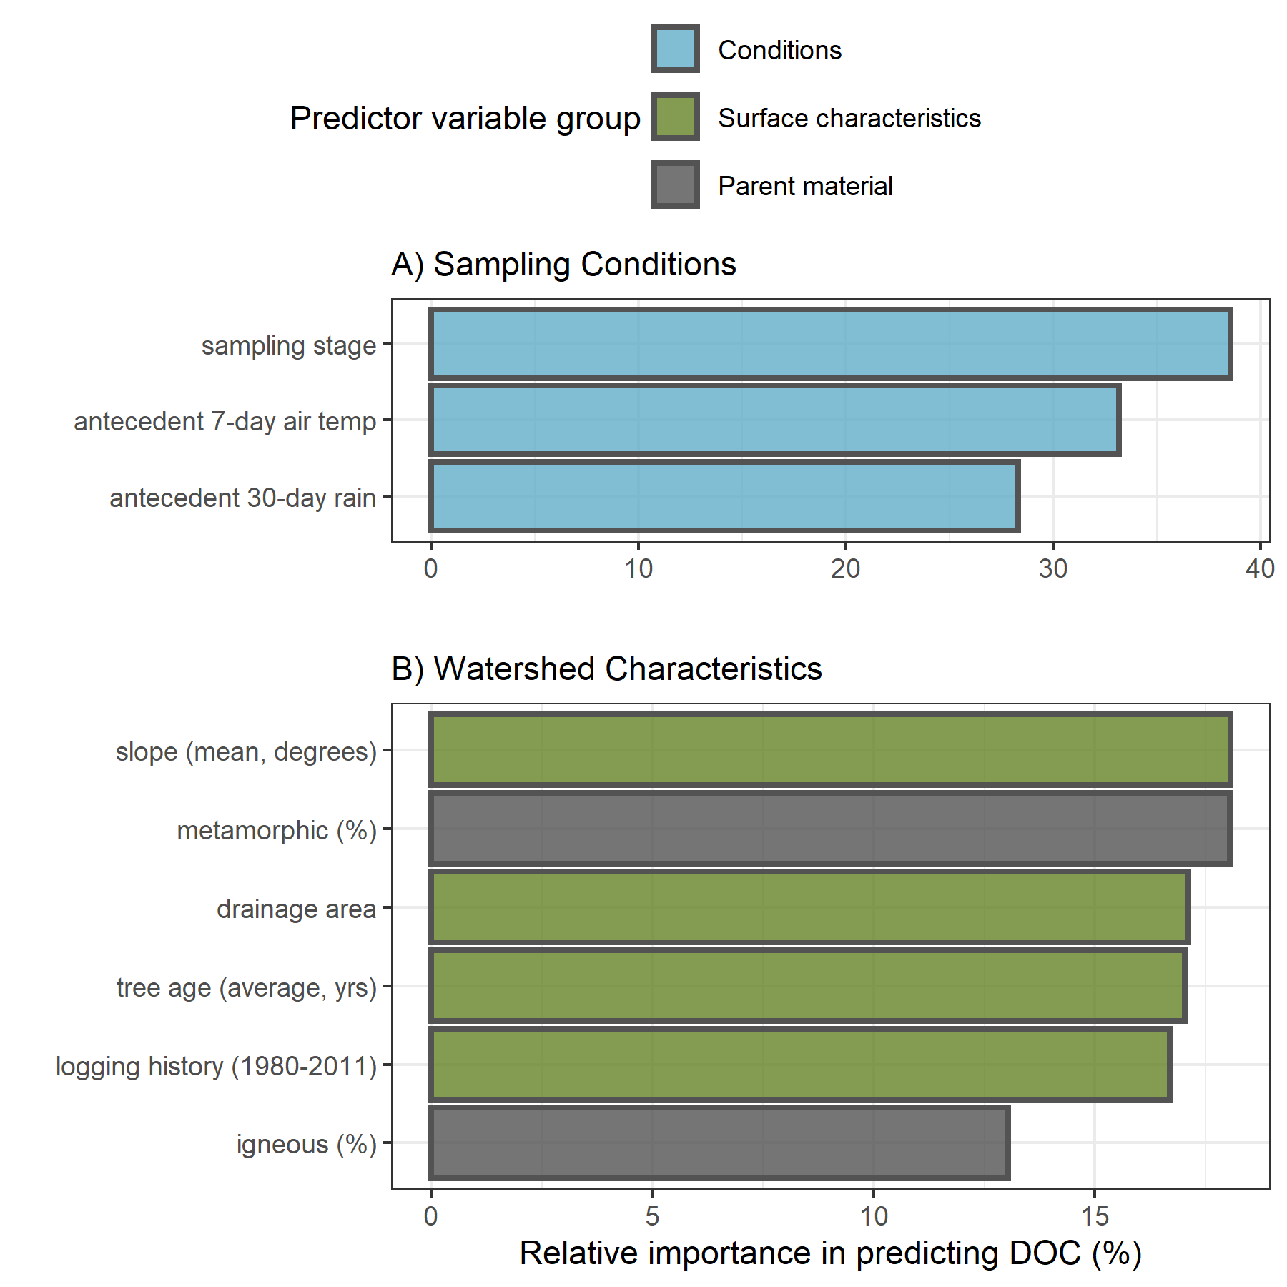

Figure 17: Variable importance for predicting NOM concentration (DOC) across six stream monitoring sites in the Leech River watershed. Variable importance measures were extracted from *randomForest* (in R) and determined by mean decrease in prediction accuracy (increase in the mean square error) in the absence of the predictor variable (i.e. type 1 importance measure).

##### Predicting SAC254: aromatic NOM reactivity

Like DOC, SAC254 was best predicted by sampling stage; unlike DOC, SAC254 was relatively more sensitive to antecedent rain than air temperatures. The top three watershed characteristic predictors for NOM aromaticity and reactivity (SAC254) were slope, percent of the basin underlain by metamorphic parent material (wark gneiss), and logging history (Figure 18).

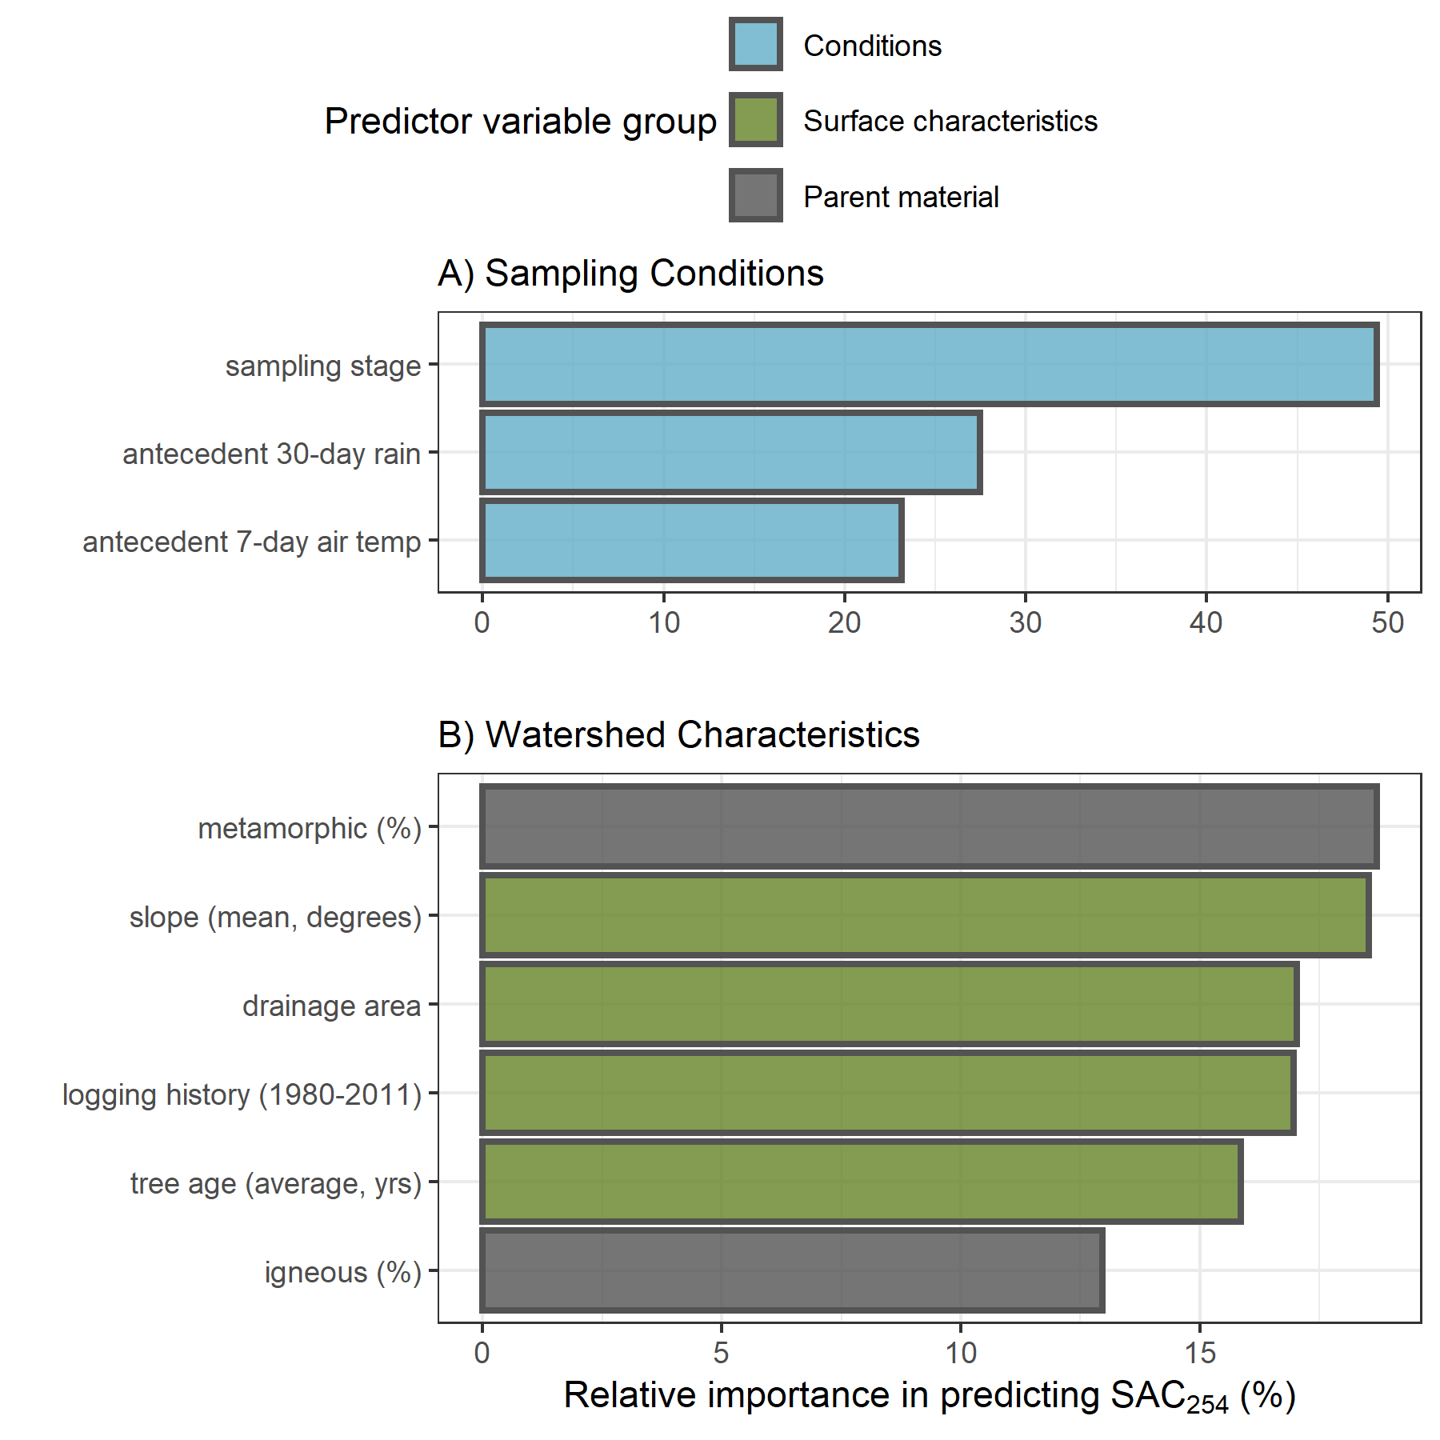

Figure 18: Variable importance for predicting NOM molecular aromaticity (SAC254) across six stream monitoring sites in the Leech River watershed. Variable importance measures were extracted from *randomForest* (in R) and determined by mean decrease in prediction accuracy (increase in the mean square error) in the absence of the predictor variable (i.e. type 1 importance measure).

##### Predicting E2:E3: NOM molecular size & aromaticity

Sampling conditions VIM ranking for E2:E3 were the reverse of those for DOC. NOM molecular size and aromaticity (E2:E3) was best predicted by antecedent 30-day rain, followed by 7-day air temperatures and then sampling stage. The top three watershed characteristic predictors for E2:E3 were percent of the basin logged from 1980-2011, followed by percent underlain by metamorphic parent material (wark gneiss) which was nearly tied with average tree age (Figure 19).

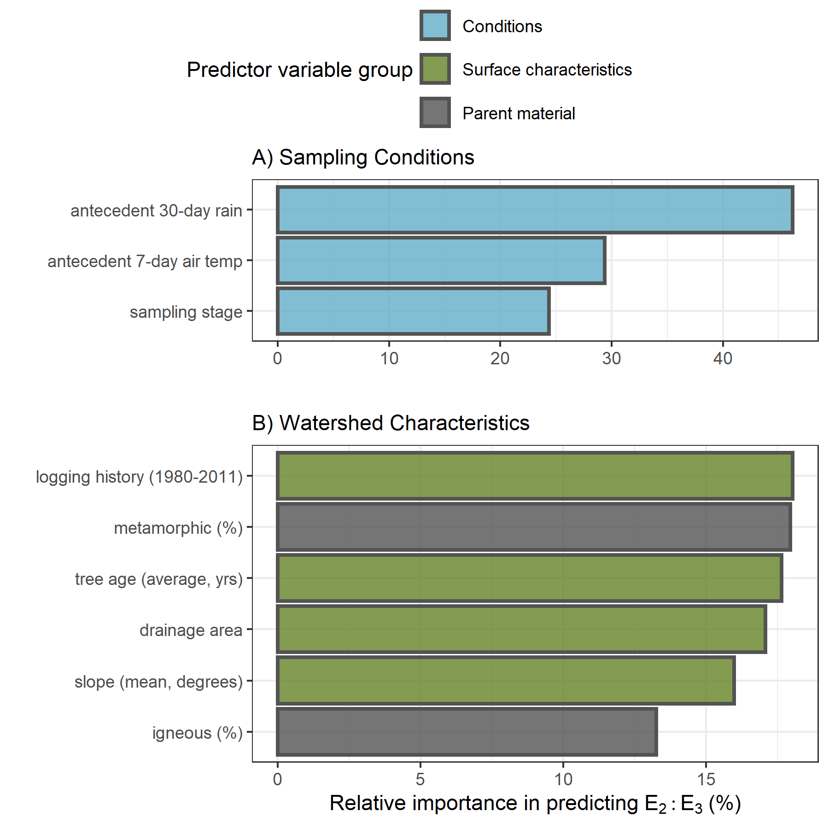

Figure 19: Variable importance for predicting NOM aromaticity & molecular size (E2:E3) across six stream monitoring sites in the Leech River watershed. Variable importance measures were extracted from *randomForest* (in R) and determined by mean decrease in prediction accuracy (increase in the mean square error) in the absence of the predictor variable (i.e. type 1 importance measure).

#### Predictors in relation to NOM quantity and quality

When all variables were assessed together, sampling conditions were relatively more important than watershed characteristics for predicting NOM concentration and character across the Leech WSA monitoring sites (Appendix E2, Figure 39).

##### Sampling conditions

The ranking of relative importance for sampling conditions were in reverse order for DOC (stage, temp, rain) and E2:E3 (rain, temp, stage). Like DOC, SAC254 was influenced most by sampling stage; and like E2:E3, SAC254 was more sensitive to antecedent wetness than antecedent air temperatures.

###### Sampling stage

Stream stage at the time of sample collection was the most important condition predictor variable for DOC and SAC254. Concentration of DOC increased with increasing stage up to approximately 60% of maximum sampling stage at each site. The same relationship was seen (albeit more dramatically) for SAC254 (Figure 20). This indicates that as stream levels increased, so too did NOM concentration and aromaticity. This was expected based on results in Chapter 3 that showed higher concentrations of more aromatic NOM in Vertical Rack samples compared to (inter-event) Grab samples. The threshold level (~0.6 of peak stage) points to a change where increasing stage led to dilution rather than mobilization.

Stream stage was the least important sampling condition for predicting E2:E3 (below antecedent rain and air temperature), and the two variables were inversely related. This pattern supports results of stage in relation to SAC254 and shows that as stream stage increased across the Leech WSA, so too did NOM molecular size and aromaticity. Like SAC254, E2:E3 and stage had a weaker relationship around 60-75% of maximum stage (indicated by the greater uncertainty in the loess trend line, Figure 20) which indicates a point at which aromaticity no longer increased with stage. While there were fewer high-flow samples collected compared to mid-range and low-flow samples, this apparent sampling stage threshold may indicate depletion of a terrestrial NOM aromatic pool, or could suggest that the most aromatic sources had reached peak connectivity to the streams and NOM could get no more humic in nature. Grab samples from falling hydrograph limbs supported this concept of peak hydrologic connectivity as sample NOM quantity and aromatic quality decreased on the recession limb.

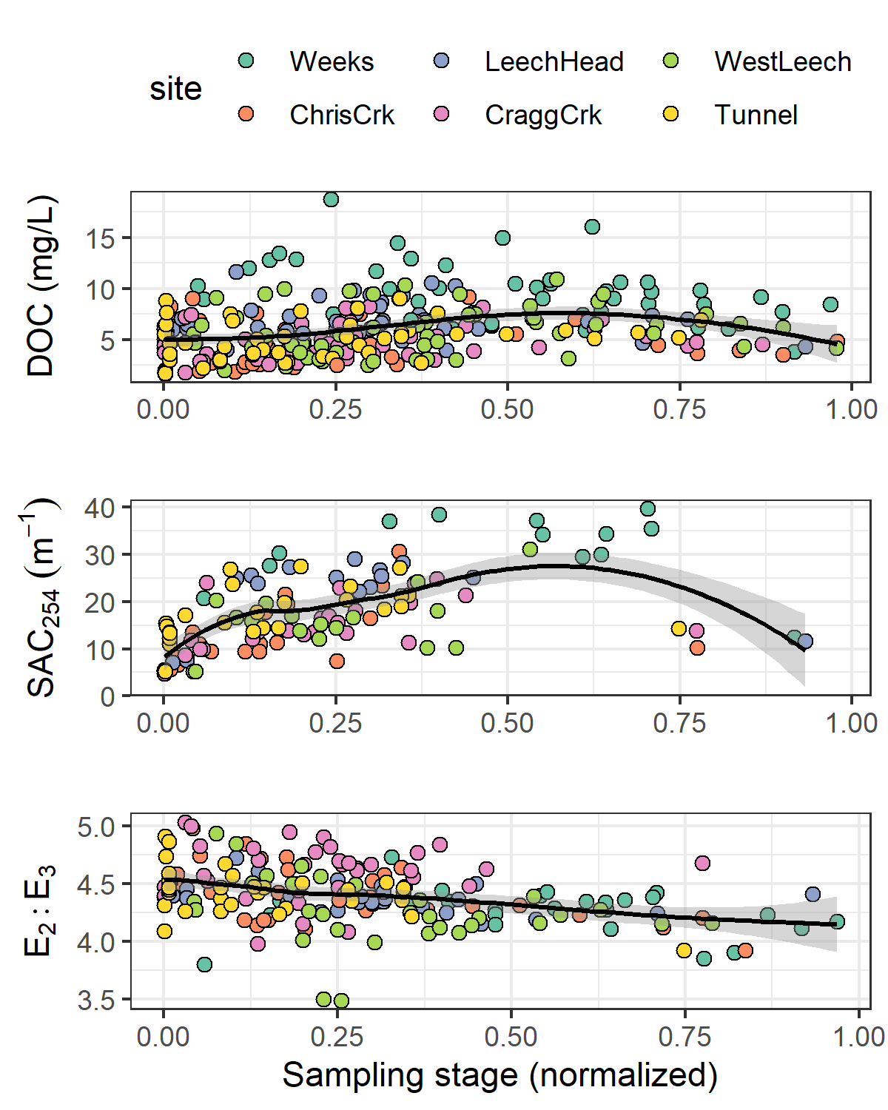

Figure 20: Sampling stage as a predictor for NOM quantity (as DOC concentration) and molecular quality (as SAC254 and E2:E3) across six monitoring sites in the Leech watershed. Each plot includes a loess trend line.

###### Antecedent 7-day air temperature

Antecedent 7-day air temperature (mean air temperature for the 7-day period prior to sample collection) ranked second most important for predicting DOC and E2:E3 and was the least important (third) sampling condition for predicting SAC254. The concentration, reactivity, aromaticity and molecular weight of NOM increased with antecedent air temperature up to approximately 10° C (Figure 21). DOC and 7-day temperature were positively related in the wet season with no obvious relationship in the dry season (Appendix E2, Figure 40) and too few spectral samples were collected in the dry season to shed light on seasonal trends in NOM character with antecedent temperatures.

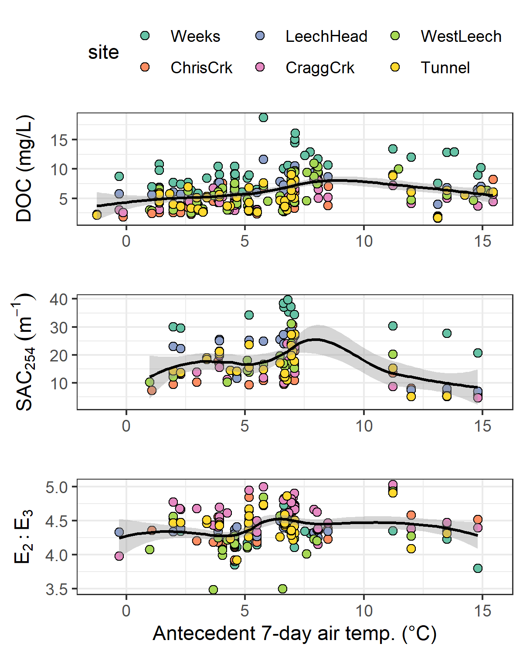

Figure 21: Antecedent 7-day air temperature as a predictor for NOM quantity (as DOC concentration) and molecular quality (as SAC254 and E2:E3) across six monitoring sites in the Leech watershed. Each plot includes a loess trend line.

###### Antecedent 30-day rain

Antecedent 30-day cumulative rain (i.e. antecedent wetness) was the sampling condition calculated to have the greatest relative importance in predicting E2:E3, second-most importance for SAC254 and was the least important sampling condition for predicting DOC concentration. As antecedent 30-day rain increased to approximately 150 mm, there was an apparent decrease in NOM aromaticity and molecular size (E2:E3 increased); above ~150 mm (~25% of maximum antecedent 30-day rain), NOM aromaticity and molecular size increased. At approximately 300 mm of 30-day antecedent rain, NOM aromaticity and molecular size appeared to become less variable (Figure 22).

Fewer sample results were obtained for SAC254, with a data gap for samples collected between 200 mm and 400 mm of 30-day antecedent rain; therefore, the pattern of SAC254 with antecedent wetness was less precise (large uncertainty, Figure 22). For these available data, rain accumulation in the 30 days prior to sample collection was positively related to SAC254 up to approximately 150 mm and SAC254 was relatively low with antecedent 30-day rain above 400 mm. Though the relationship was non-linear, there was a slight initial increase in DOC with increasing antecedent wetness, followed by a gradual decline in DOC with increasing accumulated rain (Figure 18). Lower order streams (Weeks, Chris Creek, Leech-head) showed a steeper decline in DOC with increasing 30-day antecedent rain (site-specific plot in Appendix E2, Figure 41).

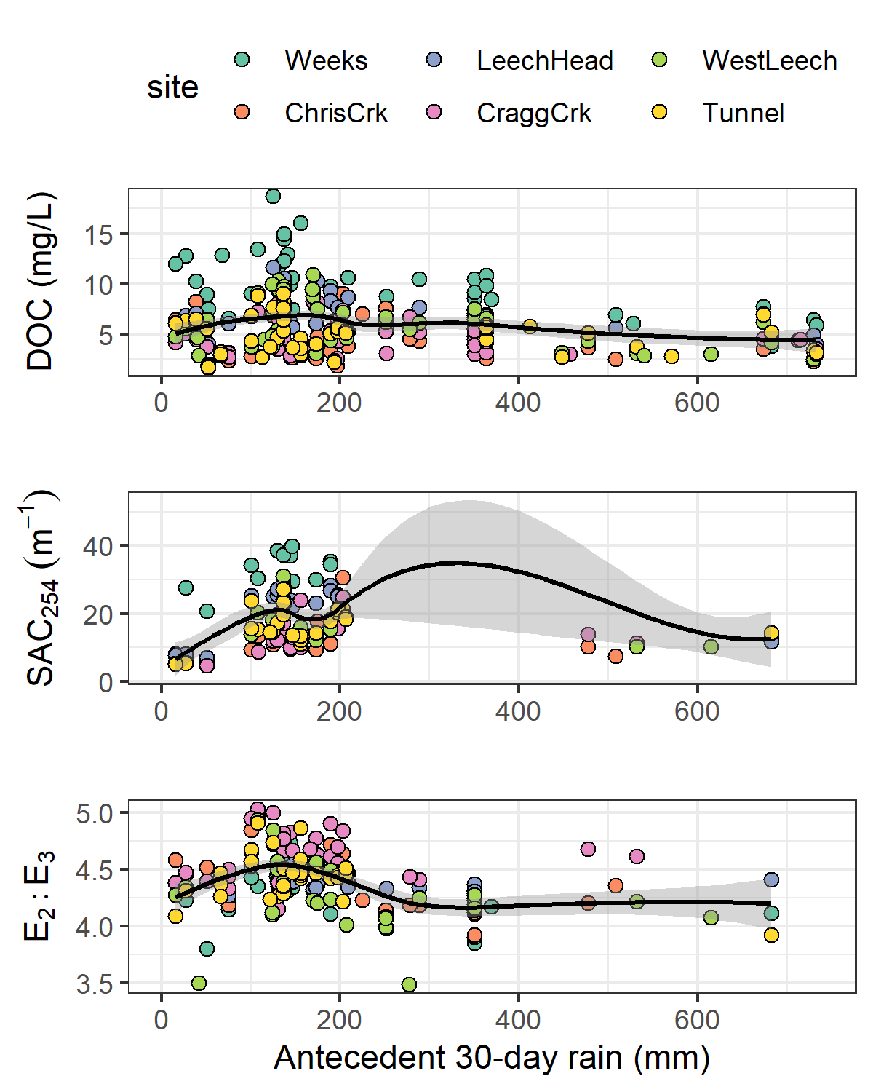

Figure 22: Antecedent 30-day rain as a predictor for NOM quantity (as DOC concentration) and molecular quality (as SAC254 and E2:E3) across six monitoring sites in the Leech watershed. Each plot includes a loess trend line.

These patterns of antecedent wetness with DOC and E2:E3 suggest that smaller, more aliphatic NOM was flushed through the Leech system when antecedent wetness was low (i.e. near the onset of the wet season). As rains continued, streams had greater connection to more aromatic NOM source pools (humic material, possibly from upland sources). The slight decline in aromatic DOC with antecedent wetness (above approximately 350 mm in 30 days) suggests exhaustion of humic NOM source pools and a shift to dilution. These results largely support seasonal characteristic shifts described in Chapter 3, which follow prediction of the River Continuum Concept.

##### Watershed characteristics

Of watershed characteristics, the top predictors for NOM concentration and character were a combination of mean sub-basin slope, metamorphic parent material (percent of basin), logging history (percent of basin harvested 1980-2011), tree age (average) and/or drainage area.

###### Sub-basin slope

Sub-basin slope ranked most important as a predictor for DOC and SAC254. Across the six monitoring sites, the relationship between slope and these two variables was not linear but in general, lower sub-basin slope was related to higher DOC. A pattern appeared, where the six monitoring basins were grouped in pairs with two sites each between mean slopes of 9°- 10°, 10°- 11° and 11°- 12°. Within these pairs, the basin with lower slope had slightly greater NOM aromaticity, reactivity and concentration (Figure 23). SAC254 indicated greater reactivity in sub-basins with lower mean slope (Figure 23). While slope was not ranked as a strong predictor for E2:E3, the relationship between the two largely agreed with results for SAC254.



Figure 23: Sub-basin mean slope as a predictor for NOM quantity (as DOC concentration) and molecular quality (as SAC254 and E2:E3) across six monitoring sites in the Leech watershed.

###### Parent material (metamorphic wark gneiss)

The percent of wark gneiss underlying each sub-basin was ranked as the second most important watershed characteristic for predicting each of DOC, SAC254 and E2:E3. Wark gneiss was inversely correlated (-0.92) to the metasedimentary Leech River Formation.

For the five sites that were underlain by some proportion of wark gneiss, stream DOC concentrations decreased with increasing percentage of this metamorphic surficial deposit. While more metamorphic material corresponded to lower DOC, the absence of wark gneiss in West Leech sub-basin did not correspond to the highest DOC concentration (Figure 24). NOM character had a similar pattern to concentration, where greater metamorphic parent material corresponded to lower NOM aromaticity and reactivity (SAC254), but its absence did not correspond to the sub-basin with the lowest SAC254 (Figure 24). E2:E3 showed that greater metamorphic parent material corresponded to lower NOM aromaticity and molecular weight (higher E2:E3 values) and, in contrast to DOC and SAC254, the sub-basin with the greatest molecular weight NOM (lowest mean E2:E3) did correspond with the absence of wark gneiss (Figure 24).



Figure 24: Percent of each sub-basin underlain by wark gneiss (metamorphic parent material) as a predictor for NOM quantity (as DOC concentration) and molecular quality (as SAC254 and E2:E3) across six monitoring sites in the Leech watershed.

###### Logging history and mean tree age

Logging history (percent of basin harvested from 1980-2011) was ranked first among watershed characteristics for predicting E2:E3 and third for predicting SAC254. Average tree age was third in variable importance for predicting E2:E3 and DOC. Tree age and logging history were examined together because average tree age was largely due to the history of forest harvest.

Sub-basin area harvested between 1980 and 2011 was positively related to E2:E3 at four of the six sub-basin sites. West Leech, Weeks, Leech Tunnel, and Cragg Creek sub-basins showed decreasing NOM molecular weight and aromaticity (increasing E2:E3) with increasing area harvested. However, the sub-basins of Chris Creek and Leech-head (just downstream) had higher harvested area (ergo younger trees) and did not match this pattern of less aromatic, lower molecular weight NOM with greater harvest history (Figure 25). The sites with more aromatic and higher molecular weight NOM were not clearly linked to average tree age (Figure 25).

Chris Creek and Cragg Creek sub-basins had the youngest (40 yrs) and oldest (59 yrs) trees, respectively; yet, these two sites had very similar averages for NOM quantity and quality, though Chris Creek had slightly higher molecular weight NOM. While Cragg Creek sub-basin had, on average, the oldest trees (likely due to old growth maintained on Horton Ridge, between Sooke Lake catchment and the Leech River watershed), it was West Leech that was the least-harvested sub-basin of the six monitoring sites (~26% area harvested 1980-2011). Cragg Creek and West Leech had similar mean DOC and SAC254 values but mean E2:E3 was different; Cragg Creek had greater molecular weight NOM than West Leech (but their error bars overlapped entirely). It is possible that the GIS data for forest harvest and tree age were missing some details, or that the average tree age was not a good indicator variable.



Figure 25: Sub-basin mean tree age as a predictor for NOM quantity (as DOC concentration) and molecular quality (as SAC254 and E2:E3) across six monitoring sites in the Leech watershed.

##### Variable importance Summary

Of the watershed characteristics examined, the percent of each basin with metamorphic wark gneiss parent material appeared to be the most relevant and was a common predictor variable to each of DOC, SAC254 and E2:E3. The absence of wark gneiss was not related to the site with highest DOC, despite DOC decreasing with increasing metamorphic representation. Because subsurface materials were largely cross-correlated, the observed patterns with wark gneiss may point to more nuanced relationships that couldn’t be teased out in this RF analysis because of cross-correlations with other predictor variables. It could be that what is observed as a negative relationship with wark gneiss is a positive relationship between NOM and another parent material, possibly the schist-like Leech River Formation, or a dominant soil type.

Across the Leech WSA, warm and wet conditions were an important driver for NOM concentration and character. Antecedent rain was positively related to DOC concentrations and sample aromaticity up to a threshold of approximately 150 mm of 30-day antecedent rain, at which point NOM concentration and aromaticity/reactivity/molecular weight declined with increasing wetness. This suggested a threshold at which dilution overtook NOM transport. In a similar way, NOM aromaticity increased with sampling stage up to approximately 60-75% of maximum stage at each site.

#### Warm and wet: seasonal patterns and rain events

Moisture and temperature, important to each of the three predictant variables, corresponded to different seasons. Given the evidence of strong seasonality for NOM character (Chapter 3), a comparison between wet and dry season sample results was used to assess spatial difference between seasons for DOC, SAC254 and E2:E3. During the dry-season, SAC254 and E2:E3 indicated that Weeks Creek had greater aromaticity compared to the other sites. Aside from the highly aromatic character of NOM observed at Weeks, E2:E3 suggested that aqueous NOM in the dry-season had increasing aromaticity from upstream to downstream sites; while this quotient can also be indicative of molecular size (by an inverse relationship), the simultaneous decrease in DOC concentration indicates that molecular weight was not increasing downstream (Figure 26). SAC254 showed a similar increase in aromatic character from headwaters to mouth during the dry season, albeit the pattern was less pronounced and there was a larger difference between Chris Creek and Leech-head in SAC254 than in E2:E3. These results show that dry season aqueous NOM increased in aromaticity from upstream to downstream sites.

The dry season pattern of decreasing DOC from low- to high-order streams was apparent in the wet season also. But the wet season spatial pattern of E2:E3 was almost the reverse of what was seen in the dry season. While dry season samples’ E2:E3 showed increasing aromaticity from upstream to downstream, the wet season E2:E3 showed decreasing aromaticity from head to mouth. These seasonal differences support a shift in NOM source material, and/or a shift from NOM processing in the dry season and transport/dilution effects in the wet season.

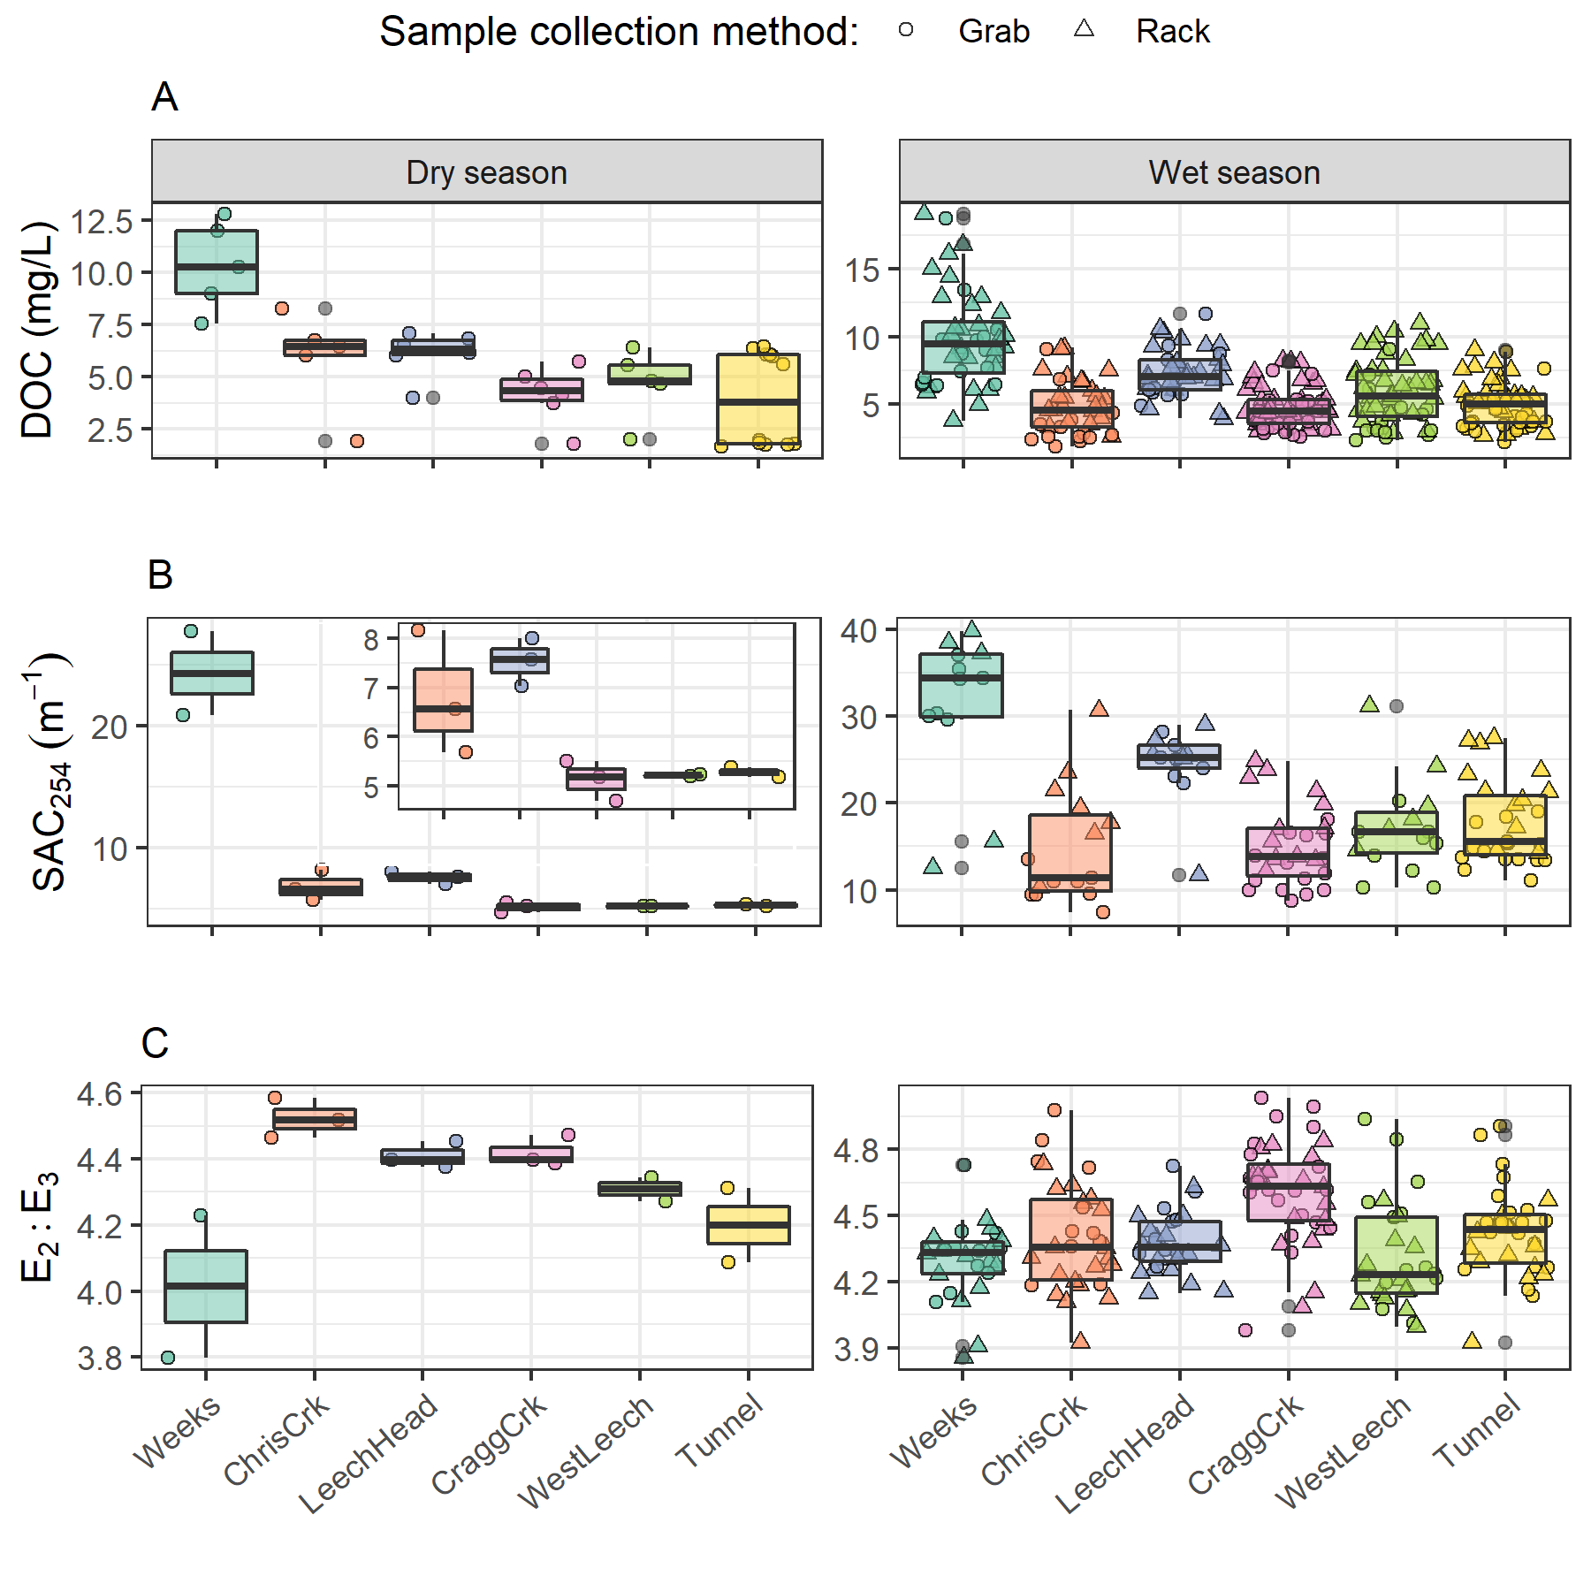

Figure 26: Sample results over the dry and wet seasons for [A] dissolved organic carbon concentrations (DOC), [B] specific absorbance coefficient at 254 nm (SAC254, m-1), and [C] the quotient of SAC250/SAC365 (E2:E3). Note that each season has a different y-scale to clarify patterns. The inset in panel B is an enlargement of SAC254 for all sites except Weeks, which dominated the group set plot.

##### Rising stage and aqueous NOM dynamics

Antecedent moisture and/or sampling stage was important for each of the three predictant variables evaluated though RF VIM. Across the Leech WSA, the highest DOC concentration occurred in the earliest events of each wet season (events 1 & 9, Table 16), while NOM reactivity (SAC254) peaked later, during the third major event in the 2019/2020 wet season (event 11, Table 16). Maximum NOM aromaticity and molecular size (E2:E3) occurred during the last major events, at the end of each wet season (events 3 & 17). Peak DOC occurred in low intensity storms early in the wet season and samples with least concentrated DOC occurred in the winter cold months during high intensity storms (Table 16.

Table 16: Rain events (with a threshold of 50 mm and 14-hour inter-event period) defined by Vertical Rack sample collection across the six monitoring sites of the Leech WSA

|  |  |  |  |  |  |  |  |  |
| --- | --- | --- | --- | --- | --- | --- | --- | --- |
| Major event no. | Start Date | Rainfall (mm) | Intensity (mm/24-hr) | Samples collected | mean DOC (mg/L) | max DOC (mg/L) | mean SAC254 | mean E2:E3 |
| 1 | 2018-10-27 | 124.4 | 20.2 | 19 | 9.09 | 12.93 | 29.13 | 4.34 |
| 2 | 2018-11-03 | 54.8 | 60.5 | 18 | 6.40 | 10.66 | 25.15 | 4.20 |
| 3 | 2018-11-25 | 156.1 | 43.9 | 34 | 6.23 | 10.49 | 27.93 | 4.18 |
| 4 | 2018-12-09 | 205.1 | 41.6 | 18 | 5.88 | 10.83 |  |  |
| 7 | 2019-01-02 | 227.6 | 54.2 | 22 | 4.68 | 7.73 |  |  |
| 8 | 2019-01-17 | 68.7 | 22.8 | 3 | 2.97 | 3.18 |  |  |
| 9 | 2019-09-12 | 58.4 | 18.8 | 14 | 9.97 | 18.74 | 16.75 | 4.82 |
| 10 | 2019-10-15 | 136.2 | 21.3 | 44 | 6.73 | 16.12 | 19.74 | 4.53 |
| 11 | 2019-11-15 | 67.6 | 29.1 | 28 | 6.44 | 10.62 | 22.84 | 4.51 |
| 12 | 2019-12-10 | 70.4 | 22.8 | 25 | 5.30 | 9.03 | 18.90 | 4.51 |
| 13 | 2019-12-18 | 112.1 | 27.7 | 1 | 4.46 | 4.46 | 16.55 | 4.61 |
| 15 | 2020-01-02 | 180.0 | 31.7 | 3 | 5.13 | 5.26 | 15.78 | 4.40 |
| 16 | 2020-01-18 | 238.3 | 24.0 | 8 | 4.11 | 5.10 | 11.42 | 4.43 |
| 17 | 2020-01-30 | 208.8 | 111.3 | 5 | 4.46 | 5.21 | 12.82 | 4.15 |
| 18 | 2020-02-05 | 75.9 | 22.4 | 10 | 3.79 | 6.95 | 9.61 | 4.48 |

Streams across the Leech WSA responded harmoniously to precipitation with synchronous changes in stage. Over the full sixteen-month study period, stage changes at the six monitoring sites were synchronized and confirmed to be congruent with high confidence (p-value < 0.001, based on 1050 randomizations) via Kendall’s coefficient of concordance (Kendall’s W = 0.9721) and Spearman’s ranked correlation (ρ = 0.9666). Rates of change in stream response were calculated for each site to determine the fastest and slowest times to peak stage and relative magnitudes of stage change (Table 17). Time to peak stage was most rapid at Chris Creek (a narrow channel) and slowest at Leech-head (a headwater pool below turbulent steps). Stage changed at the fastest rate (cm/hr) in the highest order stream, the Tunnel site, and at the slowest rate at Weeks Creek which drains with attenuated flow from Weeks Lake and surrounding wetlands.

Table 17: Summary of stream response to rain events across six monitoring sites in the Leech Water Supply Area

|  |  |  |  |  |  |  |
| --- | --- | --- | --- | --- | --- | --- |
| site | shortest time to peak stage (hr) | longest time to peak stage (hr) | smallest change in stage (cm) | largest change in stage (cm) | minimum rate of stage change (cm/hr) | maximum rate of stage change (cm/hr) |
| Weeks | 16.5 | 159.8 | 9.9 | 47.9 | 0.17 | 0.6 |
| ChrisCrk | 15.0 | 192.3 | 5.3 | 44.6 | 0.03 | 2.7 |
| LeechHead | 33.0 | 167.7 | 22.1 | 57.1 | 0.29 | 1.3 |
| CraggCrk | 18.2 | 125.2 | 32.7 | 97.3 | 0.26 | 5.4 |
| WestLeech | 25.8 | 122.8 | 36.7 | 70.2 | 0.33 | 1.4 |
| Tunnel | 18.2 | 123.8 | 29.0 | 135.3 | 0.45 | 7.4 |

To determine if a similar harmony was present for fluctuations in DOC or spectral properties, the proportion of common DOC and stage extrema samples were calculated (Table 18). A proportion of 1 indicates perfect agreement between samples of extreme DOC and sample stage, and zero indicates complete asynchrony between DOC and stage highs and lows. Most samples showed congruence between highs and lows of DOC with stage. West Leech was the only site which had a greater proportion of common maxima compared to minima, all other sites had more frequent occurrence of low DOC occurring at low stage that they did of high DOC occurring at high stage.

Table 18: Proportion of samples for which the highest dissolved organic carbon (DOC) concentration was collected at the highest sample stage

|  |  |  |
| --- | --- | --- |
| Site | Proportion of common maxima | Proportion of common minima |
| Weeks | 0.5882 | 0.6471 |
| ChrisCrk | 0.8000 | 0.8000 |
| LeechHead | 0.8889 | 0.8889 |
| CraggCrk | 0.8000 | 0.9000 |
| WestLeech | 0.8636 | 0.7727 |
| Tunnel | 0.7647 | 0.9412 |
| all sites | 0.7895 | 0.8246 |

Four of the six site’s samples showed majority, but not absolute, agreement in extremes of DOC-stage relationships; Chris Creek and Leech-head each had the same proportion of common maxima and minima. In general DOC concentrations were lowest at the beginning of events and increased with a rise in stage (Figure 27). Early in the wet season, peak stage was more associated with minimum DOC, and later in the wet season peak stage was more associated with peak DOC. These results suggest dilution of NOM early in the wet season, and enrichment later in the wet season.

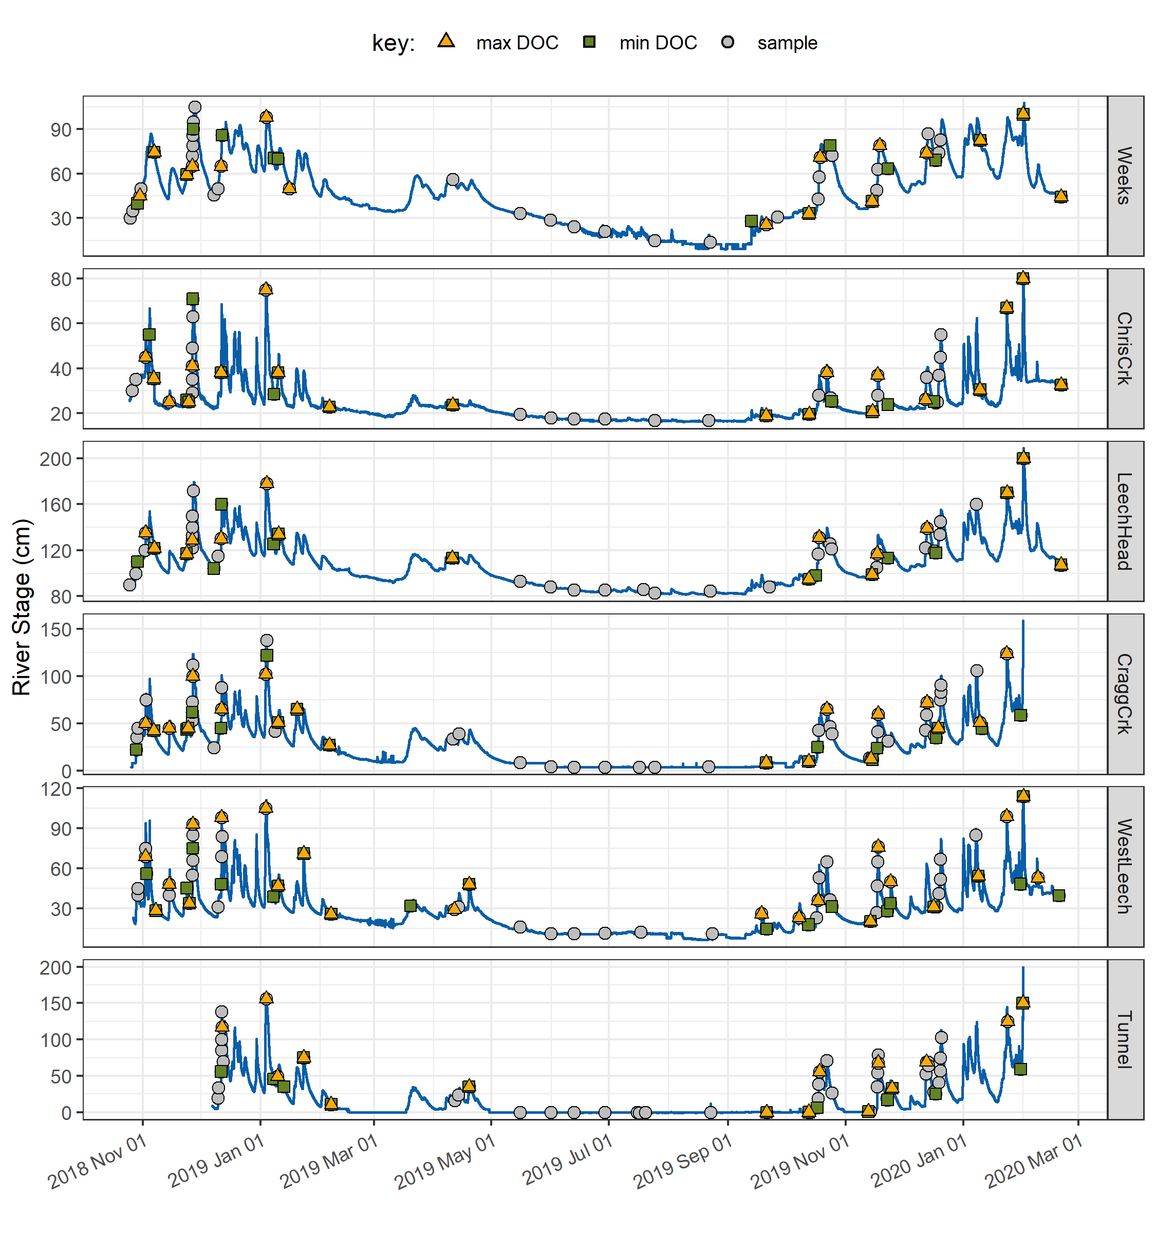

Figure 27: Stage and samples collected, highlighting samples with maximum and minimum DOC concentrations for each sampled rain event and collection period

For events where several samples were collected, the change in DOC concentration varied from a little more than 1% to nearly 100% (Table 19). The smallest event-based concentration changes occurred at the head and mouth of Leech River: Leech-head (1.2%) and the Tunnel (1.4%). The largest event-based change in concentration was observed at West Leech (94.6%), and the second largest change occurred at Chris Creek (82% change in DOC).

Table 19: Summary of DOC changes within stormflow response to precipitation events across the Leech WSA (samples from wet season only)

|  |  |  |  |  |  |  |
| --- | --- | --- | --- | --- | --- | --- |
| site | lowest DOC in stormflow (mg/L) | highest DOC in stormflow (mg/L) | smallest change in DOC (mg/L) | largest change in DOC (mg/L) | smallest difference in DOC during stormflow (%) | largest difference in DOC during stormflow (%) |
| Weeks | 6.1 | 16.1 | 1.0 | 6.4 | 9.6 | 53.2 |
| ChrisCrk | 2.3 | 9.2 | 1.2 | 3.9 | 26.1 | 82.0 |
| LeechHead | 5.7 | 10.3 | 0.1 | 2.0 | 1.2 | 29.5 |
| CraggCrk | 3.0 | 8.2 | 1.2 | 3.2 | 28.8 | 67.5 |
| WestLeech | 2.5 | 10.9 | 0.1 | 5.8 | 4.5 | 94.6 |
| Tunnel | 3.4 | 5.9 | 0.0 | 2.0 | 1.4 | 42.5 |

### Discussion

The sampling conditions and watershed characteristics included in Random Forest variable importance measures (RF VIM) showed that across the six monitoring sites in the Leech WSA, stream NOM quality and quantity were most influenced by warm and wet conditions and the parent material in each basin. No model is perfect, and the relative importance derived from RF VIM in this chapter was limited to the data provided and the assumptions associated with those data. Based on the variables assessed, sampling stage and antecedent wetness ranked among the most important variables for predicting NOM quantity and quality, as did the percent of wark gneiss underlying each basin.

NOM quantity and quality in each sub-basin was inversely related to representation of metamorphic wark gneiss parent material, but the absence of wark gneiss did not correspond to the site with greatest NOM quantity or reactive character. The patterns observed between NOM and metamorphic parent material suggests that aqueous NOM may be affected by combinations of watershed characteristics and more complex relationships that weren’t elucidated in this analysis. For example, combinations of parent materials and soil development may be more important than either variable alone. Similarly, the metasedimentary Leech River formation (argillite metagreywacke and metagreywacke) was inversely correlated (-0.92) to wark gneiss (and cross correlated to other variables) in the monitoring basins and therefore was not included in RF VIM analyses. The Leech River formation was the predominant parent material on the west side of the Leech WSA. Sub-basins draining from the west, Weeks creek and West Leech, also had the lowest percent area harvested from 1980 to 2011 (~28% and ~26%, respectively), and had greater quantities of larger, more aromatic and reactive aqueous NOM. While there was no clear link between NOM quantity and quality with average tree age or harvest history, perhaps the combination of less logging on this more erodible metasedimentary geolith contributed to NOM dynamics more than either other those variables alone.

Sub-basin slope was negatively correlated to percent wetland (-0.73), and wetlands are known to be linked with high DOC concentrations and NOM aromaticity (e.g. Oliver et al. (2017); Aiken and Cotsaris (1995); Ågren et al. (2008); Musolff et al. (2018)). In general, lower sub-basin slope was related to greater NOM aromaticity, reactivity and concentration.

Stream stage was an important variable for predicting the quantity and reactivity of NOM in streams, whereas antecedent wetness conditions were more important for predicting NOM molecular size and aromaticity. The relative sensitivity of DOC concentration to stream stage points to hydrologic mass transport, whereas the sensitivity of NOM molecular character to antecedent wetness points to the importance of hydrologic connectivity between streams and the terrestrial landscape as a source of allochthonous NOM.

Antecedent wetness is an important watershed driver for NOM export as it influences flow paths and hydrologic connectivity to source material (McMillan et al. 2018). Solute supply and hydrologic connectivity can be interpreted through the magnitude and direction of water quality changes in response to precipitation (Vidon, Wagner, and Soyeux 2008; Abbott et al. 2018; Creed et al. 2015; Zarnetske et al. 2018). In the Leech WSA, stage changed in response to precipitation and there was an apparent threshold (near 0.75 of peak sampling stage) that suggested a point at which terrestrial aromatic NOM pools had reached peak connectivity to the monitored streams.

A pattern in DOC concentration during rising stage can provide information about NOM source and flux dynamics. Increasing DOC with rising stage suggests NOM transport dynamics were driven by hydrologic connectivity to an unlimited supply of source material. Alternatively, if DOC concentrations decreased with rising stage it’s likely that the NOM source pool was limited (Zarnetske et al. 2018). Event-based rising limb changes in DOC concentration varied from a little more than 1% (at Leech-head and the Tunnel) to 95% (at West Leech). Early in the wet season there was a decrease in NOM quantity with increasing flows (higher stage), and as the wet season progresses, stream NOM quantity and aromaticity increased with increasing flows. These results show a temporal shift in NOM source pools, from those of limited supply early in the wet season, to those of near-unlimited supply later in the wet season (Zarnetske et al. 2018). In the Leech WSA monitoring sites, the most aromatic and highest molecular weight NOM samples were collected late in the wet season. Late wet-season samples results were more in line with the pulse-shunt concept than early wet-season samples (PSC, Raymond et al. (2016), Aguilera and Melack (2018)).

Certainly, stream discharge is well respected as a key driver for NOM flux in stream systems (Raymond et al. 2016; Zarnetske et al. 2018; Oliver et al. 2017; Musolff et al. 2015). In a west coast small-basins (< 1 km2) study in the H. J. Andrews Experimental Forest (Oregon, CA) pre-storm DOC was measured at three sites as 1-2 mg/L with increases to 5-7 mg/L (~200% increase) during events (Hood, Gooseff, and Johnson 2006). In the Leech WSA, DOC concentrations at the onset of stream rise were higher (2-6 mg/L) as were peak rising limb concentrations (6-16 mg/L), resulting in relative rising limb DOC changes bring less dramatic (<100% increase) than Hood et. al found (2006). While the same relative magnitude of change in DOC was not measured in the Leech WSA, the methods used by Hood et al (2006) included continuous monitoring as opposed to this study which quantified discrete samples. It’s possible that the changes in DOC that were not captured (i.e. in the stage between vertically staggered Rack bottles) could have shown greater deviation. Or, the magnitude of change in the Leech WSA could simply be lower than in H.J. Andrews, possibly due to relatively higher baseline DOC concentrations.

Across the Leech WSA, stream samples with the highest DOC were collected at the highest sampled stage 83% of the time; and there was an 80% co-occurrence of low DOC with low sampling stage. These results indicate an overall pattern of increasing DOC with stage, suggesting that approximately 80% of the time Leech Watershed streams were hydrologically connected to a rich supply of NOM. Furthermore, there was a positive relationship between sample aromaticity and stage at the Tunnel, where streamflow from all sub-basins’ is integrated; when coupled with the observed stage-DOC dynamics, this indicates that the supply of NOM was humic in origin approximately 80% of the time.

In three of the six monitoring sites, low DOC was more often collected at low stages than high DOC was at high stages; the opposite was found at West Leech, where concentration and stage had a greater proportion of common maxima compared to common minima. The headwater sub-basin sites of Chris Creek and Leech-head had the same proportions of samples with common maxima and minima of DOC and stage. These patterns changed across the wet season. Peak stage was more often associated with minimal DOC early in the wet season, whereas DOC tended to peak with stage (or close to peak stage) later in the wet season. That is, when there was more water (later in the wet season) DOC tended to peaked with stage, whereas early in the wet season DOC was diluted as stage increased; these results point to NOM supply and hydrologic connectivity to terrestrial source pools and not to in-stream dilution effects. These observed temporal changes in NOM concentration with stage are additional evidence of early wet-season NOM being limited in supply and subject to rapid flushing, while late wet-season NOM in streams was drawn from a more sustainable pool of source material. The apparent stage and wetness threshold for NOM concentration and character (approximately 75% of maximum stage and about 150 mm of antecedent 30-day rain), suggested a point at which humic NOM sources either reached maximum connectivity with the streams, or that the aromatic source pools were depleted. Aanother possible explanation for the concentration-stage threshold could be indicative of a transition point in the event hydrograph from soil water contributions to throughfall and overland flow (Penna and Meerveld 2019).

The quantity of stream NOM was greatest early in the wet season, with peak DOC concentrations found in the first event-based samples; while NOM aromaticity, reactivity and molecular weight peaked later in the wet season. Coupled with the other results, this indicates that early wet-season rain events exported high concentrations of aliphatic NOM from sources that were likely autochthonous and quickly depleted. Between the wet and dry season, there were opposite spatial patterns for NOM molecular size and aromatic character. NOM aromaticity and molecular size increased from upstream to downstream in the dry season, while the wet season showed decreasing aromaticity from head to mouth. The different seasonal patterns in NOM quality support a change in source material and a shift from NOM processing in the dry season to dilution effects in the wet season. These results show that the Pulse Shunt Concept dominated aqueous NOM dynamics in the wet season (when hydrologic pulses were strongest). The River Continuum Concept may better explain the spatial NOM dynamics observed in the absence of hydrologic pulses, during the dry season.

### Summary

Spatial variation in aqueous NOM quantity and quality was determined to be partly driven by sub-basin parent material. Parent material and soil types are linked to chemical loads in surface waters, which can be partially attributed to differences in hydraulic conductivity and water storage capacity (Musolff et al. 2015). Geological factors have been linked to stream alkalinity and total dissolved solids (e.g. Johnson et al. (1997)) and inorganic chemicals (Feller 2005). As geological weathering is strongly linked to temperature, as well as physical forces (e.g. Feller (2005)), the RF VIM results of warm and wet conditions coupled with sub-basin parent material point to a set of interrelated abiotic drivers for aqueous NOM dynamics. Although the precise relationship was not completely resolved, it was evident that a greater proportion of metamorphic parent material corresponded to lower concentrations of less aromatic and less reactive NOM in streams. Not studied in this project were biotic variables (e.g. in-stream and riparian invertebrates, microbes and algae), which would also be affected by temperature regimes and would display dynamic fluctuations with NOM quantity and quality.

Approximately 80% of the time during hydrologic pulses in the wet season, monitoring sites were connected to rich supplies of humic NOM. For a shorter time, early in the wet-season, streams exported high concentrations of aliphatic NOM from autochthonous sources that were subject to rapid flushing and were quickly depleted. Streams were hydrologically connected to sustainable pools of allochthonous source material later in the wet season. It appeared that when streams were near 75% of their maximum stage (therefore, approximately 0.75 of peak flow) humic source pools reached maximum connectivity with the streams.

Overall, wet season NOM dynamics followed the Pulse Shunt Concept, with greater concentrations of DOC moving through the streams near peak flow, relative to other stream stages. There was also a longitudinal reduction in wet-season NOM quantity and reactive quality along the reach of Leech WSA streams. In the wet season, spatial NOM dynamics also followed predictions of the River Continuum Concept (RCC) in that NOM quantity and reactive quality decreased from headwaters to higher order streams, though this may have been due more to dilution effects than ecological processing. Counter to anticipated RCC-based patterns, NOM with greater aromaticity and molecular size was found at downstream sites in the dry season. Further exploration of NOM quality across stream reaches in the dry season may yield insights into variable sources such as relative groundwater contributions to dry-season baseflow.

Although sampling stage was directly related to rain conditions in the Leech WSA, in that more rain generated greater stream rise (and therefore discharge), antecedent rain was relatively more important as a predictor for NOM quality than sampling stage was. These results indicated that antecedent landscape wetness created greater hydrologic connectivity to terrestrial NOM source pools, and that connectivity was more important than stream stage itself. Antecedent wetness has been shown to be important for pre-concentration of soluble allochthonous NOM and associated constituents (Oswald and Branfireun 2014), and increasing hydrologic connectivity for greater fluvial NOM export (Kiewiet et al. 2020; McMillan et al. 2018; Biron et al. 1999; McGuire and McDonnell 2010; Musolff et al. 2018).

### Future directions

In the future, Vertical Rack sampling (and matched filling-stage with continuous logger stage) could be combined with a rating curve to determine mass transport or loading. Combining methods of vertical sampling racks with standard synoptic grab sampling provided useful time-stamped discrete river samples data that could be adapted and correlated to local rating curves to calculate loads of river material (e.g. nutrients, metals, organics, etc.) exported from monitored catchments. Material transport loads are important for management decisions and comprehensive system understanding.

It was assumed that the arithmetic means of precipitation measured at Chris Creek and Martin’s Gulch Fire Weather Stations were representative of conditions across the Leech WSA and mean rain data were applied to all monitoring sites (Chapter 2). However, it is entirely likely that the West Leech sub-basin experienced different weather than the rest of the watershed; observations during field work (Appendix A2) support this possibility. When a weather station is constructed in the West Leech basin, more precise explorations could be conducted with respect to antecedent wetness and water quality dynamics.

The security of drinking water supply quality depends on weather, which is also a major player in other risks to the forested watershed. It was evident that antecedent wetness and stream stage were important in dictating NOM dynamics in the Leech; with additional weather data it would be informative to establish relationships for NOM dynamic predictor variables that are also associated with increased fire risk (i.e. temperature, relative humidity, antecedent rain, wind speed and direction) or mass wasting (i.e. excessive rainfall). Identifying hydrometeorological indicators common to water quality and natural risk management could provide efficiency in operational watershed management. With greater understanding of the conditions and characteristics that drive water quality dynamics, an index system could be created that incorporates predictors for drinking water supply quality with those for forested watershed threats (e.g. wildfire, windthrow, or mass wasting events).

## Recap and Conclusions

### Introduction

This research was conducted to better understand spatial and temporal variations in source water quality across a second-growth forested watershed. Water quality dynamics were evaluated as the quantity and quality of natural organic matter (NOM), a master variable in aquatic systems. Three research questions and objectives were addressed in this thesis. The first research objective was to design a sampling strategy for evaluation of spatial and temporal patterns and variance in NOM quality and quantity across 12 sites in the Greater Victoria Water Supply Areas (Chapters 2 and 3). The second research objective was to identify which watershed characteristics and hydroclimatic conditions best explained the aqueous NOM dynamics observed through sampling (Chapter 4). This chapter speaks to the third research objective, of framing results in context of continued water quality monitoring and planning for drinking water supply and future inter-basin transfers in the Greater Victoria Water Supply Areas (GVWASA).

### Synopsis

Vertical Racks were used to passively sample the rising-limb of event hydrographs at six monitoring sites in the Leech WSA. Rack sampling was coupled with synoptic Grab sampling campaigns to measuring water quality changes over 16 months from October 2018 to February 2020. Aqueous natural organic matter (NOM) quantity was measured as the concentration of dissolved organic carbon (DOC), and NOM quality was assessed by proxy using UV-Vis spectroscopic proxies. The molecular structure of NOM (i.e. it’s quality) can vary from large, highly aromatic compounds to smaller aliphatic molecules and differences can be attributed to the source material. Terrestrial humic substances (i.e. allochthonous NOM) tends to be higher molecular weight, larger and more aromatic in structure; while in-stream sources of NOM (i.e. autochthonous NOM), such as algae, are typically more aliphatic in structure. The spectral absorbance coefficient at 254 nm (SAC254) was used as an indicator of NOM reactivity and the quotient of SAC250 to SAC365 (E2:E3) was used as an indicator of NOM molecular size and aromaticity (Peuravuori and Pihlaja 1997; Helms et al. 2008). Results of these studies yielded six key findings which are provided below and discussed in the following sections.

### Key findings

Foundational results and method development (Chapter 2) elucidated two key findings:

1. Vertical Rack stream water sample stability depended on the field conditions that samples were held under and the character of NOM contained in the sample: early wet season NOM was more aliphatic and less stable, mid- to late-season samples were stable up to 20 days at temperatures between 0-7° C, and freezing appeared to change NOM molecular attributes
2. SAC254 was a better indicator of disinfection byproduct formation potential (DBP-FP) than was DOC concentration or specific UV absorbance at 254 nm (SUVA254).

Analyses of NOM quantity and quality over space and time clarified spatiotemporal patterns and drivers for NOM dynamics, which included these main findings:

1. In each season, DOC concentration was loosely correlated to air temperature, with higher concentrations occurring at warmer temperatures and lower concentrations occurring at lower temperatures
2. There was a seasonal shift in NOM character, from predominantly aliphatic in the dry season to predominantly aromatic in the wet season. And despite differences in seasonal patterns, averages in DOC concentration were equal (6 ± 3 mg/L) in both wet and dry seasons
3. NOM quantity decreased from upstream to downstream in both seasons, as did NOM reactivity. However, while NOM molecular size and aromaticity decreased from low to high order streams in the wet season, the reverse was observed in the dry season
4. In the Leech WSA, streams draining the west of the watershed had higher DOC concentrations of more reactive and aromatic NOM compared to streams draining from the east; the western sites also had the least area harvested (1980-2011) of the six sub-basins. While Random Forest (RF) variable importance measure (VIM) identified forest age and harvest history as important predictor variables for NOM aromaticity and molecular size, RF VIM determined that subsurface parent material was a key driver for NOM quantity as well as quality. The west of Leech watershed has predominantly Leech River formation (metasedimentary) as parent material, while the east is predominant wark gneiss parent material (metamorphic).

### Implications for drinking water supply and watershed management

The quantity and quality of aqueous NOM varied over space and through time; understanding these patterns can help to inform source drinking water management decisions by providing insights to the origins, transport and fate of aqueous NOM and other parameters associated with it (e.g. metals, correlated DBPs). Treatability concerns could result from natural fluctuations in NOM character and concentrations across a water supply area and over time (Levine, Yang, and Goodrich 2016); Li et al. (2014); Yang et al. (2015)). The molecular composition and physical structure of NOM influence its functionality and reactivity, therefore different types of aqueous NOM have different DBP-FPs and aquatic ecosystem roles (Cory, Boyer, and McKnight 2011; Delpla and Rodriguez 2016; Yang et al. 2015; Health Canada 2019b; Chow et al. 2008). As NOM is an aquatic master variable, site-specific knowledge of relationships between NOM quantity and quality with other water quality parameters or contaminants (e.g. metals, nutrients, algae blooms) could allow for extrapolation and anticipation of treatment challenges.

Overall, DOC concentrations in the Leech WSA were higher than BC source water Guidelines suggest (4 mg/L). However, it should be noted that if Leech River water is transferred to a reservoir prior to treatment that NOM is likely to be photodegraded or diminished through microbial processing (Kalbitz et al. 2000; Stanley et al. 2012; Aiken, Hsu-Kim, and Ryan 2011). While it is important to understand the source, transport and fate of aqueous NOM (and its associated parameters) in the Leech WSA, the fluvial source water quality is unlikely to directly reflect the water at the intake tower due to reservoir residence times and the effects of photodegradation, physiochemical reactions and changes, biodegradation, transformation, or possibly bioproduction of NOM. Having a sound understanding of the timing and magnitude of NOM flux and anticipating temporal changed in NOM quality (especially reactivity) will provide valuable baseline information to feed into further water supply studies.

It will be informative to explore mixing studies between Leech River water with a balancing reservoir or other tributary in Sooke basin. The Leech River will introduce new material and new conditions (e.g. different temperatures, dissolved oxygen, carbonate for buffering or organic acids altering pH, new microbiota). As mixing is likely to change source water attributes, a balancing reservoir to stabilize between river and reservoir may be extremely useful. Future studies of Sooke Reservoir limnology and watershed water balance would be helpful to anticipate potential biogeochemical interactions and possible treatment challenges.

### Concluding remarks

This research contributes to baseline understanding of spatiotemporal dynamics of NOM quantity and quality across the GVWSA second growth forested watershed. These baseline data can be applied in further exploration of forest management strategies, such as fire fuel management, and impacts on source water quality and supply. For example, knowing that hydrologic connectivity to the terrestrial landscape increases throughout the wet season suggests that there may be a delay in measurable water quality changes following experimental forest treatments (e.g. prescribed burning, closed canopy fire break thinning, etc.) or natural disturbances (e.g. wasting events, wildfire). Therefore, hydrologic and water quality monitoring programs could be tailored to this consideration.

Further evaluation of water quality data with hydrometeorological variables could foster the establishment of operational risk indices that link to current monitoring programs (i.e. wildfire risk index). And coupling Vertical Rack sampling methods with hydrometric monitoring and rating curves would contribute to estimates of fluvial mass transport and loads (e.g. of contaminants).

Although this research was site-specific to the GVWSA, results – including sampling strategies and spatial and temporal variation in water quality – can be applied in other forested hydrology water quality studies that examine adjacent basins and nested catchments.

# References

# Appendices

NSERC forWater Network & the Capital Regional District

The forWater NSERC Network for source water protection strategies is a transdisciplinary, cross-Canada, applied research collaboration focused on the connections between treated drinking water quality and land-use impacts of forest management. The majority of source drinking water originates in forested headwaters, so forWater researchers are studying water quality in watersheds across Canada, under a variety of different forest management strategies. Through collaborative analyses, forWater is working to evaluate source water treatability metrics, downstream propagation effects, and resource economics with the goal of providing a framework for treatment demands as they relate to forested source water.

Greater Victoria Regional Water Supply System, CRD

The Capital Regional District (CRD) owns and operates the water supply system for the Greater Victoria region. As a water purveyor, CRD supplies an average of 130 million liters of treated water to customers each day (130,000 m3 day-1) (CRD 2017). The provision of safe and sustainable drinking water has three tiers of regulation above the CRD: federal, provincial, and regional. Federally, Health Canada publishes Canadian Drinking Water Quality Guidelines which outline quantitative bounds for microbial, chemical, radiological parameters and physical aesthetic characteristics for safe drinking water. The province of British Columbia sets requirements for planning, reporting and regulating of drinking water providers through the Drinking Water Protection Act and the Water Sustainability Act, and the Public Health Act and Regulations. Regionally, the CRD reports to the Vancouver Island Health Authority (Island Health) regarding water quality information and provincial legislation.

The Greater Victoria Water Supply Area (GVWSA) includes 20,549 hectares (205.49 km2) of protected drinking water catchment lands. The primary water supply is sourced from Sooke reservoir, the secondary supply source is Goldstream reservoir and the designated (supplemental) future water supply is the Leech River watershed. Unfiltered source water is first treated with ultraviolet light and free chlorine (to deactivate parasites, bacteria and viruses); secondarily, ammonia is added to produce chloramine, a long-lasting disinfectant that persists through distribution systems (CRD 2017).

The Leech River watershed is a sub-catchment of the Sooke River watershed (~25% by area), located west of Sooke Reservoir (primary water supply for the Greater Victoria Area). In anticipation of future water demands and uncertainty related to rainfall and climate change, the Capital Regional District (CRD) purchased 9,628 hectares (about 92%) of the Leech River watershed in 2007 (84%) and 2010 (additional 8%), and designated the Leech Water Supply Area (LWSA) for future supplemental water supply.

In 1977, the CRD obtained a provincial water license authorizing the diversion of up to 30.6 million cubic meters per year from the Leech River to the Sooke Reservoir (Ussery and AECOM 2015). Based on the 2017 strategic plan statement of a daily average water supply of 130,000 m3 (2017), the Leech water license could contribute about 65% of 2017 average water supply. The license allows diversion only as long as minimum flows (>5.7 m3 s-1) are maintained to protect fish and downstream ecology (Ussery and AECOM 2015). Based on current hydroclimatic dynamics, the water license flow requirements will exclude the summer months from inter-basin transfer and limit streamflow diversion to the winter (November to approximately April). The Leech Tunnel was constructed in the 1980s to transfer Leech River water into the Sooke Reservoir. The Tunnel is not currently operational, and it’s anticipated that inter-basin transfer won’t be required until 2050 or later.

Leech water supply area monitoring sites: details and observations

The Leech River watershed (“the Leech”) is located on south-east Vancouver Island, British Columbia, Canada. Like most of coastal BC, it is in the Coastal Western Hemlock Biogeoclimatic Zone. The hydroclimatic regime of the Leech is pluvial (i.e. rain-dominated). Annual rainfall is typically around 2500 mm/yr. This areas has a strong seasonal distribution of rainfall: approximately 90% of rain falls from September to April, with only about 10% of annual rainfall occurring from May to August. Across the Leech, elevation ranges from approximately 200 m above sea level (asl), near the Leech Tunnel, to 941 m asl in the centre of the watershed, at the top of Survey Mountain. While the majority of precipitation falls as rain, snow does accumulate for short periods at higher elevations.

Around 99% of the Leech WSA is forested. The Leech forests are dominated by western red cedar, western hemlock, and Douglas fir; subspecies include Amabalis fir (Pacific silver fir), white pine, yellow cedar (at higher elevations), Alder, broadleaf maple, and arbutus. Prior to purchase by the CRD, the LWSA was privately managed forest land that was harvested from the mid-1940s to 2007 (Ussery and AECOM 2015). Approximately 95% of the Leech watershed was harvested by clear cut prior to 2007 (Ussery and AECOM 2015, @CRD2019); as a result, ~94% of LWSA forests are younger than 60 years old and a large portion of stands are under 30 years of age. Now designated as a Water Supply Area, the CRD manages the Leech for source water protection, ecosystem services, and forest resilience. As forest fires pose a serious threat to monocultured and even-aged stands, particularly during the drought of summer, forest fuel management is an important preemptive risk reduction for the CRD (CRD 2019).

The Leech River system is composed of three mainstem rivers, numerous tributaries, and four small headwater lakes. Hydrologic responses vary with terrain steepness, soil infiltrability, vegetation, percent cover of lakes and wetlands, air temperature and the intensity and duration of precipitation. In the Leech, runoff peaks in the winter under saturated conditions. In the wet season, rivers in the Leech watershed are flashy: they respond rapidly to precipitation events, rising and falling dramatically. In 1993 CRD Water Services set up a hydrometric monitoring station on the Leech River (about 3.5 km downstream of the Tunnel) to measure discharge with hourly stage measurements (Ussery and AECOM 2015). Peak flow on the lower Leech River was recorded as 168 m3s-1 (in October, 2003) (Ussery and AECOM 2015). However, the rating curve at this historic gauging station was not verified over time and hydraulic action rendered it unreliable.

Overall, the hydrology of the LWSA is poorly understood, as are water quality dynamics. In the mid-1980s, some water was transferred from the Leech River into Deception Gulch and Reservoir (adjacent to but physically separated from Sooke Reservoir). The mixing resulted in biological water quality problems that included odour and raised concerns about the operational usage of the existing tunnel. The Leech River Tunnel and anticipated inter-basin transfer will provide interesting research opportunities which are beyond the scope of this thesis research. Before work is done on inter-basin transfers, the hydrology and water quality of the Leech River system need to be better understood. Understanding source water quality, as well as the timing and magnitude of flows, is an essential component to multiple barrier approach to ensuring clean drinking water.

Six sites were selected across the Leech Water Supply Area. The six research sites represent five nested catchments and the entire water supply area basin defined from the point of (future) diversion, the Leech Tunnel.

Weeks Creek (site 1)

The Weeks Creek (on Weeks Main) research site monitored water draining approximately 16 km2 of the northwest Leech River watershed, including a wetland (Jordan Meadows fen) and Weeks Lake (approximately 27 ha) (Ussery and AECOM 2015). Jordan Meadows wetland drains to the east and joins the outflow of Weeks Lake (south end of the lake). The wetland and lake outflow streams join and flow east to Research Site #1, “Weeks”, which is a third order stream (Strahler) of the western headwaters of Leech River. The channel is straight, with bed and bank material appearing to be primarily silt/clay (fine grain, easily suspended). The water at this site was notably tannin-coloured. This research site was located about 0.4 km west (upstream) of the confluence with Chris Creek.

A large culvert upstream of the monitoring site was replace with a bridge in August of 2019. The culvert had been perched above the streambed level and was obstructing the movement of fish and water flow. Prior to the culvert removal, several groundwater seeps were observed downstream; these seeps maintained base flow of summer waters in this low-relief stream reach. There were high levels of iron (above Guideline aesthetic objectives) in the water downstream of the culvert, possibly due to culvert rust.

(Figure 28).



Figure 28: Photo of Weeks Creek, site 1 in the Leech WSA

Chris Creek (site 2)

Chris Creek is the western headwaters of Leech River. This research site was approximately 0.2 km east (upstream) of the confluence with Site 1, Weeks Creek. The study site on Chris Creek monitored waters draining from approximately 9.6 km2 of forested land, including Worley Lake (approximately 3.5 ha) (Ussery and AECOM 2015). The monitoring site of Chris Creek was downstream of a bridge, on a slightly sinuous reach with boulders and bedrock and turbulent cascading step-pool morphology. Coarse woody debris was observed upstream of the Chris Creek monitoring site, with obvious new deposits on the banks following a high intensity rain event and associated flooding in January 2020.

Leech Head (site 3)

Research site 3 was approximately 1.4 km downstream of the confluence of Weeks and Chris Creeks. The “Leech Head” study site, a 4th order stream, was in a pool between riffles with predominantly Schist bedrock and low relief (~2%) and relatively straight morphology. The water at this site was often coloured by tannins (likely from Weeks, upstream). There once was a logging bridge across the river at this site; rip-rap remains on either bank.

Cragg Creek (site 4)

Cragg Creek is a mainstem river that originates in the northeast of the Leech River watershed. Cragg Creek site, a 4th order stream, had a drainage area of approximately 37 km2 that included Jarvis Lake (15 ha). The Cragg Creek research station was installed upstream of a bridge, at a CRD hydrological monitoring site (installed over the span of this thesis project). The bed morphology at this site is Schist bedrock and the stream is straight channel with fairly high width-to-depth ratio. Upstream of the bridge Cragg Creek flows turbulently along a low slope, and downstream of the bridge it cascades into several deep pools. From the Cragg Creek research site, the river flows approximately 4.5 km through a steep ravine to confluence with the Leech River (this confluence is around 6 km downstream of the Leech Head site, site #3).

A fall algae bloom was observed in Cragg Creek November 2019 and was also observed in most of the streams and creeks draining the east side of Survey Mountain. The Algae was identified by CRD microbiologist Huy Nguyen as Draparnaldia, a green-algal species, that occurs mostly in clean, cool (often spring-fed) streams (personal communication).



Figure 29: Draparnaldia species of green algae (nicknamed ‘Christmas Tree’) identified in a fall bloom at Cragg Creek (site 4) November 2019

West Leech (site 5)

Originating in the west of the Leech River watershed, West Leech River is a 4th order mainstem river. The West Leech research site monitored a drainage area of approximately 35 km2 which included a small lake (Boulder lake) at the southwest of Leech watershed. This research site had boulder and bedrock substrate, straight channel with relatively high width-to-depth ratio and pool-riffle morphology. The West Leech site is approximately 120 m upstream of the confluence with Leech mainstem (~1.5 km downstream of the confluence of Cragg Creek with Leech River). During sampling trips, different weather patterns were consistently observed at the West Leech monitoring site compared to other sampling sites in the Leech watershed. For example, consistent rain was sometimes falling at the West Leech site, when other sites in the Leech were dry.

Leech Tunnel (site 6)

This research site was at the point of future diversion, the Leech River Tunnel. The Leech is a 5th order river, and this research site had a drainage area of approximately 96 km2 (the entire watershed above the point of diversion). The stream bed here is dominated by Schist bedrock and boulders. The bedrock in the center of the channel is deeply incised but overall, the river is wider than it is deep. The Tunnel site was approximately 1 km downstream of the West Leech confluence.

Field protocol

Following the installation of a vertical sampling rack, the field protocol was to visit the site approximately biweekly (or more frequently, based on storms) to check, collect and set the rack. Every time a site was visited, a grab sample was also collected. When a bottle was placed on its rack (attached by 3" hose clamp), the filling stage (height of intake tube crown) was recorded relative to the central still well tape. Bottles were staggered, generally from water level to approximately 120 cm above water level (as experience showed that a bottle should always be placed above the stage of anticipated peak streamflow). Following a rain event, each site was revisited to collect rack samples; for full bottles, the siphon lid was replaced with a labelled HDPE lid and samples were transported in a cooler with ice packs back to the lab and refrigerated until analysis.

Weather and Climate (Chapter 2 results extended, ancillary data)

Climate normals and weather anomalies

The Pacific Climate Impacts Consortium (PCIC, pacificclimate.org) assembles data from BC Ministry of Environment and Climate Change’s Monitoring Program to provide BC climate data of monthly weather anomalies from 1970 onward. Departures from normal were collated for monthly average daily maximum and minimum air temperature as well as total precipitation measured at two stations located southwest (Bear Creek. Res.) and northeast (Shawnigan Lake) of the GVWSA (Table 20).

Table 20: Pacific Climate Impacts Consortium British Columbia weather stations used to establish weather anomalies and departures from normal for the study period from Oct. 2018 to Feb. 2020

|  |  |  |  |
| --- | --- | --- | --- |
| Station_name | Elevation_asl | Latitude (°W) | Longitude (°N) |
| Bear Ck Res. | 419 | -123.9139 | 48.50333 |
| Shawnigan lake | 138 | -123.6767 | 48.64722 |

Based on the PCIC weather anomaly data, the study period (October 2018 through to February 2020) was 0.56° C warmer and 13.4% drier than normal (Table 21). On average, each of the sampled wet seasons were drier than normal (26% and 5%) and the dry season was 1.4% wetter than normal. Prior to the start of the project, the summer/dry-season was 38% drier than normal and 1.6°C warmer.

Table 21: Average weather departures from climate normals from Bear Creek Reservoir and Shawnigan Lake weather stations

|  |  |  |  |  |
| --- | --- | --- | --- | --- |
| Sampling season | Date range | Temperature departure (°C) | Precipitation departure (%) | Precipitation departure (mm/mo) |
| Dry period before project start | June 2018 - Sept. 2018 | 1.58 | -37.9 | -14.8 |
| 2018/2019 wet season | Oct. 2018 - May 2019 | 0.48 | -26.2 | -25.5 |
| 2019 dry season | June 2019 - Sept. 2019 | 0.94 | 1.4 | 6.4 |
| 2019/2020 wet season | Oct. 2019 - Feb. 2020 | 0.38 | -4.6 | 10.2 |
| Study period | Oct. 2018 - Feb. 2020 | 0.56 | -13.3 | -7.5 |

Most, though not all, months had weather anomalies that were warmer and drier than normal (Table 22). In the 4.5 months prior to the start of the project, it was 1.6° C warmer and 38 % drier than normal; the 2018 wet season (October 2018 - April 2019) was 0.5° C warmer and 26 % drier than normal; the 2019 dry season (May - Oct) was 0.9° C warmer and 1 % wetter than normal; and the 2019 wet season was 0.38° C warmer and 5% drier than normal, with two precipitation anomalies that departed from normal by more than 100%: Sept 2019 was 108% wetter than normal and January 2020 was 136% wetter than normal)

Table 22: Average monthly weather anomalies from 1970 onward at Bear Creek Reservoir and Shawnigan Lake weather stations

|  |  |  |  |  |  |  |  |  |  |  |
| --- | --- | --- | --- | --- | --- | --- | --- | --- | --- | --- |
| Year | Month | Min. temp. departure (°C) | Max. temp. departure (°C) | Precipitation departure (%) | Precipitation departure (mm/mo) | X7 | X8 | X9 | X10 | X11 |
| 2018 | June | 0.53 | 1.47 | -32 | -36.5 |  |  |  |  |  |
| 2018 | July | 1.20 | 4.63 | -95 | -33.1 |  |  |  |  |  |
| 2018 | August | 1.05 | 4.10 | -89 | -40.2 |  |  |  |  |  |
| 2018 | September | 0.46 | -0.78 | 64 | 50.8 |  |  |  |  |  |
| 2018 | October | 0.22 | 0.64 | -45 | -60.2 |  |  |  |  |  |
| 2018 | November | 2.21 | 1.42 | -16 | -15.4 |  |  |  |  |  |
| 2018 | December | 1.36 | 0.85 | 32 | 119.1 |  |  |  |  |  |
| 2019 | January | 1.86 | 1.57 | 19 | 65.0 |  |  |  |  |  |
| 2019 | February | -3.74 | -4.87 | -51 | -123.2 |  |  |  |  |  |
| 2019 | March | -2.59 | 1.13 | -86 | -151.0 |  |  |  |  |  |
| 2019 | April | 1.06 | 0.50 | 5 | 13.4 |  |  |  |  |  |
| 2019 | May | 2.12 | 3.90 | -69 | -51.3 |  |  |  |  |  |
| 2019 | June | 0.87 | 1.92 | -75 | -29.9 |  |  |  |  |  |
| 2019 | July | 1.00 | 0.06 | 12 | 4.9 |  |  |  |  |  |
| 2019 | August | 1.55 | 1.35 | -40 | -15.4 |  |  |  |  |  |
| 2019 | September | 2.01 | -1.25 | 108 | 66.1 |  |  |  |  |  |
| 2019 | October | -1.17 | -0.91 | -18 | -18.4 |  |  |  |  |  |
| 2019 | November | 0.05 | 1.39 | -65 | -212.8 |  |  |  |  |  |
| 2019 | December | 2.21 | 0.80 | -17 | -32.5 |  |  |  |  |  |
| 2020 | January | 1.07 | -0.14 | 136 | 407.9 |  |  |  |  |  |
| 2020 | February | 0.36 | 0.12 | -60 | -93.0 |  |  |  |  |  |
|  |  |  |  |  |  |  |  |  |  |  |

FWx stations in the LWSA

There were two weather stations that operated during the study period: Chris Creek station is in the headwaters of the LWSA and Martin’s Gulch station is located near the future diversion point (Leech River Tunnel).

The CRD provided weather station data from Chris Creek and Martin’s Gulch weather stations from January 2018 to March 2020. Slightly more precipitation was recorded at Martin’s Gulch than Chris Creek station (Figure 30, Table 23). Data from these two FWx stations were used to calculate arithmetic means of LWSA weather (see Chapter 2).



Figure 30: Weather from FWx stations in the Leech water supply area. Coloured sections of plots highlight the field study period of this project

Table 23: Annual weather from CRD FWx stations in the Leech water supply area

|  |  |  |  |  |  |  |  |
| --- | --- | --- | --- | --- | --- | --- | --- |
| Year | station name | annual rain. (mm) | max snow (m) | mean air temp. (°C) | stdev air temp. (± °C) | mean max. temp. (°C) | mean min. temp. (°C) |
| 2018 | FWx Chris Creek | 1967.8 | 0.53 | 8.1 | 7.5 | -11.9 | 34.8 |
| 2018 | FWx Martins Gulch | 2042.3 | 0.24 | 8.9 | 7.3 | -9.5 | 32.9 |
| 2019 | FWx Chris Creek | 1428.4 | 0.48 | 7.5 | 7.2 | -13.7 | 31.9 |
| 2019 | FWx Martins Gulch | 1486.7 | 0.35 | 8.4 | 6.9 | -12.7 | 30.5 |
| Jan-Feb 2020 | FWx Chris Creek | 837.2 | 0.62 | 1.6 | 3.7 | -9.6 | 10.5 |
| Jan-Feb 2020 | FWx Martins Gulch | 930.4 | 0.51 | 2.2 | 3.6 | -9.3 | 11.2 |

Linear regression for air temperatures at Vertical Racks

TidbiT temperature loggers (HOBO TidbiT v2 Temperature Data Logger, Onset, USA) were attached to the top and bottom of each vertical rack installation to record air and water temperature at 30-minute intervals. Loggers at the top of racks recorded air temperature and those at the bottom recorded water temperature (Figure 31).



Figure 31: Temperatures recorded in air and water on vertical racks at each research site

While loggers were installed in both positions (air and water) on each rack at the same time, it wasn’t until mid-October that all sites’ water temperature loggers were submerged. Figure 32 shows the distributions of air and water temperatures at each site, where water temperature was limited to the period when all sites water temperature loggers were submerged. Median water temperatures increased from the headwaters of Leech River to the point of diversion (Leech-Head < Cragg-Creek < West-Leech < Tunnel).

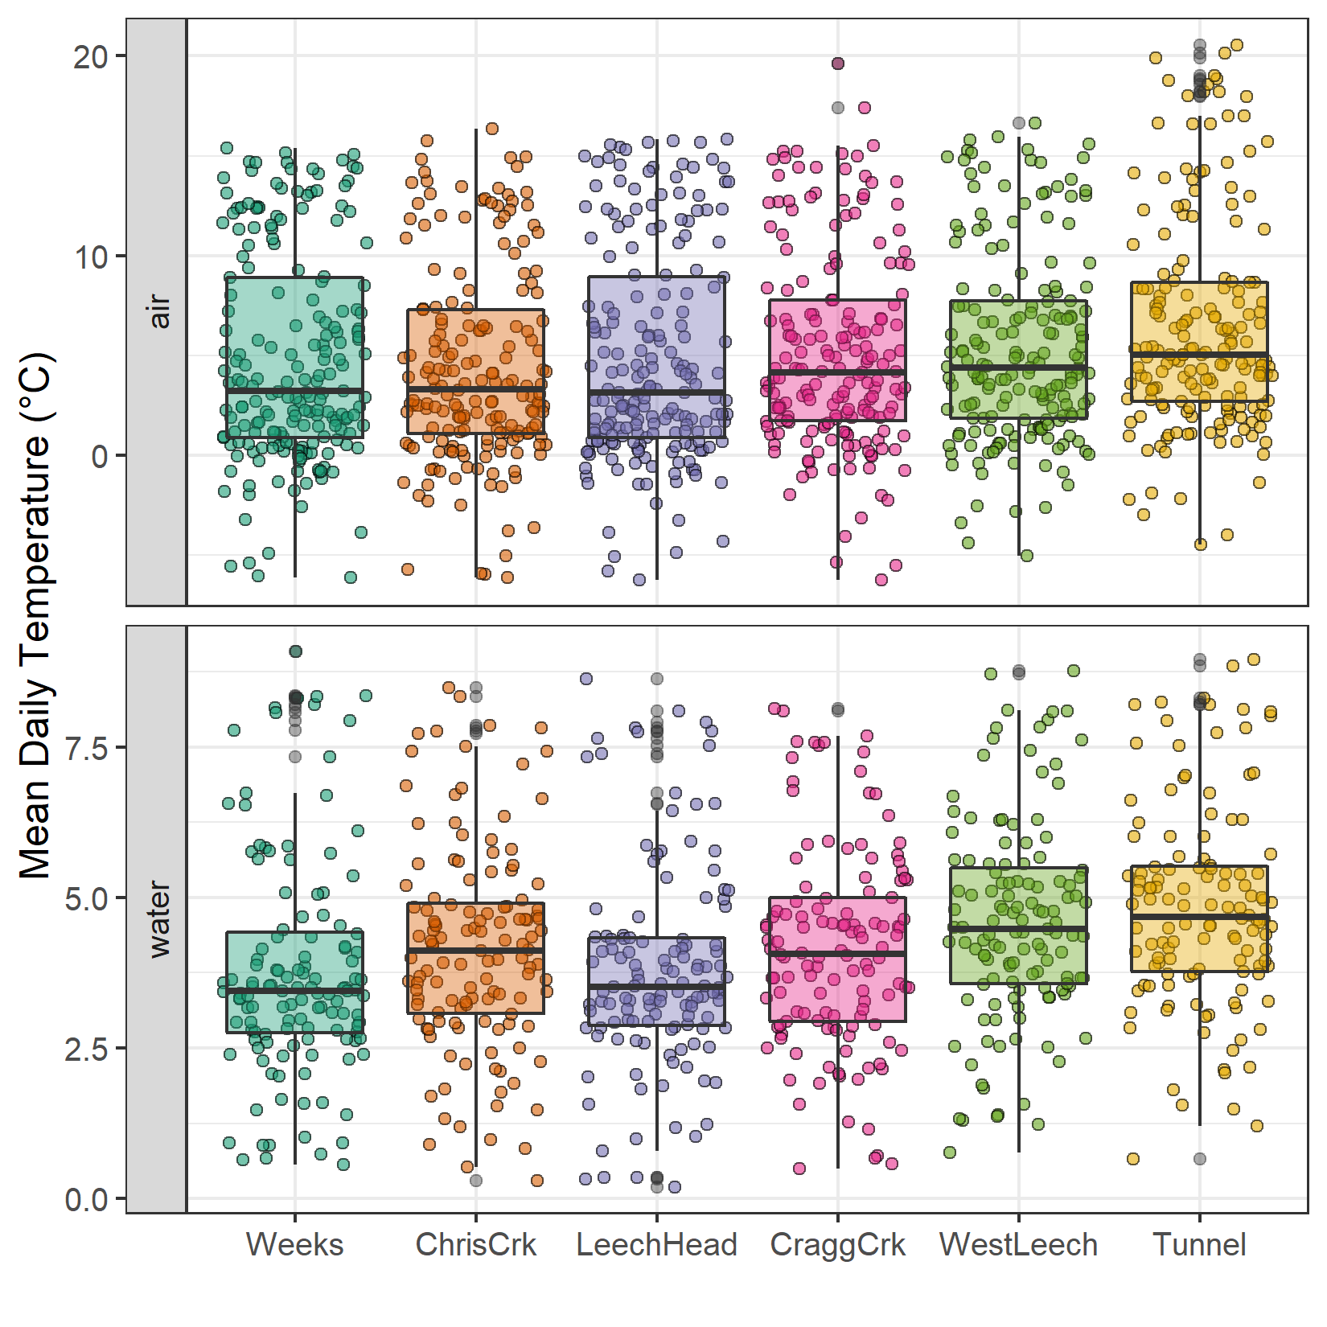

Figure 32: Temperatures recorded in air and water on vertical racks at each research site

Air temperatures recorded at each of the six sites were compared to LWSA FWx for the overlapping period (August 24, 2019 to February 20, 2020). Overall, FWx temperatures were slightly higher than those recorded at each site installation. Figure 33 shows the density distribution of air temperature measured at each site compared to the LWSA FWx mean.



Figure 33: Density distribution of air temperatures recorded at each sub-basin compared to mean LWSA air temperatures from CRD fire weather stations

Results of two-sided Wilcoxon rank sum tests revealed that 15-minute air temperatures at West Leech (site-5) were similar to LWSA FWx (p-value 0.02), and the differences between the other five sites and FWx were found to be significantly different (p-values << 0.001). However, when daily mean temperatures were compared (rather than 15 minute data) the differences between sites and FWx temperatures were less dramatic (Table 24) with no statistical difference (at 90% confidence) for Cragg Creek, West Leech and the Tunnel (sites 4, 5, 6).

Table 24: Relationships between mean daily air temperature recorded at each monitoring site compared to mean LWSA air temperature recorded by Chris Creek and Martin’s Gulch fire weather stations

|  |  |
| --- | --- |
| Site | p-value |
| Weeks | 0.0014 |
| ChrisCrk | 0.0065 |
| LeechHead | 0.0009 |
| CraggCrk | 0.0470 |
| WestLeech | 0.5745 |
| Tunnel | 0.2966 |

Despite some differences between FWx and Hobo site data, the overlapping FWx and TidbiT daily mean air temperature data were used to generate linear regression relationships to estimate air temperatures at each site for the time preceding Hobo TidbiT deployment (Figure 34). Table 25 summarizes the average percent error of estimated air temperatures based on a test period of overlapping data. Estimated mean daily air temperatures at each site were used in flagging Rack sample data for quality control with respect to days samples remained on vertical racks (hold-times).

Table 25: Summary of predicted air temperature at each site compared to mean LWSA temperature from CRD FWx stations for the same time period

|  |  |  |  |  |  |  |  |
| --- | --- | --- | --- | --- | --- | --- | --- |
| Site | Error (%) | Median Temp. (°C) | Estimated Median (°C) | Min. Temp (°C) | Estimated Min. (°C) | Max. Temp (°C) | Estimated Max. (°C) |
| Weeks | 19.4 | 2.9 | 3.9 | -6.1 | -7.6 | 15.4 | 17.7 |
| ChrisCrk | -35.1 | 3.3 | 4.0 | -6.1 | -7.5 | 15.7 | 18.0 |
| LeechHead | -39.9 | 2.7 | 3.8 | -6.2 | -7.3 | 15.8 | 17.2 |
| CraggCrk | 83.2 | 3.7 | 4.7 | -6.2 | -7.0 | 17.4 | 18.9 |
| WestLeech | -60.9 | 4.4 | 5.0 | -5.0 | -6.0 | 16.6 | 18.4 |
| Tunnel | -7.2 | 5.1 | 5.8 | -4.5 | -5.5 | 20.6 | 19.5 |



Figure 34: Linear regression relationships between mean daily air temperature recorded at each monitoring site compared to mean Leech WSA air temperature recorded by Chris Creek and Martin’s Gulch fire weather stations

Additional sampling and analysis (Chapter 2 extended)

At UBC, stream samples were also measured for phosphate concentration using a colourimetric (ascorbic acid) orthophosphate test kit (HACH PO-19); all water samples had ortho-phosphate concentrations below the detectable limit (0.1 mg/L).

Treatability: forWater coordinated treatability analyses for disinfection by-product formation potentials (DBP-FP)

Four of the synoptic sampling sites were selected as treatability sampling sites, where source water was collected and shipped to collaborative researchers in the forWater Network for analyses of drinking water treatability metrics. The four treatability sites were:

1. Leech River at the future point of diversion (near Leech Tunnel inlet)
2. Deception Reservoir, downstream from Deception Gulch (outlet of Leech Tunnel)
3. Rithet Creek (main tributary to Sooke Reservoir)
4. Judge Creek (2nd largest tributary to Sooke Reservoir)

These sites were selected to represent future supplemental source water, the future balancing reservoir between the Leech and Sooke water supply areas, and the current tributary source waters to the Sooke Reservoir.

Two sets of duplicate samples from the four sites were collected during winter of the 2020 water year (November 12, 2019 and February 18, 2020) and were shipped to the Universities of Alberta and Waterloo for treatability analyses. At the University of Waterloo, the samples (*n* = 8) were analyzed for treatability parameters including: maximum potential disinfection byproduct formation potential (for trihalomethanes (THMs) and haloacetic acids (HAAs) in μg/L), pH, UV254(cm-1), DOC (mg/L), Turbidity (NTU), and Zeta Potential (mV). Relationships between disinfection by-product formation potentials (DBP-FPs), UV-absorbance at 254 nm, and DOC concentrations were examined.

Results: Treatability & DOC

Dissolved organic matter – particularly high molecular weight aromatic compounds – are precursors to disinfection by-products (DBPs), which are formed during chlorination of source drinking water. Drinking water supply for the CRD is treated simply by chlorinating raw source water, and therefore source water NOM could have important implications for treatability. To assess the potential of source water to form potentially harmful DBPs, samples were collected from four locations and sent to partners at the University of Waterloo for treatability analyses (specifically, DBP formation potentials (DBP-FPs)).

Results from two sets of samples at four selected sites showed DBP-FPs were weakly correlated to DOC concentrations and SUVA254 and more strongly correlated to SAC254 (Figure 6). The relatively stronger correlation between DBP-FPs and SAC254 indicates that while DOC concentration is an important indicator of source water treatability challenges, SAC254 is a better indicator of NOM reactivity with respect to DBP-FPs (Table 26, Figure 6). In particular, SAC254 was well correlated with total trihalomethanes (THM, r=0.9882) including trichloromethane (TCM, r=0.9869), total haloacetic acids (HAAs, r=0.9927) including dichloroacetic acid (DCAA, r=0.9945) and trichloroacetic acid (TCAA, r=0.9900); and was only weakly correlated to bromodichloromethane (BDCM, r=0.6539). Below levels of detection (thus not shows here) were DBP-FP results for tribromomethane (TBM), dibromoacetic acid (DBAA), dibromochloromethane (DBCM), monochloroacetic acid (MCAA), monobromoacetic acid (MBAA).

Table 26: Correlation coefficients for disinfection byproducts with spectral absorbance coefficient at 254 nm (SAC254), dissolved organic carbon concentration (DOC), and specific UV absorbance at 254 nm (SUVA254). DBP-FP values that were below detection were not included in the matrix

|  |  |  |  |  |  |  |  |  |  |
| --- | --- | --- | --- | --- | --- | --- | --- | --- | --- |
|  | SAC254 | DOC | SUVA254 | THMs | BDCM | TCM | HAAs | DCAA | TCAA |
| SAC254 | 1.00000 | 0.74485 | 0.51273 | 0.98817 | 0.65387 | 0.98694 | 0.99270 | 0.99446 | 0.99000 |
| DOC | 0.74485 | 1.00000 | -0.16925 | 0.80285 | 0.32781 | 0.80575 | 0.69292 | 0.71389 | 0.68315 |
| SUVA254 | 0.51273 | -0.16925 | 1.00000 | 0.44361 | 0.44857 | 0.43977 | 0.57143 | 0.54897 | 0.57868 |
| THMs | 0.98817 | 0.80285 | 0.44361 | 1.00000 | 0.58166 | 0.99992 | 0.97608 | 0.98281 | 0.97143 |
| BDCM | 0.65387 | 0.32781 | 0.44857 | 0.58166 | 1.00000 | 0.57154 | 0.59953 | 0.61545 | 0.59263 |
| TCM | 0.98694 | 0.80575 | 0.43977 | 0.99992 | 0.57154 | 1.00000 | 0.97547 | 0.98198 | 0.97090 |
| HAAs | 0.99270 | 0.69292 | 0.57143 | 0.97608 | 0.59953 | 0.97547 | 1.00000 | 0.99642 | 0.99937 |
| DCAA | 0.99446 | 0.71389 | 0.54897 | 0.98281 | 0.61545 | 0.98198 | 0.99642 | 1.00000 | 0.99294 |
| TCAA | 0.99000 | 0.68315 | 0.57868 | 0.97143 | 0.59263 | 0.97090 | 0.99937 | 0.99294 | 1.00000 |

It’s important to note that while SAC254 is related to aqueous NOM and DOC, naturally occurring aqueous nitrate and iron can interfere with spectroscopic analyses and lead to positive bias in spectroscopy. Dissolved or colloidal nitrate, nitrite and iron species can absorb light at 250 nm, 254 nm or 365 nm, the wavelengths common to NOM absorption (Baird, Eaton, and Rice 2017b). However, aqueous nitrogen, in combination with NOM, can also play an important roll as a precursor to nitrogenous-DBPs, which could potentially make SAC254 an even better indicator of DBP-FP. It would be interesting to evaluate nitrogenous DBPs in realtion to SAC254, NOM, and DBP-FPs.

Metals & DOC: collaborative sampling for Metals on behalf of the CRD

Aqueous natural organic matter (NOM) can play an important role in transportation of metals in solution because it has the physiochemical ability to act as a ligand and create coordinated complexes with metals. From November 2018 to July 2019, eight sets of samples were collected from the six Leech WSA monitoring sites. Metals samples were collected on behalf of the CRD and were analyzed at Bureau Veritas Laboratories (BL Labs, formerly Maxxam Analytics Inc., Sidney, BC). For each metals sample collected, a parallel Grab sample was analyzed for DOC (at UBC). A suite of total metals was included in the analyses and reports from BL Labs were provided by the CRD (for the samples collected in association with this research). Data were used to evaluate relationships between DOC and metals in solution. Samples which had detectable metals concentrations were plotted against parallel sample DOC concentrations. Figure 35 shows DOC with total metals in μg/L, and Figure 36 shows metals in mg/L.

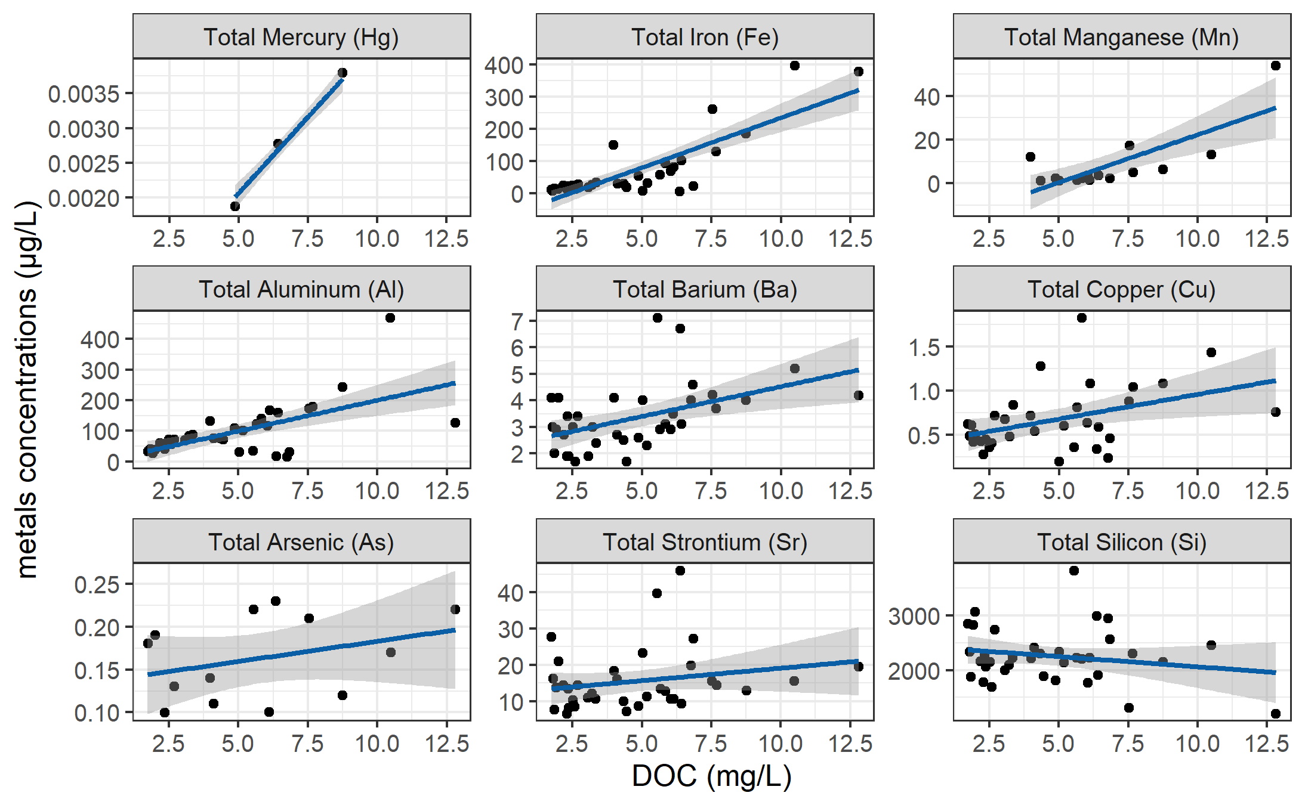

Figure 35: Concentrations of total metals (in µg/L) and dissolved organic carbon (DOC) concentrations in stream water samples collected across the Leech WSA

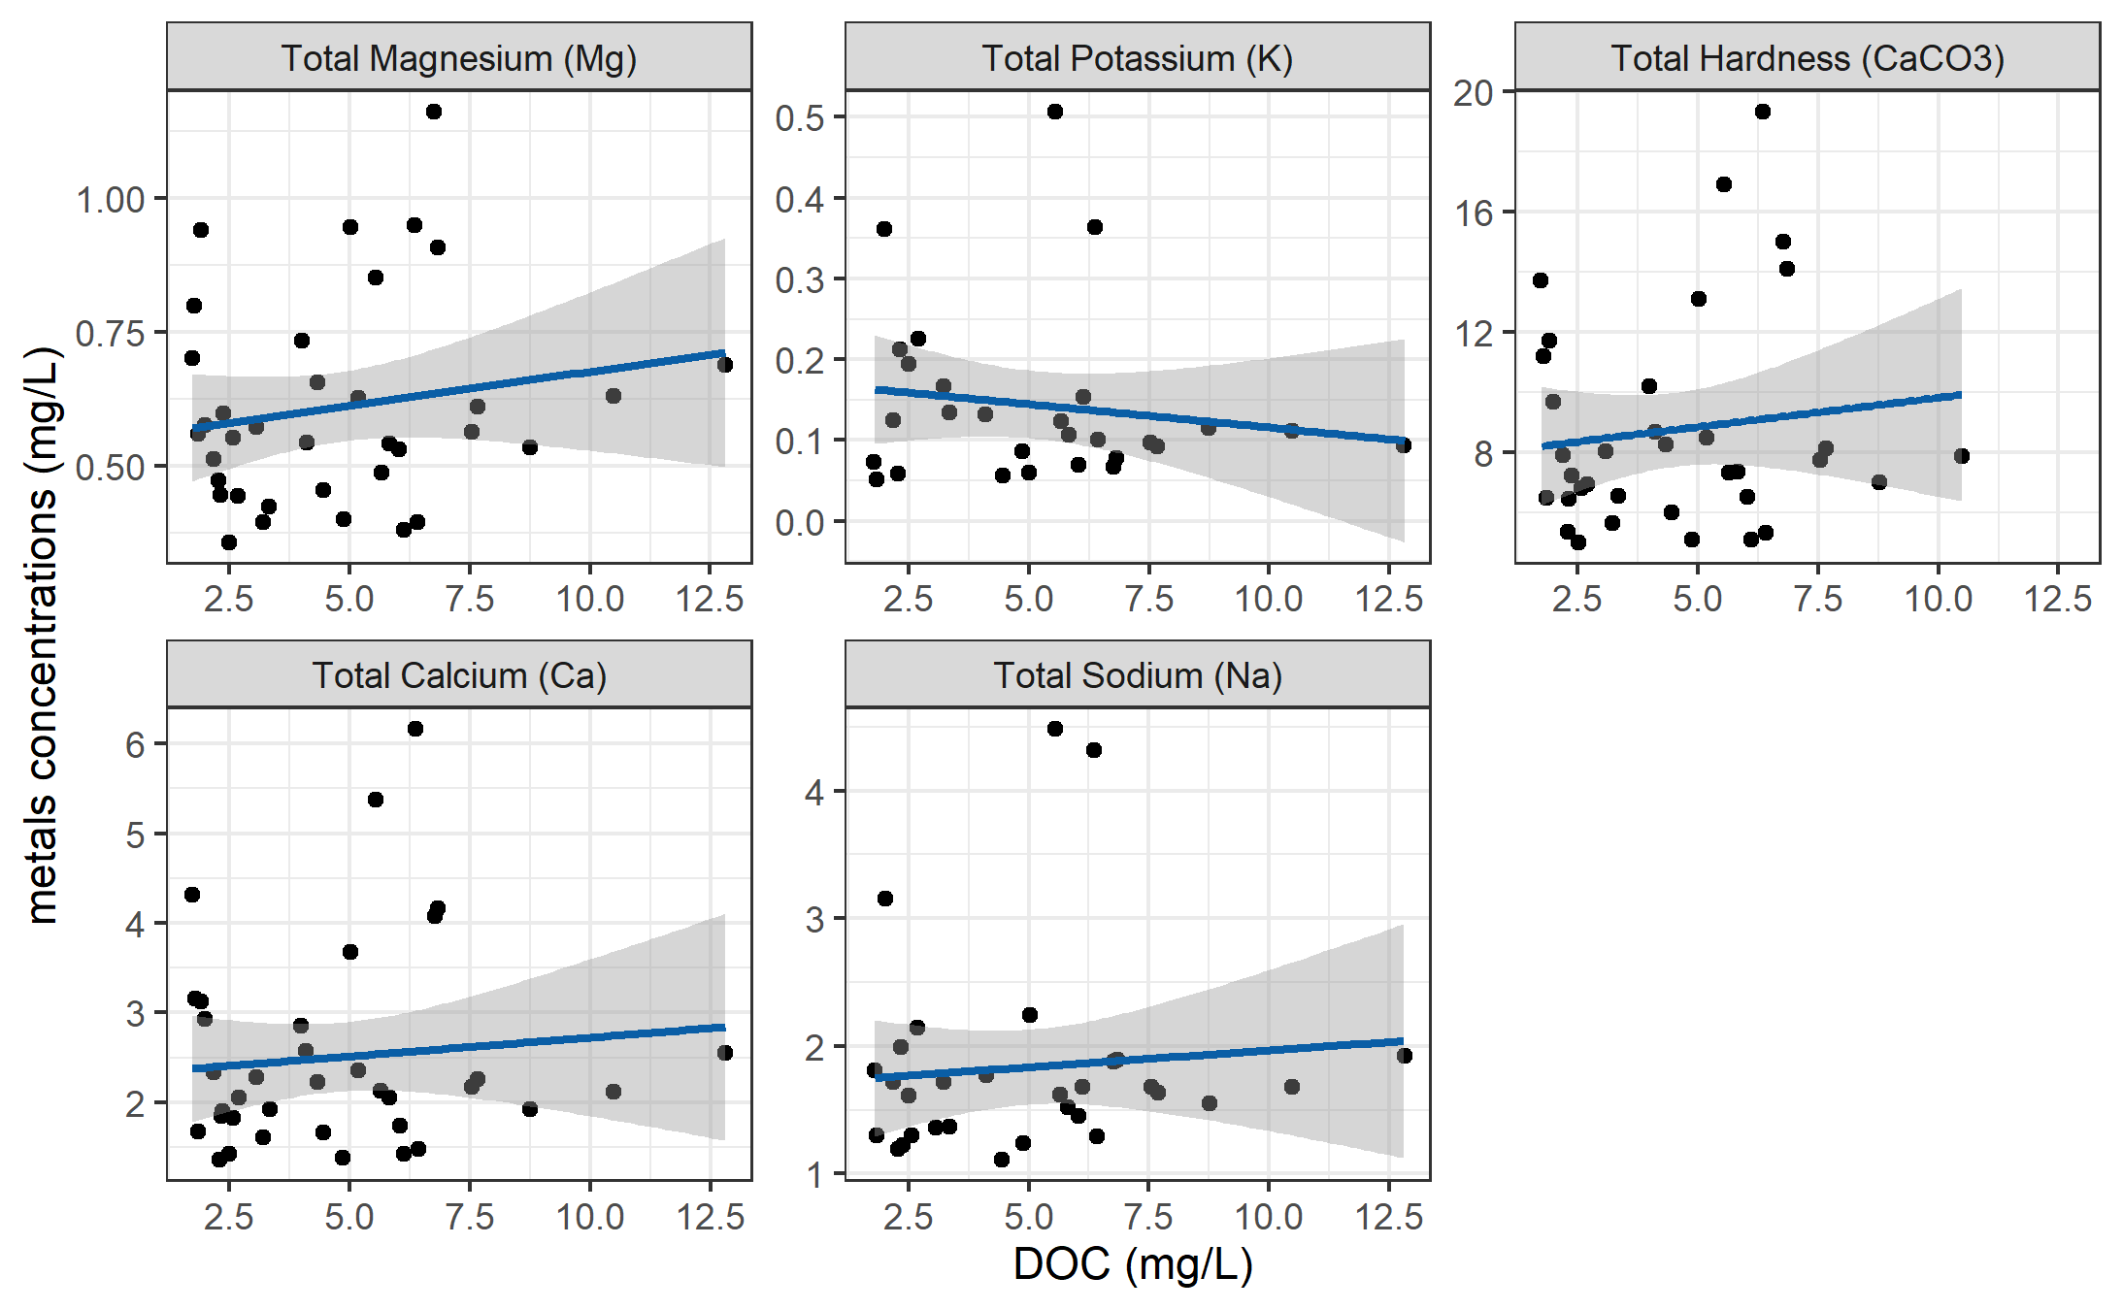

Figure 36: Concentrations of total metals (in mg/L) and dissolved organic carbon (DOC) concentrations in stream water samples collected across the Leech WSA

DOC concentrations had strong positive relationships with total mercury, iron, manganese, aluminum. While the relationships were not as strong, DOC was also positively related to concentrations of barium, copper, and arsenic. There was a weak inverse relationship between DOC with silicon and potassium (Table 27). All metals concentrations were below maximum allowable concentrations and aesthetic objectives for drinking source water quality guidelines (British Columbia Ministry of Environment 2017).

Table 27: Linear relationships between total metals with dissolved organic carbon in stream water samples collected across the Leech WSA

|  |  |  |  |  |  |
| --- | --- | --- | --- | --- | --- |
| Metal | unit | n | slope | Y intercept | R squared |
| Total Mercury (Hg) | ug/L | 3 | 0.00 | 0.00 | 0.9998 |
| Total Iron (Fe) | ug/L | 40 | 30.86 | -74.47 | 0.6933 |
| Total Manganese (Mn) | ug/L | 18 | 4.38 | -21.41 | 0.5939 |
| Total Aluminum (Al) | ug/L | 42 | 20.13 | -1.21 | 0.3965 |
| Total Barium (Ba) | ug/L | 42 | 0.22 | 2.28 | 0.2251 |
| Total Copper (Cu) | ug/L | 39 | 0.06 | 0.40 | 0.1762 |
| Total Arsenic (As) | ug/L | 14 | 0.00 | 0.14 | 0.1112 |
| Total Strontium (Sr) | ug/L | 42 | 0.69 | 12.21 | 0.0445 |
| Total Silicon (Si) | ug/L | 42 | -37.45 | 2433.98 | 0.0383 |
| Total Magnesium (Mg) | mg/L | 42 | 0.01 | 0.55 | 0.0298 |
| Total Potassium (K) | mg/L | 32 | -0.01 | 0.17 | 0.0216 |
| Total Hardness (CaCO3) | mg/L | 41 | 0.19 | 7.87 | 0.0153 |
| Total Calcium (Ca) | mg/L | 42 | 0.04 | 2.30 | 0.0095 |
| Total Sodium (Na) | mg/L | 37 | 0.03 | 1.70 | 0.0081 |

NOM sampling in nested catchments (Chapter 3 extended)

Below the confluences of headwaters sites (Figure 37, plots A & B), the combination of Rack and Grab sampling did not capture the ranges of SAC254 observed in upstream Grab samples alone. At both sets of headwater sites, the variance obtained by combining Rack and Grab samples downstream was not the same as upstream Grab sampling variance (Levene’s test for homoscedasticity p-value = 0.0174). At higher order rivers, the combination of Rack and Grab samples at the Leech Tunnel site did capture the SAC254 ranges observed in Grab samples at three upstream river sites (Figure 37, plot C). Levene’s test for homogeneity of variance (homoscedasticity) confirmed that there was no difference in SAC254 variance in the downstream Rack/Grab combination results compared to Grab-only from upstream (p-value 0.105).

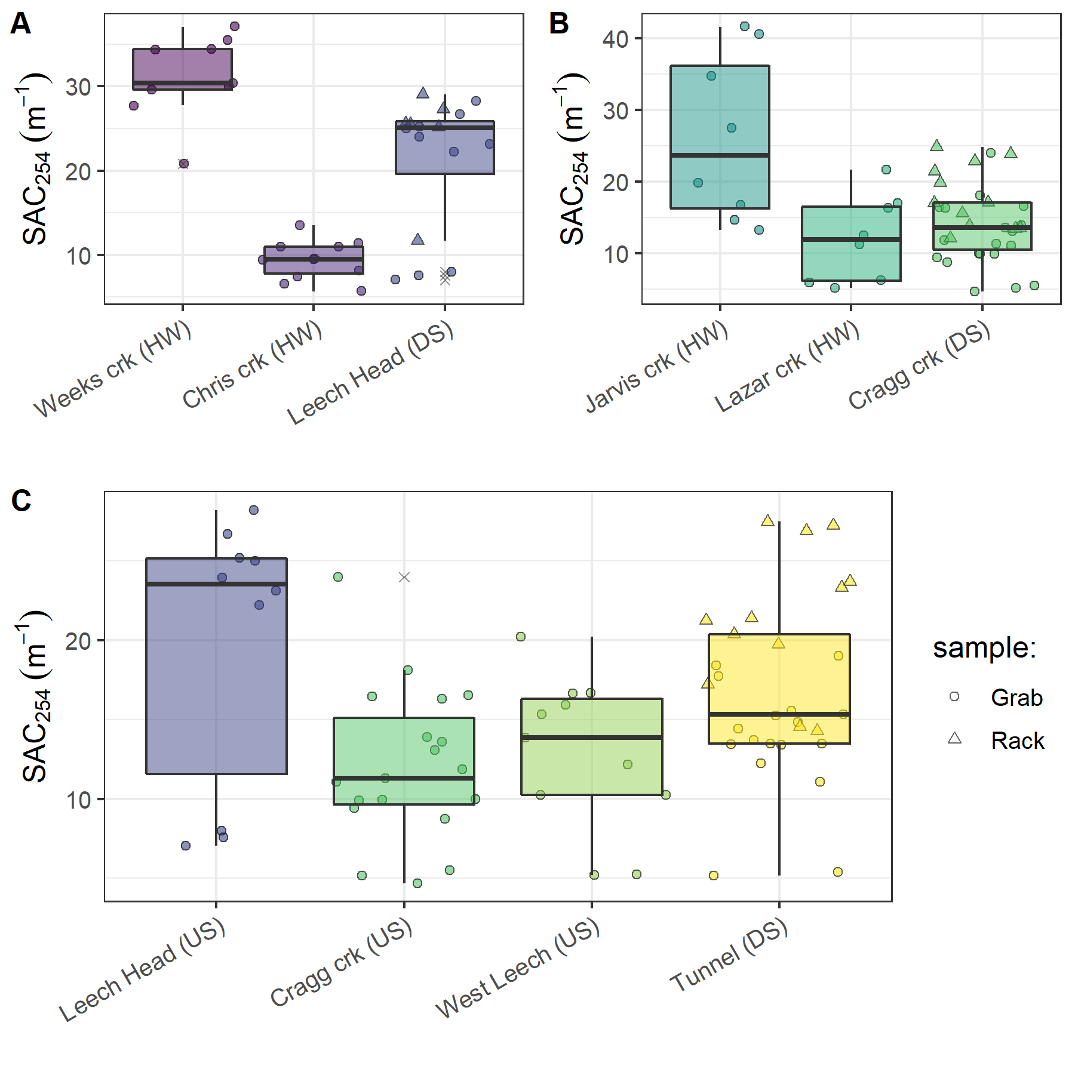

Figure 37: Grab sample SAC254 at upstream locations compared to Rack and Grab sample SAC254 below their confluence(s). A and B show grab samples from headwaters (HW) compared to downstream (DS) monitoring sites; C shows upstream river sites (US) compared to mainstem monitoring

No apparent trend was seen in the E2:E3 characteristic for aromaticity/molecular size (Figure 38). There were similar variances in E2:E3 values across all groupings (Levene’s p-values 0.1225, 0.09551, 0.09298 for sets A, B, C).

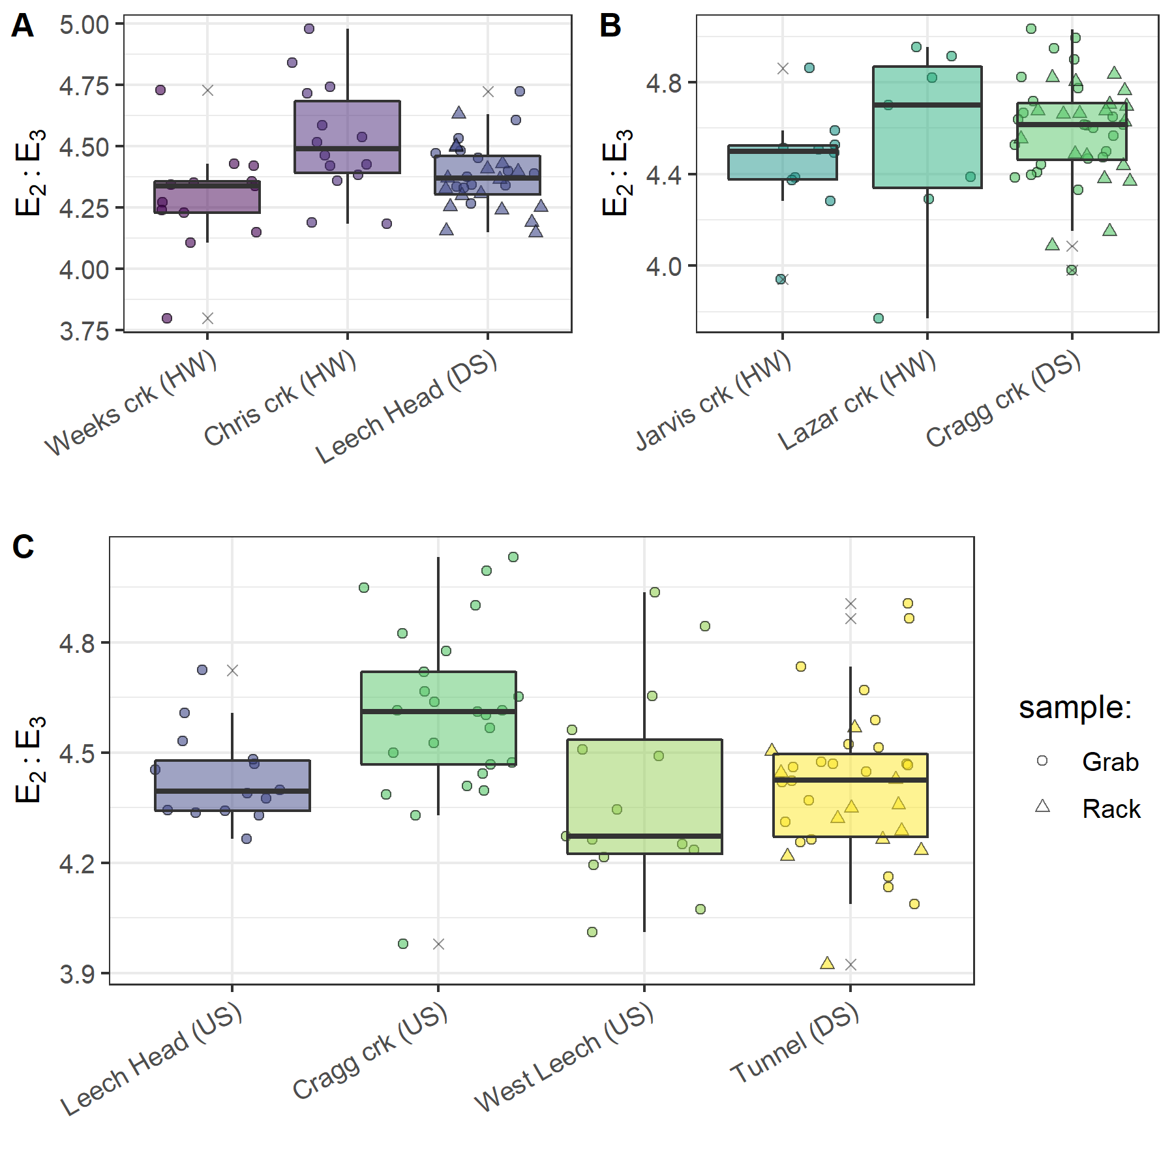

Figure 38: Grab sample E2:E3 at upstream locations compared to Rack and Grab sample E2:E3 below their confluence(s). A and B show grab samples from headwaters (HW) compared to downstream (DS) monitoring sites; C shows upstream river sites (US) compared to mainstem monitoring

Random Forests (Chapter 4 extended)

Random Forests background

A Random Forest is a collection of decision trees, that collectively comprise a statistical tool for non-parametric regression, prediction, classification and assessment of variable importance (Strobl, Malley, and Tutz 2009). Breiman’s Random Forests (RF) is a machine learning algorithm for practical applications, which is popular for its accuracy in real-world systems (Tyralis, Papacharalampous, and Langousis 2019; Biau and Scornet 2016) and does not require independence among samples; as such, it is appropriate for analysis of nested catchments, which by definition are not independent. RF has been widely published in hydrologic and water resource research in recent years, particularly in streamflow and water quality studies (see Tyralis, Papacharalampous, and Langousis 2019 and references therein). In RF, a set of predictor variables (features) are used to predict the outcome of another variable (the predictant) through supervised learning algorithms which are grouped as either regression or classification, depending on whether the variables are quantitative (i.e. numeric) or qualitative (Breiman 2001; Tyralis, Papacharalampous, and Langousis 2019).

The RF algorithm learns from many independent Classification And Regression Trees which undergo bootstrap-aggregating (“bagging”) with randomization; meaning that no single tree includes all the data, which reduces over-fitting and improves prediction performance (Breiman 2001; Tyralis, Papacharalampous, and Langousis 2019; Biau and Scornet 2016). In RF, many decision trees are created, each one generated by randomly sampling from the full data set (with replacement) and each tree is trained until only one possible solution remains (i.e. leaf nodes contain one deciding variable). For problems of regression (i.e. quantitative numeric variables, such as the data in this thesis), the final forest prediction is equal to the average of individual tree predictions (Tyralis, Papacharalampous, and Langousis 2019; Biau and Scornet 2016).

The capacity to evaluate variable importance metrics sets RF apart from other data-driven models that focus on prediction (Tyralis, Papacharalampous, and Langousis 2019). The relative importance of each feature can be determined by assessing the accuracy of how well the response variable (predictant) is anticipated in the absence or presence of each predictor feature. Through the RF algorithm, the variable importance measure (VIM) is assessed by removing predictor variables one at a time and measuring the decrease in prediction accuracy in their absence (Breiman 2001). This is achieved based on either the increase in mean square error (MSE, type 1) or the increase in sum of square errors (SSE, type 2). Type 1 of VIM is calculated by permutation (Liaw and Wiener 2018) and type 2 is assessed as a decrease in node impurity; for classification problems this is measured by the Gini index and for regression, it’s measures by the residual sum of squares (Liaw and Wiener 2018). The SSE method may be more appropriate for categorical variables than quantitative variables, for which MSE method appears to be more appropriate (Chapter 4, ‘RF quality control’ section). Despite the ability of RF to handle non-independent real world data, bias can result from cross-correlations among predictor variables, and mixing categorical and quantitative data may result in bias towards variables with many categories or many missing values (C. Strobl et al. 2008). Therefore, some predictor refinement is important and was conducted in the Chapter 4 analysis.

Random Forests Variable Importance Measure

Random Forest variable importance measure (VIM) treated static watershed characteristics categorically and treated dynamic sampling conditions as numeric variables to be used in regression. When conditions and characteristics were combined for RF VIM, the relative ranking of each predictant was changed compared to when conditions and characteristics were analyzed separately. While it was expected that the relative importance (as a percent) would shift when all predictants were combined, it was not expected that the relative ranking would change, and that suggests that these two groups (static and dynamic) of predictants should be separated for RF VIM. Compare plots for the two groups (Ch 4) to Figure 39 and see how the relative rankings changed.

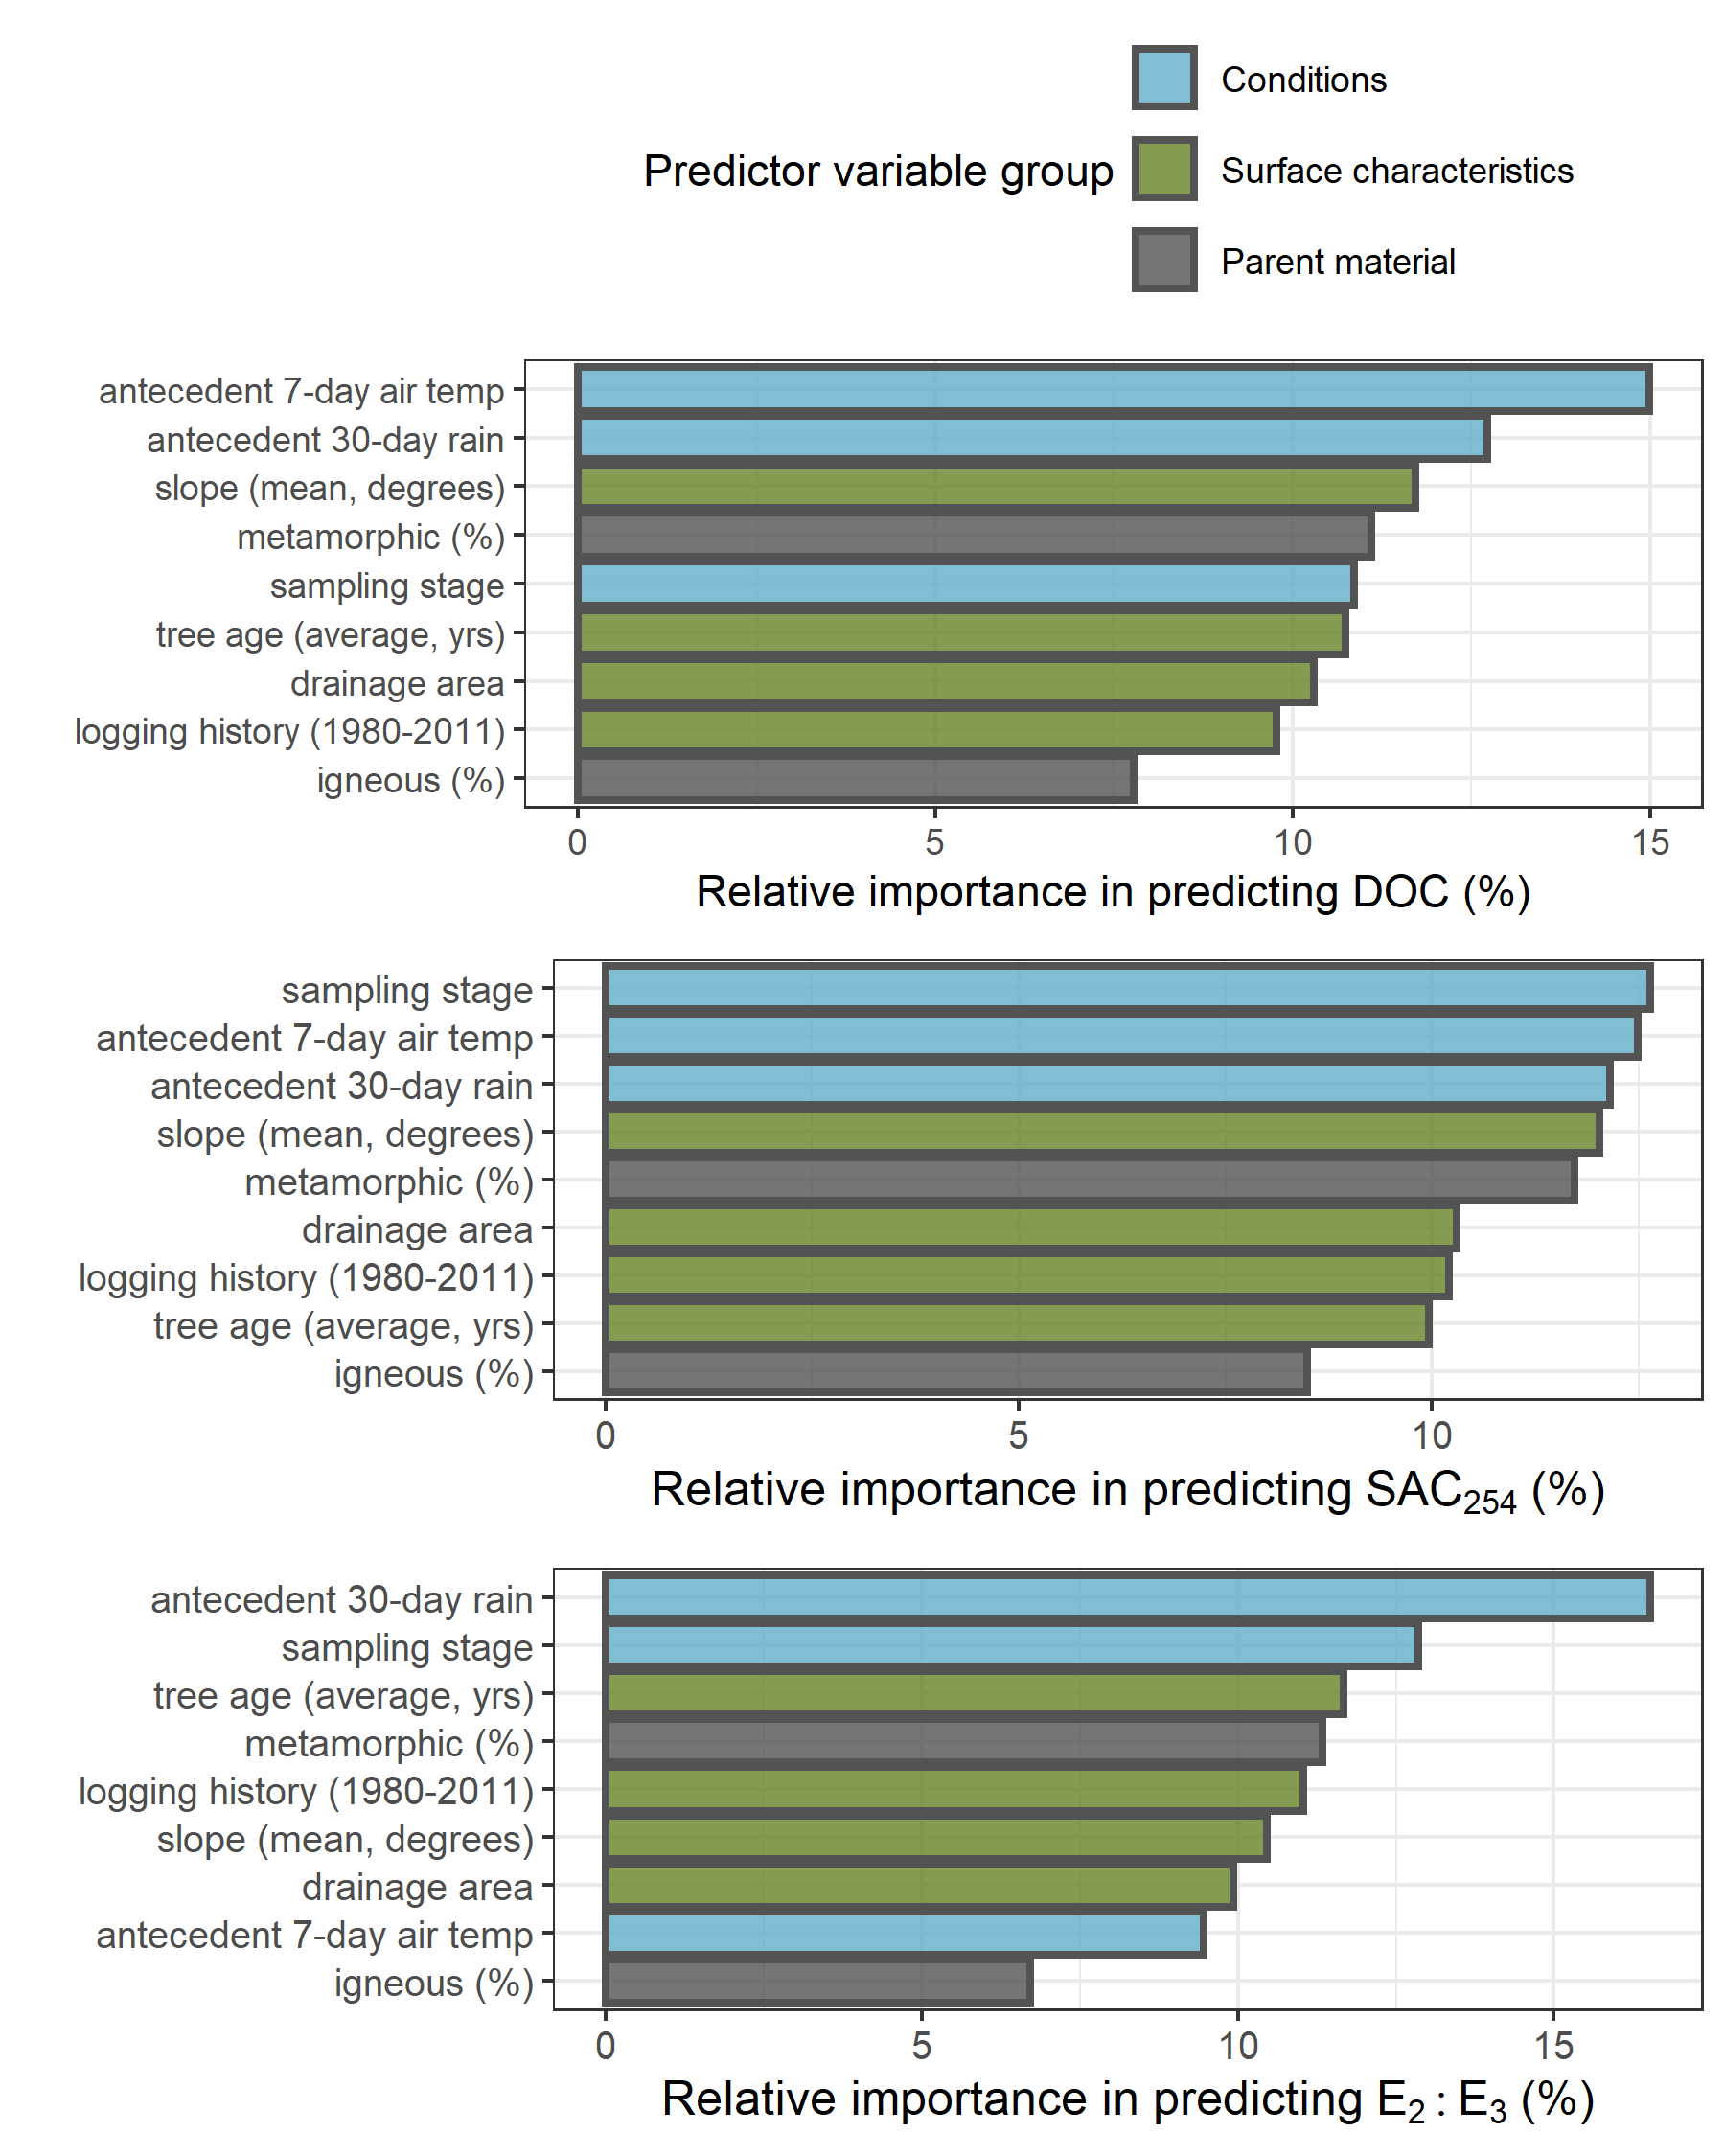

Figure 39: Random Forest variable importance measure for NOM concentration and character using combined predictant types (dynamic conditions and static watershed characteristics), which altered the relative importance ranking compared to when the groups were assessed separately

Enough samples were collected for DOC assessment in both the dry and wet seasons to see a pattern of wet season increase in DOC with increasing antecedent air temperatures; there was no clear pattern in the dry season (Figure 40).

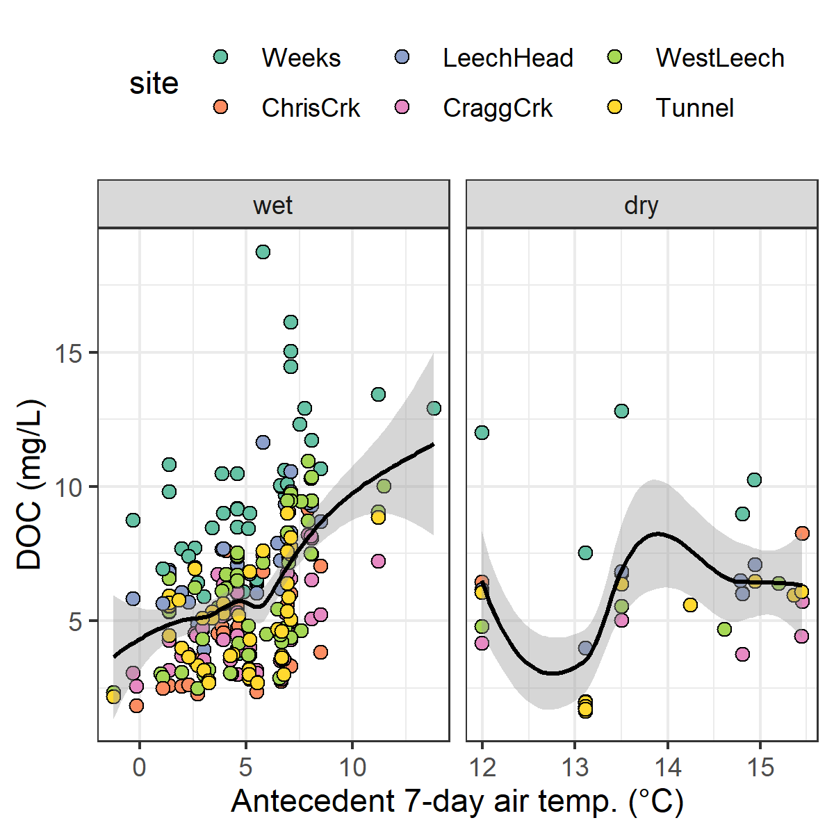

Figure 40: Antecedent 7-day air temperature as a predictor variable for concentrations of dissolved organic carbon in the wet and dry seasons of the Leech Water Supply Area (including loess trend lines)

The relationships between NOM proxy parameters (DOC, SAC254 and E2:E3) with 30-day antecedent rain were slightly different at each site (Figure 41). Generally, DOC decreased with increasing 30-day antecedent rain at all site above approximately 200 mm of accumulated rain. There were insufficient data at each site to tease out clear patterns with SAC254 or E2:E3.

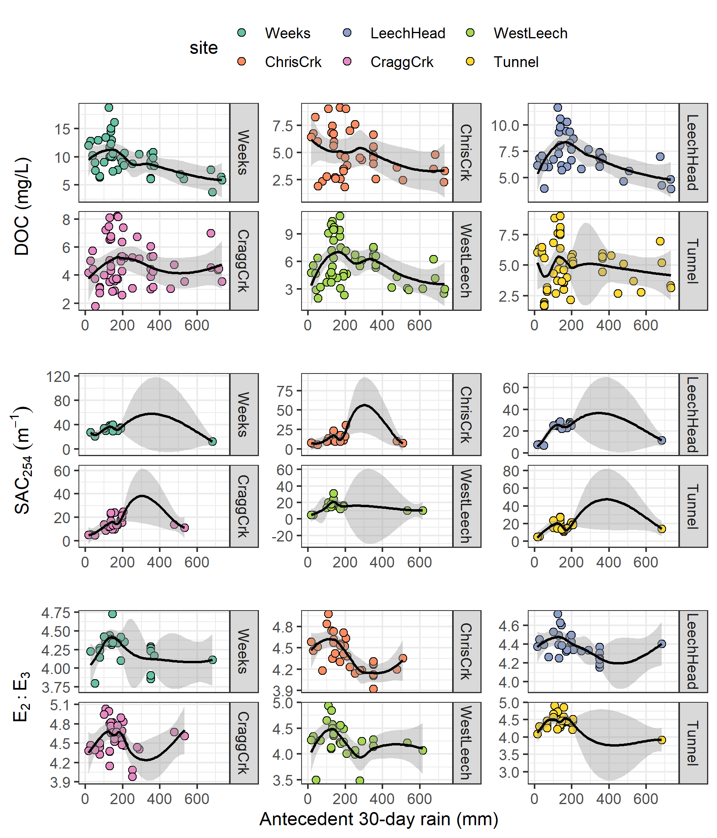

Figure 41: Antecedent 30-day rain as a predictor for NOM concentration (DOC) and character (SAC254 & E2:E3) across six monitoring sites in the Leech watershed. Each plot includes a loess trend line.

Hysteresis (Chapter 4 Bonus!)

Background

Storm events are understood to be a key driver for solute and particle mobilization in streams (e.g. Aguilera and Melack 2018). Material transport (be it in solution or suspension) tends to show a non-linear relationship to discharge, in that concentrations do not necessarily peak in congruence with flow. This hysteretic behaviour, where the relationship between concentration and discharge (i.e. C-Q) is different on the rising limb versus the falling limb of the hydrograph, creates a hysteresis loop that can reveal information about origins and transport of aquatic material, relative to the point of measurement (Vaughan et al. 2019; Evans and Davies 1998; Aguilera and Melack 2018). Concentration-discharge hysteresis may be due to episodic flushing of material or from component mixing processes (Evans and Davies 1998). Information about flow-paths and source pools can be obtained from four elements of the C-Q relationship plot: the shape (linear, circular, figure-eight), the direction of a hysteresis loop (i.e. clockwise vs. counterclockwise), the magnitude, and the direction of slope (Aguilera and Melack 2018).

Concentration-discharge relationships can elucidate flow-paths and aid in estimating proportional streamflow contributions (i.e. subsurface vs. overland, or near-stream vs. upland) (Evans, Davies, and Murdoch 1999). C-Q can be used to determine whether a catchment’s solute export regime is chemostatic or chemodynamic (Musolff et al. 2015). For example, in an assessment of ~400 stream events in coastal California, Aguilera and Melack (2018) found that sediment-associated concentrations peaked during high flows but dissolved nitrogen species had hysteretic behaviour with flow, the direction of which differed depending on land-use.

Dominant sources and flow paths during events can be inferred from the slope (positive or negative) and the direction of the hysteresis loop rotation (Evans and Davies 1998; Aguilera and Melack 2018). A clockwise C-Q hysteresis loop indicates rapid flushing and dilution (higher concentration on the rising limb than falling limb) while a counter-clockwise loop indicates enrichment via delayed material delivery from distant (upstream) or deeper subsurface source pools (Aguilera and Melack 2018). Evans et al. (1999) determined that C-Q analysis requires a minimum of five samples to determine the rotational direction of hysteresis: pre and post episode low-flow, rising and falling limbs and near to peak Q.

Using end-member mixing, with hydrometric monitoring and carbon isotope (δ13CDOC) data, Lambert et al. (2014) determined that approximately 80% of stream DOC flowed through the riparian domain’s most superficial soil horizons, and that riparian soil DOC was sourced from both riparian and upland areas. Upland NOM source pools were determined to contribute significant amounts of carbon to streams but were supply-limited; whereas riparian NOM was found to be a near-infinite carbon source. Lambert et al. (2014) also found that upland sources contributed relatively more early in the wet season (~30% of stream DOC) and less as high-flows continued (decreased to ~10% of stream DOC later in the wet period). In that vein, antecedent weather conditions are important for nutrient and sediment export and C-Q relationships, as the first precipitation events after a prolonged dry period can result in rapid flushing of accumulated material (Aguilera and Melack 2018).

Methods

Hydrochemical hysteresis is most often evaluated through C-Q relationships, but the concept of hysteresis applies to any time-based predictor and effected values. The principle of hysteresis is based on a lag between a driving force (e.g. discharge, Q) and the analyte that is driven to change (e.g. solute concentration, C). Ideally, streamflow data would accompany all sample data collected for this research, however that was not the case. Stage data was collected, and given the strong relationship between stage and discharge, stage can be evaluated as an indicator for Q. Similarly, because streamflow in the Leech WSA is governed by precipitation, antecedent wetness (rain) could be proxy data in a hysteresis analysis. Conditions that were calculated to be most important for predicting NOM concentration and character were plotted with their predictant to assess possible hysteresis; this was only possible for dynamic conditions with variable measurements (i.e. not static watershed characteristics predictors).

For a C-Q hysteresis loop, clockwise rotation indicates rapid flushing and dilution, while counter-clockwise rotation indicates enrichment via delayed material delivery from distant (upstream) or deeper subsurface source pools (Aguilera and Melack 2018). Because of the assumed relationship between antecedent rain and streamflow, a similar interpretation was used here despite the absence of discharge data.

Results and discussion: Hysteresis of NOM with antecedent wetness

Events 10 and 11 were relatively well represented by sampling at each of the six sites and were found to be representative of other rain events as well. Wilcoxon tests showed events 10 and 11 were not statistically different from the other sampling events, with the same mean rain durations (p = 0.837), rain amounts (p = 0.732), rain intensity (p = 0.549), DOC (p = 0.512), SAC254 (p= 0.218) and E2:E3 (p = 0.148). Samples were collected across the rising limb, near peak-flows, and at least one sample on the falling limb and at low flow (Figure 42).



Figure 42: Stage and sample collection points at six Leech watershed monitoring sites during rain events 10 and 11 (early fall 2019). Vertical yellow lines indicate the start of each rain event (event 10 and 11, respectively). Results of samples in each event were compared to antecedent 30-day rain to assess hysteretic behaviour of NOM with catchment wetness.

Sample DOC concentrations from rain events 10 and 11 were plotted with their corresponding antecedent wetness (30-day rain) to explore possible hysteresis (Figure 43). The relationship of DOC to antecedent wetness within a hydrologic event was interpreted in the same manner as a concentration-discharge (C-Q) relationship, where rapid flushing and dilution are indicated by a hysteresis loop with clockwise rotation, and counterclockwise rotation points to delayed material delivery and stream enrichment. Event 10 was the second measured rain event in the 2019/2020 wet season and had twice as much rain fall as event 11 (136 mm in event 10 compared to 68 mm in event 11, Table 16). Event 10 was longer in duration (6.4 days) compared to event 11 (2.3 days) with slightly lower intensity (21 vs 29 mm/24-hr.). Between these two events, mean DOC concentrations were comparable (6.7 mg/L and 6.4 mg/L). There was a clockwise rotation pattern for DOC with antecedent wetness in event 10 and a counterclockwise rotation in event 11 (Figure 43). At the Tunnel, there was a change in loop direction at the end of each event.



Figure 43: Dissolved organic carbon (DOC) concentrations plotted with antecedent 30-day rain during events 10 and 11 at six monitoring sites in the Leech watershed

The antecedent wetness hysteresis loop of event 10 supports the hypothesis for dilution of near-stream (or in-stream) NOM early in the wet season. Later wet-season rain events transported larger, more aromatic NOM from source pools that were likely allochthonous humic material and whose export relied on greater landscape saturation and hydrologic connectivity. The hysteresis loop for event 11 supported the idea of stream NOM enrichment occurring as antecedent wetness increased (i.e. hydrologic connectivity increased).

Antecedent rain was used like a surrogate for stream discharge in a proxy Q-C hysteresis evaluation. This seemed reasonable because in the Leech WSA rain is a main contributor to streamflow. For each sample collected at each of the six monitoring sites, the relationship between antecedent rain (from LWSA Fwx mean of Chris Creek and Martin’s Gulch rain data) and measured stage loosely resembles the shape of an expected rating curve (Figure 44).



Figure 44: Relationship between sample stage and antecedent 30-day rain at the six Leech WSA monitoring sites.

Technology summary

Digital equipment used in this thesis are summarized in Table 28.

Table 28: Summary of hardware and sofware used in this thesis project

|  |  |  |  |
| --- | --- | --- | --- |
| Location | Device / Instrument | Software (Version) | Application |
| Office | computer | Windows 10 | operating system |
| Office | computer | R (4.0.2) | Programming language used for Data Analysis |
| Office | computer | QGIS desktop (3.1.2 with Grass 7.8.2) | Geospatial data analysis and mapping |
| Office | computer | RStudio (1.3.959) | IDE for R programming language |
| Office | cloud/computer | GitHub | Version control (through RStudio) |
| Field (monitoring sites) | Odyssey capacitance water level logger | Odyssey Data Logging Software (2.0.0.2) | Stream level monitoring |
| Field (monitoring sites) | Hobo TidbiT field temperature sensors | HOBOware Pro (3.7.17) | Air and water temperature recording |
| Field (monitoring sites) | Reconyx Trail Cams | SD card & reader | Site monitoring |
| Laboratory | Shimadzu TOC-V | TOC-Control | DOC quantification via NPOC |
| Laboratory | Sc::an Spectro::lyser | ana::pro (Version 5.9h, 1.0.z) | NOM characterization (UV-Vis spectroscopy) |

Done

Hannah McSorley thanks you for reading this thesis, and thanks her pal Stewart Butler again for helping with field installations in the coldest and darkest parts of 2018 and 2019 (Figure 45).



Figure 45: Photo of Hannah J. McSorley and Stewart Butler near the Sooke Gate in the Greater Victoria Water Supply Area, circa November 2018

Abbott, Benjamin W., Gérard Gruau, Jay P. Zarnetske, Florentina Moatar, Lou Barbe, Zahra Thomas, Ophélie Fovet, et al. 2018. “Unexpected spatial stability of water chemistry in headwater stream networks.” *Ecology Letters* 21 (2): 296–308. <https://doi.org/10.1111/ele.12897>.

Aguilera, Rosana, and John M. Melack. 2018. “Concentration-Discharge Responses to Storm Events in Coastal California Watersheds.” *Water Resources Research* 54 (1): 407–24. <https://doi.org/10.1002/2017WR021578>.

Aiken, George, and Evangelo Cotsaris. 1995. “Soil and hydrology: Their effect on NOM.” *American Water Works Association* 87 (1): 36–45. <https://doi.org/10.1002/j.1551-8833.1995.tb06299.x>.

Aiken, George R., Heileen Hsu-Kim, and Joseph N. Ryan. 2011. “Influence of dissolved organic matter on the environmental fate of metals, nanoparticles, and colloids.” *Environmental Science and Technology* 45 (8): 3196–3201. <https://doi.org/10.1021/es103992s>.

Avagyan, Armine, Benjamin R. K. Runkle, and Lars Kutzbach. 2014. “Application of high-resolution spectral absorbance measurements to determine dissolved organic carbon concentration in remote areas.” *Journal of Hydrology* 517: 435–46. <https://doi.org/10.1016/j.jhydrol.2014.05.060>.

Ågren, Anneli, Ishi Buffam, Martin Berggren, Kevin Bishop, Mats Jansson, and Hjalmar Laudon. 2008. “Dissolved organic carbon characteristics in boreal streams in a forest-wetland gradient during the transition between winter and summer.” *Journal of Geophysical Research: Biogeosciences* 113 (3): 1–11. <https://doi.org/10.1029/2007JG000674>.

Baird, Rodger, Andrew D. Eaton, and Eugene W. Rice, eds. 2017a. “5310 Total Organic Carbon (TOC) - 5310 A.” In *Standard Methods for the Examination of Water and Wastewater*, 23rd ed. Washington, DC: American Public Health Association. <http://www.standardmethods.org/>.

———, eds. 2017b. “UV-Absorbing Organic Constituents: Ultraviolet Absorption Method - 5910 B.” In *Standard Methods for the Examination of Water and Wastewater*, 23rd ed. Washington, D.C: American Public Health Association. <https://doi.org/10.2105/SMWW.2882.113>.

Beauchamp, Nicolas, Olivier Laflamme, Sabrina Simard, Caetano Dorea, Geneviève Pelletier, Christian Bouchard, and Manuel Rodriguez. 2018. “Relationships between DBP concentrations and differential UV absorbance in full-scale conditions.” *Water Research* 131: 110–21. <https://doi.org/10.1016/j.watres.2017.12.031>.

Biau, Gérard, and Erwan Scornet. 2016. “A random forest guided tour.” *Test* 25 (2): 197–227. <https://doi.org/10.1007/s11749-016-0481-7>.

Biron, Pascale M., André G. Roy, François Courschesne, William H. Hendershot, Benoît Côté, and Jim Fyles. 1999. “The effects of antecedent moisture conditions on the relationship of hydrology to hydrochemistry in a small forested watershed.” *Hydrological Processes* 13 (11): 1541–55. [https://doi.org/10.1002/(SICI)1099-1085(19990815)13:11<1541::AID-HYP832>3.0.CO;2-J](https://doi.org/10.1002/(SICI)1099-1085(19990815)13:11%3C1541::AID-HYP832%3E3.0.CO;2-J).

Breiman, Leo. 2001. “Random forests.” *Machine Learning* 45: 5–32. <https://doi.org/10.1201/9780367816377-11>.

British Columbia Ministry of Environment. 2017. “BC Source Drinking Water Quality Guidelines: Guideline Summary.” Victoria, B.C.: Prov. B.C. <https://www2.gov.bc.ca/gov/content/governments/organizational-structure/ministries-organizations/ministries/environment-climate-change>.

Canadian Council of Ministers of the Environment. 2004. “From source to tap : guidance on the multi-barrier approach to safe drinking water.”

Canadian Society of Soil Science. 2020. “Soils of Canada.” <https://soilsofcanada.ca>.

Capital Regional District. 2015. “Facts and Figures for the Greater Victoria Water Supply Area.” <https://www.crd.bc.ca/service/public-tours/watershed-tours/facts-figures>.

CCME. 2011. *Protocols Manual for Water Quality Sampling in Canada*. Canadian Council of Ministers of the Environment.

Chow, Alex T., Randy A. Dahlgren, Qian Zhang, and P. K. Wong. 2008. “Relationships between specific ultraviolet absorbance and trihalomethane precursors of different carbon sources.” *Journal of Water Supply: Research and Technology - AQUA* 57 (7): 471–80. <https://doi.org/10.2166/aqua.2008.064>.

Cory, Rose M., Elizabeth W. Boyer, and Diane M. McKnight. 2011. “Spectral Methods to Advance Understanding of Dissolved Organic Carbon Dynamics in Forested Catchments.” In *Forest Hydrology and Biogeochemistry, Synthesis of Past Research and Future Directions*, 216:xxii, 740. Biswas 1970. Springer Netherlands. <https://doi.org/10.1007/978-94-007-1363-5>.

CRD. 2017. “Regional Water Supply 2017 Strategic Plan.” Victoria, B.C.: Capital Region District, Integrated Water Services. <https://www.crd.bc.ca/project/past-capital-projects-and-initiatives/water-supply-plan>.

———. 2019. “Leech Water Supply Area Restoration Update: Report to Regional Water Supply Commission (Wednesday, June 19, 2019).” Victoria, B.C.: Capital Regional District. <https://doi.org/IWSS-297445977-5079>.

———. 2020. “Unpublished weather station data, Greater Victoria Water Supply Area.” Victoria, B.C.: Capital Regional District, Watershed Protection Division, Integrated Water Services.

Creed, IF Irena F, DM Diane M Mcknight, Brian A Pellerin, Mark B Green, Brian A Bergamaschi, George R Aiken, Douglas A Burns, et al. 2015. “The river as a chemostat : fresh perspectives on dissolved organic matter flowing down the river continuum.” *Canadian Journal of Fisheries and Aquatic Sciences* 14 (April): 1–14. <https://doi.org/10.1139/cjfas-2014-0400>.

Critten, John C., Rhodes. Trussell, David. Hand, Kerry. Howe, and George. Tchobanoglous. 2012. *MWH Water Treatment Principles and Design*. 3rd ed. Hoboken, New Jersey: John Wiley & Sons, Inc. <https://doi.org/10.1016/B978-0-12-382092-1.00019-1>.

Delpla, Ianis, and Manuel J. Rodriguez. 2016. “Experimental disinfection by-product formation potential following rainfall events.” *Water Research* 104: 340–48. <https://doi.org/10.1016/j.watres.2016.08.031>.

Diehl, Timothy H. 2007. “A Modified Siphon Sampler for Shallow Water.” U.S. Department of the Interior, U.S. Geological Survey. <https://pubs.er.usgs.gov/publication/sir20075282>.

Dudley, N, and S Stolton. 2003. “Running Pure: The importance of forest protected areas to drinking water.” World Bank / WWF Alliance for Forest Conservation; Sustainable Use. [http://scholar.google.com/scholar?hl=en{\&}btnG=Search{\&}q=intitle:Running+Pure{\#}1](http://scholar.google.com/scholar?hl=en%7B\&%7DbtnG=Search%7B\&%7Dq=intitle:Running+Pure%7B\#%7D1).

Emelko, Monica B., Uldis Silins, Kevin D. Bladon, and Micheal Stone. 2011. “Implications of land disturbance on drinking water treatability in a changing climate: Demonstrating the need for " source water supply and protection" strategies.” *Water Research* 45 (2): 461–72. <https://doi.org/10.1016/j.watres.2010.08.051>.

Epps, Deborah Norine. 1994. “Factors Affecting Disinfection By-Products from Surface Source Waters on Vancouver Island.” Master of Science, University of Victoria.

Evans, C., T. D. Davies, and P. S. Murdoch. 1999. “Component flow processes at four streams in the Catskill Mountains, New York, analysed using episodic concentration/discharge relationship.” *Hydrological Processes* 13 (4): 563–75. [https://doi.org/10.1002/(SICI)1099-1085(199903)13:4<563::AID-HYP711>3.0.CO;2-N](https://doi.org/10.1002/(SICI)1099-1085(199903)13:4%3C563::AID-HYP711%3E3.0.CO;2-N).

Evans, Christopher, and Trevor D. Davies. 1998. “Causes of concentration/discharge hysteresis and its potential as a tool for analysis of episode hydrochemistry.” *Water Resources Research* 34 (1): 129–37. <https://doi.org/10.1029/97WR01881>.

Feller, Michael C. 2005. “Forest Harvesting and Streamwater Inorganic Chemistry in Western North America: a Review.” *Journal of the American Water Resources Association* 41 (4): 785–811. <https://doi.org/10.1111/j.1752-1688.2005.tb03771.x>.

Fellman, Jason B., David V. D’Amore, and Eran Hood. 2008. “An evaluation of freezing as a preservation technique for analyzing dissolved organic C, N and P in surface water samples.” *Science of the Total Environment* 392 (2-3): 305–12. <https://doi.org/10.1016/j.scitotenv.2007.11.027>.

Government of Canada. 2018. “Soils of British Columbia.” <http://sis.agr.gc.ca/cansis/soils/bc/soils.html>.

Graczyk, David J., Dale M. Robertson, William J. Rose, and Jeffrey J. Steur. 2000. “Comparison of water-quality samples collected by siphon samplers and automatic samplers in Wisconsin.” Middleton, Dane County, Wisconsin: U.S. Department of the Interior U.S. Geological Survey. <https://doi.org/10.3133/fs06700>.

Groome, Wesley G, Derek J Thorkelson, Richard M Friedman, James K Mortensen, Daniel D Marshall, and Paul W. Layer. 2003. “Magmatic and tectonic history of the Leech River Complex, Vancouver Island, British Columbia: Evidence for ridge-trench intersection and accretion of the Crescent Terrane.” *Geological Society of America Special Papers* 371: 327–53.

Harmel, R. D., K. W. King, and R. M. Slade. 2003. “Automated storm water sampling on small watersheds.” *Applied Engineering in Agriculture* 19 (6): 667–74. <https://doi.org/10.13031/2013.15662>.

Health Canada. 2019a. “Guidance on Natural Organic Matter in Drinking Water.” <https://www.canada.ca/content/dam/hc-sc/documents/programs/consultation-organic-matter-drinking-water/NOM20190129-eng.pdf>.

———. 2019b. “Guidelines for Canadian Drinking Water Quality – Summary Table.” Ottawa, Ontario: Water; Air Quality Bureau, Healthy Environments; Consumer Safety Branch. [https://www.canada.ca/content/dam/hc-sc/migration/hc-sc/ewh-semt/alt{\_}formats/pdf/pubs/water-eau/sum{\_}guide-res{\_}recom/summary-table-August-15-2019-eng.pdf](https://www.canada.ca/content/dam/hc-sc/migration/hc-sc/ewh-semt/alt%7B_%7Dformats/pdf/pubs/water-eau/sum%7B_%7Dguide-res%7B_%7Drecom/summary-table-August-15-2019-eng.pdf).

HealthCanada. 2006. “Drinking Water Chlorination.” <https://www.canada.ca/en/health-canada/services/healthy-living/your-health/environment/drinking-water-chlorination.html>.

HealthLinkBC. 2018. “Drinking Water Chlorination Facts.” <https://www.healthlinkbc.ca/healthlinkbc-files/drinking-water-chlorination>.

Helms, John R, Avon Stubbins, Jason D Ritchie, Elizabeth C Minor, and Kenneth Mopper. 2008. “Absorption Spectral Slopes and Slope Ratios as Indicators of Molecular Weight, Source, and Photobleaching of Chromophoric Dissolved Organic Matter.” *Limnology and Oceanography* 53 (3): 955–69. <https://www.jstor.org/stable/40058211>.

Hood, Eran, Michael N. Gooseff, and Sherri L. Johnson. 2006. “Changes in the character of stream water dissolved organic carbon during flushing in three small watersheds, Oregon.” *Journal of Geophysical Research: Biogeosciences* 111 (1): 1–8. <https://doi.org/10.1029/2005JG000082>.

Jacangelo, Joseph G., Jack DeMarco, Douglas M. Owen, and Stephen J. Randtke. 1995. “Selected processes for removing NOM: An overview.” *Journal / American Water Works Association* 87 (1): 64–77. <https://doi.org/10.1002/j.1551-8833.1995.tb06302.x>.

Jiménez Cisneros, Blanca E., Taikan Oki, Nigel W. Arnell, Gerardo Benito, J. Graham Cogley, Petra Döll, Tong Jiang, Shadrack S. Mwakalila, Zbigniew Kundzewicz, and Asako Nishijima. 2014. “Freshwater resources.” Contribution of Working Group II to the Fifth Assessment Report of the Intergovernmental Panel on Climate Change. <https://doi.org/10.1017/CBO9781107415379.008>.

Johnson, Lucinda, Carl Richards, George Host, and John Arthur. 1997. “Landscape influences on water chemistry in Midwestern stream ecosystems.” *Freshwater Biology* 37: 193–208. <https://doi.org/doi:10.1046/j.1365-2427.1997.d01-539.x>.

Kalbitz, K., S. Solinger, J. H. Park, B. Michalzik, and E. Matzner. 2000. “Controls on the dynamics dissolved organic matter in soils: A review.” *Soil Science* 165 (4): 277–304. <https://doi.org/10.1097/00010694-200004000-00001>.

Karanfil, Tanju, Ilke Erdogan, and Mark A. Schlautman. 2003. “Selecting filter membranes for measuring DOC and UV₂₅₄.” *American Water Works Association* 95 (3): 86–100. <https://www.jstor.org/stable/41311011>.

Karanfil, Tanju, Mark A. Schlautman, and Ilke Erdogan. 2002. “Survey of DOC and UV measurement practices with implications for SUVA determination.” *Journal / American Water Works Association* 94 (12): 68–80. <https://doi.org/10.1002/j.1551-8833.2002.tb10250.x>.

Kellerman, Anne M., François Guillemette, David C. Podgorski, George R. Aiken, Kenna D. Butler, and Robert G. M. Spencer. 2018. “Unifying Concepts Linking Dissolved Organic Matter Composition to Persistence in Aquatic Ecosystems.” *Environmental Science and Technology* 52 (5): 2538–48. <https://doi.org/10.1021/acs.est.7b05513>.

Kiewiet, Leonie, Ilja Van Meerveld, Manfred Stähli, and Jan Seibert. 2020. “Do stream water solute concentrations reflect when connectivity occurs in a small, pre-Alpine headwater catchment?” *Hydrology and Earth System Sciences* 24 (7): 3381–98. <https://doi.org/10.5194/hess-24-3381-2020>.

Kirchner, James W. 2006. “Getting the right answers for the right reasons: Linking measurements, analyses, and models to advance the science of hydrology.” *Water Resources Research* 42 (3): 1–5. <https://doi.org/10.1029/2005WR004362>.

Lambert, T., A. C. Pierson-Wickmann, G. Gruau, A. Jaffrezic, P. Petitjean, J. N. Thibault, and L. Jeanneau. 2014. “DOC sources and DOC transport pathways in a small headwater catchment as revealed by carbon isotope fluctuation during storm events.” *Biogeosciences* 11 (11): 3043–56. <https://doi.org/10.5194/bg-11-3043-2014>.

Laudon, Hjalmar, Doerthe Tetzlaff, Chris Soulsby, Sean Carey, Jan Seibert, Jim Buttle, Jamie Shanley, Jeffrey J. Mcdonnell, and Kevin Mcguire. 2013. “Change in winter climate will affect dissolved organic carbon and water fluxes in mid-to-high latitude catchments.” *Hydrological Processes* 27 (5): 700–709. <https://doi.org/10.1002/hyp.9686>.

LaZerte, Bruce. 1991. “Metal transport and retention: the role of dissolved organic carbon.” December. Ontario: Dorset Research Centre, for Ontario Ministry of the Environment. <https://archive.org/details/metaltransportre00lazeuoft/mode/2up>.

Levine, Audrey D., Y. Jeffrey Yang, and James A. Goodrich. 2016. “Enhancing climate adaptation capacity for drinking water treatment facilities.” *Journal of Water and Climate Change* 7 (3): 485–97. <https://doi.org/10.2166/wcc.2016.011>.

Li, Angzhen, Xu Zhao, Ran Mao, Huijuan Liu, and Jiuhui Qu. 2014. “Characterization of dissolved organic matter from surface waters with low to high dissolved organic carbon and the related disinfection byproduct formation potential.” *Journal of Hazardous Materials* 271: 228–35. <https://doi.org/10.1016/j.jhazmat.2014.02.009>.

Liaw, Andy, and Matthew Wiener. 2018. “randomForest: Breiman and Cutler’s Random Forests for Classification and Regression.” CRAN. <https://doi.org/10.1023/A:1010933404324>.

Mackay, A. K., and M. P. Taylor. 2012. “Event-based water quality sampling method for application in remote rivers.” *River Research and Applications* 28 (8): 1105–12. <https://doi.org/10.1002/rra.1504>.

Matilainen, Anu, Egil T. Gjessing, Tanja Lahtinen, Leif Hed, Amit Bhatnagar, and Mika Sillanpää. 2011. “An overview of the methods used in the characterisation of natural organic matter (NOM) in relation to drinking water treatment.” *Chemosphere* 83 (11): 1431–42. <https://doi.org/10.1016/j.chemosphere.2011.01.018>.

Matilainen, Anu, Mikko Vepsäläinen, and Mika Sillanpää. 2010. “Natural organic matter removal by coagulation during drinking water treatment: A review.” *Advances in Colloid and Interface Science* 159 (2): 189–97. <https://doi.org/10.1016/j.cis.2010.06.007>.

McGuire, Kevin J., and Jeffrey J. McDonnell. 2010. “Hydrological connectivity of hillslopes and streams: Characteristic time scales and nonlinearities.” *Water Resources Research* 46 (10): 1–18. <https://doi.org/10.1029/2010WR009341>.

McMillan, Sara K., Henry F. Wilson, Christina L. Tague, Daniel M. Hanes, Shreeram Inamdar, Diana L. Karwan, Terry Loecke, Jonathan Morrison, Sheila F. Murphy, and Philippe Vidon. 2018. “Before the storm: antecedent conditions as regulators of hydrologic and biogeochemical response to extreme climate events.” *Biogeochemistry* 141 (3): 487–501. <https://doi.org/10.1007/s10533-018-0482-6>.

Meyer, Judy L., and Cathy M . Tate. 1983. “The Effects of Watershed Disturbance on Dissolved Organic Carbon Dynamics of a Stream.” *Ecology* 64 (1): 33–44. <https://www.jstor.org/stable/1937326>.

Mistick, Emily. 2019. “Forest harvest and water treatability : analysis of dissolved organic carbon in headwater streams of contrasting forest harvest history during base flow and storm flow.” Master of Science Thesis, University of British Columbia. <https://doi.org/10.14288/1.0387350>.

Mosher, Jennifer J., Louis A. Kaplan, David C. Podgorski, Amy M. McKenna, and Alan G. Marshall. 2015. “Longitudinal shifts in dissolved organic matter chemogeography and chemodiversity within headwater streams: a river continuum reprise.” *Biogeochemistry* 124 (1-3): 371–85. <https://doi.org/10.1007/s10533-015-0103-6>.

Musolff, A., J. H. Fleckenstein, M. Opitz, O. Büttner, R. Kumar, and J. Tittel. 2018. “Spatio-temporal controls of dissolved organic carbon stream water concentrations.” *Journal of Hydrology* 566 (November): 205–15. <https://doi.org/10.1016/J.JHYDROL.2018.09.011>.

Musolff, Andreas, Christian Schmidt, Benny Selle, and Jan H. Fleckenstein. 2015. “Catchment controls on solute export.” *Advances in Water Resources* 86: 133–46. <https://doi.org/10.1016/j.advwatres.2015.09.026>.

Newham, Lachlan T H, Barry F W Croke, and a J Jakeman. 2001. “Design of Water Quality Monitoring Programs and Automatic Sampling Techniques.” In *ANU Research Publications*. 02. <http://hdl.handle.net/1885/40940>.

Oliver, Allison A., Suzanne E. Tank, Ian Giesbrecht, Maartje C. Korver, William C. Floyd, Paul Sanborn, Chuck Bulmer, and Ken P. Lertzman. 2017. “A global hotspot for dissolved organic carbon in hypermaritime watersheds of coastal British Columbia.” *Biogeosciences* 14 (15): 3743–62. <https://doi.org/10.5194/bg-14-3743-2017>.

Oni, S. K., M. N. Futter, K. Bishop, S. J. Köhler, M. Ottosson-Löfvenius, and H. Laudon. 2013. “Long-term patterns in dissolved organic carbon, major elements and trace metals in boreal headwater catchments: Trends, mechanisms and heterogeneity.” *Biogeosciences* 10 (4): 2315–30. <https://doi.org/10.5194/bg-10-2315-2013>.

Oswald, Claire J, and Brian A Branfireun. 2014. “Antecedent moisture conditions control mercury and dissolved organic carbon concentration dynamics in a boreal headwater catchment.” *Water Resources Research* 50 (8): 6610–27. <https://doi.org/10.1002/2013WR014736>.

Owen, Douglas M., Gary L. Amy, Zaid K. Chowdhury, Rajendra Paode, George McCoy, and Kathy Viscosil. 1995. “NOM characterizatoin and treatability.” *American Water Works Association* 87 (1): 46–63. <http://www.jstor.com/stable/41295152>.

Palleiro, L., M. L. Rodríguez-Blanco, M. M. Taboada-Castro, and M. T. Taboada-Castro. 2013. “The influence of discharge, pH, dissolved organic carbon, and suspended solids on the variability of concentration and partitioning of metals in a rural catchment.” *Water, Air, and Soil Pollution* 224 (8). <https://doi.org/10.1007/s11270-013-1651-9>.

PCIC. 2020. “Seasonal Anomaly Maps, Analysis Tools.” <https://pacificclimate.org/analysis-tools/seasonal-anomaly-maps>.

Penna, Daniele, and H. J. (Ilja) van Meerveld. 2019. “Spatial variability in the isotopic composition of water in small catchments and its effect on hydrograph separation.” *Wiley Interdisciplinary Reviews: Water* 6 (5): 1–33. <https://doi.org/10.1002/wat2.1367>.

Peuravuori, Juhani, and Kalevi Pihlaja. 1997. “Molecular size distribution and spectroscopic properties of aquatic humic substances.” *Analytica Chimica Acta* 337 (2): 133–49. <https://doi.org/10.1016/S0003-2670(96)00412-6>.

Pike, R., M. Feller, J. Stednick, K Rieberger, and M Carver. 2010. “Water Quality and Forest Management.” In *Compendium of Forest Hydrology and Geomorphology in British Columbia: Volume 2 of 2*, 400–439. [https://www.for.gov.bc.ca/hfd/pubs/docs/lmh/Lmh66/LMH66{\_}volume2of2.pdf](https://www.for.gov.bc.ca/hfd/pubs/docs/lmh/Lmh66/LMH66%7B_%7Dvolume2of2.pdf).

Rasilo, Terhi, Anne Ojala, Jussi Huotari, Mike Starr, and Jukka Pumpanen. 2015. “Concentrations and quality of DOC along the terrestrial-aquatic continuum in a boreal forested catchment.” *Freshwater Science* 34 (2): 440–55. <https://doi.org/10.1086/680682>.

Raymond, Peter A, James E Saiers, Source Biogeochemistry, No September, Peter A Raymond, and James E Saiers. 2010. “Event controlled DOC export from forested watersheds.” *Biogeochemistry* 100 (1): 197–209. <https://doi.org/10.1007/sl0533-010-9416-7>.

Raymond, Peter A, James E Saiers, William V Sobczak, and E James. 2016. “Hydrological and biogeochemical controls on watershed dissolved organic matter transport: pulse-shunt concept.” *Ecology* 97 (1): 5–16. <https://www.jstor.org/stable/24702986>.

Ruhala, Sydney S., and Jay P. Zarnetske. 2017. “Using in-situ optical sensors to study dissolved organic carbon dynamics of streams and watersheds: A review.” *Science of the Total Environment* 575: 713–23. <https://doi.org/10.1016/j.scitotenv.2016.09.113>.

Stanley, Emily H., Stephen M. Powers, Noah R. Lottig, Ishi Buffam, and John T. Crawford. 2012. “Contemporary changes in dissolved organic carbon (DOC) in human-dominated rivers: Is there a role for DOC management?” *Freshwater Biology* 57 (SUPPL. 1): 26–42. <https://doi.org/10.1111/j.1365-2427.2011.02613.x>.

Strobl, Carolin, Anne Laure Boulesteix, Thomas Kneib, Thomas Augustin, and Achim Zeileis. 2008. “Conditional variable importance for random forests.” *BMC Bioinformatics* 9: 1–11. <https://doi.org/10.1186/1471-2105-9-307>.

Strobl, Carolin, James Malley, and Gerhard Tutz. 2009. “An Introduction to Recursive Partitioning: Rationale, Application, and Characteristics of Classification and Regression Trees, Bagging, and Random Forests.” *Psychological Methods* 14 (4): 323–48. <https://doi.org/10.1037/a0016973>.

Strobl, Robert O., and Paul D. Robillard. 2008. “Network design for water quality monitoring of surface freshwaters: A review.” *Journal of Environmental Management* 87 (4): 639–48. <https://doi.org/10.1016/j.jenvman.2007.03.001>.

Tyralis, Hristos, Georgia Papacharalampous, and Andreas Langousis. 2019. “A Brief Review of Random Forests for Water Scientists and Practitioners and Their Recent History in Water Resources.” *Water*. <https://doi.org/10.3390>.

Ussery, Joel, and AECOM. 2015. “Leech Water Supply Area: An Assessment for Source Water Protection and Land Management.” April. Victoria, B.C.: Capital Regional District, Watershed Protection Division, Integrated Water Services.

Vannote, Robin L., G. Wayne Minshall, Kenneth W. Cummins, James R. Sedell, and Colbert E. Cushing. 1980. “The River Continuum Concept.” *Canadian Journal of Fisheries and Aquatic Sciences* 30 (1): 130–37.

Vaughan, M. C. H., W. B. Bowden, J. B. Shanley, A. Vermilyea, and A. W. Schroth. 2019. “Shining light on the storm: in-stream optics reveal hysteresis of dissolved organic matter character.” *Biogeochemistry* 143 (3): 275–91. <https://doi.org/10.1007/s10533-019-00561-w>.

Vidon, Philippe, Laura E. Wagner, and Emmanuel Soyeux. 2008. “Changes in the character of DOC in streams during storms in two Midwestern watersheds with contrasting land uses.” *Biogeochemistry* 88 (3): 257–70. <https://doi.org/10.1007/s10533-008-9207-6>.

Weishaar, James L., George R. Aiken, Brian A. Bergamaschi, Miranda S. Fram, Roger Fujii, and Kenneth Mopper. 2003. “Evaluation of specific ultraviolet absorbance as an indicator of the chemical composition and reactivity of dissolved organic carbon.” *Environmental Science and Technology* 37 (20): 4702–8. <https://doi.org/10.1021/es030360x>.

Yang, Liyang, Jin Hur, Sonmin Lee, Soon Woong Chang, and Hyun Sang Shin. 2015. “Dynamics of dissolved organic matter during four storm events in two forest streams: source, export, and implications for harmful disinfection byproduct formation.” *Environmental Science and Pollution Research* 22 (12): 9173–83. <https://doi.org/10.1007/s11356-015-4078-6>.

Zarnetske, Jay P., Martin Bouda, Benjamin W. Abbott, James Saiers, and Peter A. Raymond. 2018. “Generality of Hydrologic Transport Limitation of Watershed Organic Carbon Flux Across Ecoregions of the United States.” *Geophysical Research Letters* 45 (21): 11, 702–11, 711. <https://doi.org/10.1029/2018GL080005>.